Instructions: Submitting this exam will be taken as evidence that you have read and understand the instructions. Please show your work in the space provided. You must show your work on this exam to receive full credit. This exam is closed book, closed notes, and electronic devices are NOT allowed except for an instructor approved scientific calculator. Simplify your answers, and be sure to include units where appropriate. Assume all drawings are not to scale, unless otherwise stated.
Name:____________________
- (1 pts) Draw an oblique triangular prism. (does not need to be constructed)

- (4 pts) For a regular square pyramid, suppose the altitude has a measure equal to that of the edges of the base. If the volume of the pyramid is $9in^{3}$, find the total area of the pyramid. (Round answer to the nearest tenth)

Total Area = _________ ____

- (3 pts)
  - Draw the solid of revolution created by revolving a rectangle whose vertical leg is 4” and horizontal leg is 2” about an axis that is parallel to the vertical leg and two inches away from the side of the rectangle.
  - Find the volume of this solid of revolution.

- (8 pts) Prove by any method you like:
  - Prove that the diagonals of a rhombus are perpendicular.

  - Prove that the median of a trapezoid is parallel to its bases. Recall that a median of a trapezoid is defined as the line segment joining the midpoints of the legs (non-parallel sides).

- (4 pts)If two points $\left(5,-1\right)\& (-1,7)$ are on the boundary of a circle and are also on a diameter of the circle.
  - Find the radius of the circle.
  - Find the center of the circle (should be an ordered pair)

$r=$______; Center: _________

- (2 pts) If a 30’ flag pole casts a 15’ shadow onto level ground, find the angle the tip of the shadow makes with the top of the flag pole. Round to nearest whole number.

Angle = __________

- (4 pts)If a flagpole casts a 15’ shadow onto level ground and the angle the tip of the shadow makes with the top of the flag pole is 60$°$, then find: (use exact numbers)
  - The height of the flagpole.
  - The distance from the tip of the shadow to the top of the flagpole.

height = ________ ___; distance from tip to top = ___________ ___

- (4 pts) Using only a compass and straightedge, complete the construction.
(a) Given: Line $\overset{⃡}{AB}$
Construct: a 30-60-90 triangle.

- (5 pts) Given the triangle below, find the following: (use exact numbers, no decimals)
$$Sin\left(θ\right)=$$ |  | $$Csc\left(θ\right)=$$
$$Cos\left(θ\right)=$$ |  | $$Sec\left(θ\right)=$$
$$Tan\left(θ\right)=$$ |  | $$Cot\left(θ\right)=$$
$$θ=$$

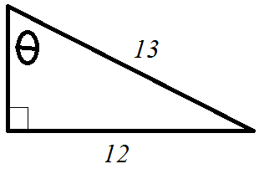

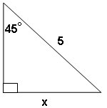
- (4 pts) Correctly fill in the blank. Use exact numbers
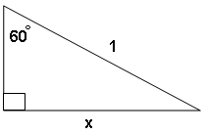

x = _____________ x = _____________

- (5 pts) Convert the following by filling in the blanks
Degree measure | 30$°$ | 45° | 60° | 90° | 120° | 270°
Radian measure |  |  |  |  |  |  | $$\frac{π}{12}$$ | $$\frac{7π}{4}$$ | $$\frac{8π}{3}$$ | $$3π$$

$$Sin\left(210°\right)=$$
$$Cos\left(180°\right)=$$
$$Tan\left(315°\right)=$$
$$Sin\left(405°\right)=$$
- (4 pts) Use exact numbers

EC: (2 pts) Round answers to the nearest tenth. Find $m∠ABC$. Now for 2 more points also find $m∠BAC$

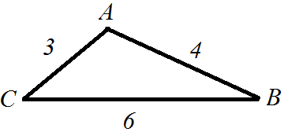

$m∠ABC=$ ___________; $m∠BAC=$____________

