In this section we will look at exponential expressions again and will focus on exponentials which are rational numbers. This type of expression is also called a radical expression because fractions in an exponent mean radicals in the math language.

In this sections we will discuss
- Square Roots and Square Root Functions
- Expressions of the form $\sqrt{a^{2}}$
- Cube Roots
- Odd and Even nth Roots

First Recall some basic facts of exponents:

Def: In the exponential expression $2^{3}$ the number 2 is called the base and the number 3 is called the exponent.

Def: The notation $2^{3}$ is exponential notation for repeated multiplication. It means the base number is being multiplied the number of times equal to the exponent.

Recall Rules of Exponents (unless you already have these at your fingertips, need to review these rules)

$$2^{3} 2^{2} 2^{1} 2^{0} 2^{-1} 2^{-2} 2^{-3}$$
$$8 4 2 1 \frac{1}{2^{1}} \frac{1}{2^{2}} \frac{1}{2^{3}}$$
$$8 4 2 1 \frac{1}{2} \frac{1}{4} \frac{1}{8}$$
$x^{m}x^{n}=x^{m+n}$ $x^{0}=1, x≠0$
$\frac{x^{m}}{x^{n}}=x^{m-n}, x≠0$ ${\left(x^{m}\right)}^{n}=x^{mn}$
$x^{-n}=\frac{1}{x^{n}}, x≠0$ ${\left(xy\right)}^{n}=x^{n}y^{n}$
$\frac{x^{-n}}{x^{-m}}=\frac{x^{m}}{x^{n}}, x≠0$ ${\left(\frac{x}{y}\right)}^{n}=\frac{x^{n}}{y^{n}}, y≠0$

These rules were presented to you where $m$ and $n$ are integers. The same rules apply even if the exponents are rational.

Square Roots and Square Root Functions

Def: Square Root

The number $c$ is a square root of $a$ if $c^{2}=a$

Ex:
3 is the square root of 9 if $3^{2}=9$ which it is.
5 is the square root of 25 if $5^{2}=25$ which it is.
9 is the square root of 81 if $9^{2}=81$ which it is.
So
$c$ is the square root of $a$ if $c^{2}=a$.

Def: Principal Square Root

The principal square root of a nonnegative number is its nonnegative square root. The symbol is called a radical sign and is used to indicate the principal square root of the number over which it appears. The number/expression the radical sign is over is called the radicand.

Ex:
$$\sqrt{25} \sqrt{\frac{1}{4}} -\sqrt{64} \sqrt{.0049} \sqrt{-1}$$

Ex: Given $f\left(x\right)=\sqrt{3x-2}$
- Find $f\left(2\right), f\left(1\right), f(f\left(1\right))$
- Find a such that $f\left(a\right)=4$

Consider the following: What is the difference between these two equations?
$x^{2}=25$ $x=\sqrt{25}$

Expressions of the form $\sqrt{a^{2}}$
Consider:
$1={\left(-1\right)}^{2}=\sqrt{{\left(-1\right)}^{2}}=-1$
what is wrong with this?
What is the consequence of this mistake?

Simplifying $\sqrt{a^{2}}$

For any real number $a$
$$\sqrt{a^{2}}=\left|a\right|$$
The principal square root of $a^{2}$ is the absolute value of $a$.

Ex: Simplify each expression.

a) $\sqrt{{\left(x-1\right)}^{2}}$ b) $\sqrt{x^{2}-10x+25}$ c)$\sqrt{{(-2)}^{4}}$ d) $\sqrt{a^{8}}$

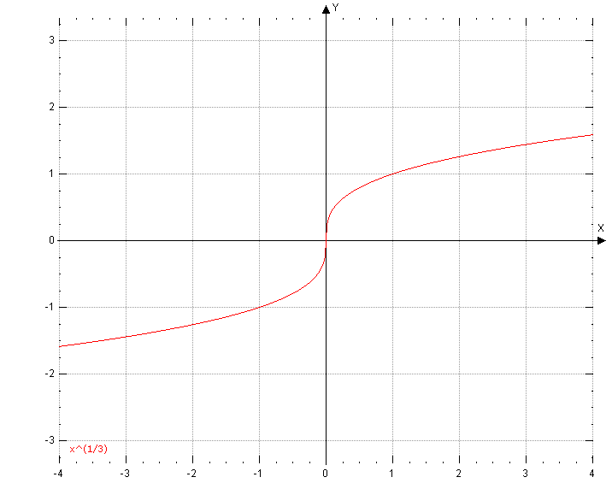

Cube Roots

Def: Cube Root

The number $c$ is a cube root of $a$ if $c^{3}=a$
In math symbols, we write $\sqrt[3]{a}$ to denote the cube root of $a$.

Ex: Simplify:

a) $\sqrt[3]{125}$ b) $\sqrt[3]{8y^{3}}$ c) $\sqrt[3]{-27}$ d) $\sqrt[3]{-81}$ e) $\sqrt[3]{-64x^{3}y^{6}}$

Odd and Even nth Roots
Ex: simplify
a) $\sqrt[5]{32}$ b)$\sqrt[4]{32}$ c) $\sqrt[5]{-32}$ d) $\sqrt[4]{-16}$ e) $-\sqrt[5]{-32}$ f) $\sqrt[4]{x^{4}}$ g) $\sqrt[7]{{\left(t-1\right)}^{7}}$

Summary of taking odd roots of negative numbers and taking even roots of negative numbers:

