In this section we will discuss
- Graphing exponential functions.
- Equations with x & y interchanged
- Applications

Graphing Exponential Functions.
Graph the following functions $f\left(x\right)=2^{x};g\left(x\right)=3^{x};h(x)=e^{x}$

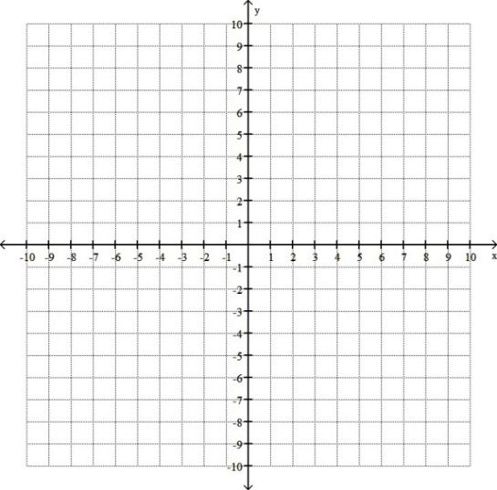
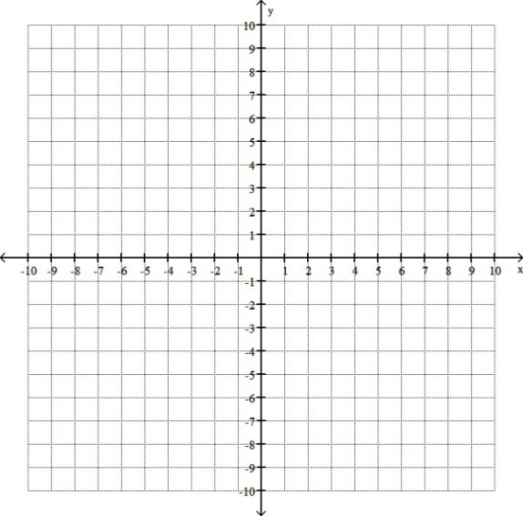

Graph the following functions $f\left(x\right)=5^{-x};g\left(x\right)=3^{-x};$ then graph $y=5^{x}$over the graph of $f\left(x\right) \& y=3^{x}$over the graph of $g\left(x\right)$
Notice the symmetry between these two functions

Recall how we graphed $y=x^{2} \& y={\left(x-1\right)}^{2}$
Replacing the variable $x$ with $(x-a)$ causes a horizontal shift.

Graph the following functions $f\left(x\right)=2^{x-1};g\left(x\right)=3^{x+2};h(x)=π^{-x+1}$

Graph the following functions $f\left(x\right)=5^{-x}+1;g\left(x\right)=3^{x-2}-5;$

Graph the inverse of following functions $f\left(x\right)=2^{x};g\left(x\right)={10}^{x};h(x)=3^{-x}$ by reflecting them across the line $y=x$

Compound Interest:
Recal Simple Interest formula
$I=Prt$ where $I=interst, P=principal amount, r=interst rate, t=time$

And the amount that you owe would be $A=P+I=P+Prt$

Compound Interest is given by the formula
$$A=P{\left(1+r\right)}^{t}$$

Derivation of formula:
$$A_{1}= P+Pr1=P(1+r)$$
$$A_{2}= A_{1}+A_{1}r1=A_{1}\left(1+r\right)= P\left(1+r\right)\left(1+r\right)=P{\left(1+r\right)}^{2}$$
$$A_{3}= A_{2}+A_{2}r1=A_{2}\left(1+r\right)= P{\left(1+r\right)}^{2}\left(1+r\right)=P{\left(1+r\right)}^{3}$$
$$A_{4}= A_{3}+A_{1}r1=A_{3}\left(1+r\right)= P{\left(1+r\right)}^{3}\left(1+r\right)=P{\left(1+r\right)}^{4}$$
.
.
.
$$A_{t}= A_{t-1}+A_{t-1}r1=A_{1}\left(1+r\right)= P{\left(1+r\right)}^{t-1}\left(1+r\right)=P{\left(1+r\right)}^{t}$$

Ex: If you charged $1000 on a credit card that has a 22% annual interest rate or .06% daily Interest rate, and then never used the card again, assuming you make no payments and the credit card company does not charge any fees, the amount you will owe after every year is given by the equation:
$$A\left(t\right)=1000{\left(1+.22\right)}^{t}$$
Find the amount of money you will owe for each of the first five years.
$$A\left(1\right)=1,222.00$$
$$A\left(2\right)=1,488.40$$
$$A\left(3\right)=1,815.85$$
$$A\left(4\right)=2,215.33$$
$$A\left(5\right)=2,702.71$$

Now find the amount of money you will owe after 10, 20 and 30 years!
$$A\left(10\right)=7,304.63$$
$$A\left(20\right)=53,357.64$$
$$A\left(30\right)=389,757.89$$

Sketch the graph of this function:
