In this section we will discuss

* Graphing logarithmic functions.
* Equivalent Equations
* Solving some Logarithmic Equations

What is a logarithmic function?

It is the inverse of an exponential function!!

Consider

$y=2^{x}$ Is this a function? ______ Is it a 1-1 function? _______ So will the inverse be a function? __________

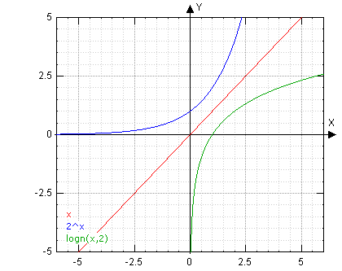

to find the inverse we __________________ the ____ & ____ variables.

Switching the $x \& y$ variables we get

$x=2^{y}$

Label each equation which is graphed on the right:

$f\left(x\right)=2^{x}$

$f^{-1}(x)$

$y=x$

This is really what we are calling the log base 2.

This says the base number (2) raised to the y value gives you the number x.

Note: $\log_{2}{x}$ is read “the log base 2 of x” and means “the exponent to which we raise 2 to get x.”

So if $2^{3}=8$

Then $\log_{2}{8}=3$

$\log_{2}{x}=y$ is just a notation we use to say $2^{y}=x$.

And it is the inverse of $f\left(x\right)=2^{x}$

Meaning:

Ex: Rewrite each as an equivalent logarithmic equation:

a) $49=7^{x}$ b) $x^{-2}=9$

Quickly, on the same graph sketch the graphs of $f\left(x\right)=2^{x};g\left(x\right)=3^{x};h(x)=5^{x}$.

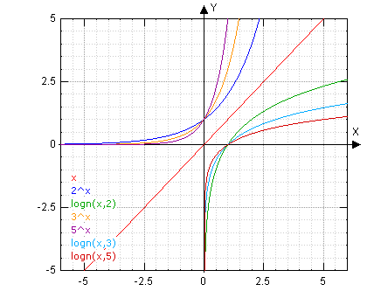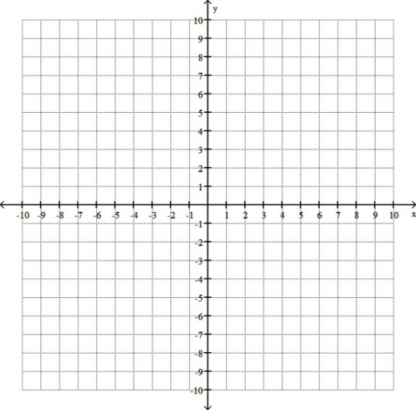

Now sketch the graphs of $f^{-1}\left(x\right)=\log_{2}{x};g^{-1}\left(x\right)=\log_{3}{x};h^{-1}\left(x\right)=\log_{5}{x}$ on the same graph above.

Ex: Label some possible functions that these graphs could represent if they were sketched.



## Solving Certain Logarithmic Equations

Ex: Solve the following:

a) $\log_{5}{125=y}$ b) $\log_{3}{x=4}$ c) $Log_{2}x=-3$

Ex:

$\log_{2}{2}=$ $=\log_{3}{3}$____ & $\log_{2}{1}=$ $=\log_{3}{1}=\log_{5}{1}$

____

Ex: Solve:

a) $\log_{6}{36}=x$ b) $\log_{5}{5}=x$ c) $\log_{8}{x}=\frac{2}{3}$

$$x=8^{2/3}$$

$$x={\left(\sqrt[3]{8}\right)}^{2}$$

$$x=2^{2}=4$$

$$5=5^{x}$$

$$5^{1}=5^{x}$$

$$1=x$$

$$36=6^{x}$$

$$6^{2}=6^{x}$$

$$2=x$$