Goals:
- What are whole Numbers?
  - Describe the embedded sets of numbers from Natural numbers to Real Numbers
- Graphing Numbers on a Number line (The order of numbers)
- Place Value (Base Ten vs. Alternate Bases) and expanded notation
  - What are Numbers really, how and why do we write them?
- Rounding Numbers

What are Whole Numbers?
First, lets define a few needed ideas.
Def: A Set is a collection of objects (numbers or otherwise) where order does not matter.
In this course as in many other math courses the use of braces, {} will be used to denote a set.

Def: Ellipsis is defined as the omission from a sentence or other construction of one or more words or objects that would complete or clarify the construction.
We use the symbol … to signify the use of an ellipsis.
In other words Ellipsis means “and so on.”

The whole numbers are a set of objects representing the numbers zero and every number one more than any other number in the set.
In easier terms:
Def: The Whole Numbers, are {0,1,2,3,4,5,6,…}

Other Numbers we will be concerned with this semester are
- Natural Numbers, $N$: {1,2,3,4,5,6,7,…}
- Whole Numbers: {0,1,2,3,4,5,…}
- Intergers, $Z$: {…,-3,-2,-1,0,1,2,3,…}
- Rational Numbers (fractions), $Q$: $\left\{\frac{a}{b} where a,b are integers and b≠0\right\}$
- Irrational Numbers: Numbers that are not Rational
- Real Numbers: The set of all rational numbers and Irrational numbers together.

Venn Diagrams are often graphical representations of sets and show the relationships between sets.
Below is a Venn Diagram of our number system:

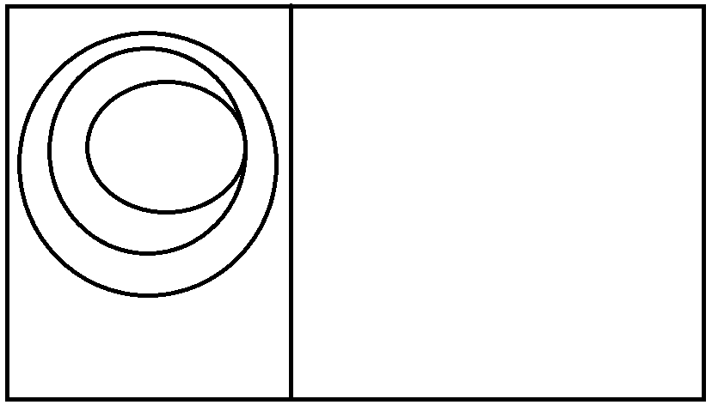

Graphing Numbers on a Number Line
A number line is used to place numbers in their natural order from least to greatest as you mover on the number line from left to right.

Unimpeachable Fact: On a number line, the number on the, , left is ALWAYs less than the number on the right.

Less than symbol: < Greater than Symbol: >
Example: 1 < 2 Example: 5 > 4

Forget about the alligator!

Place Value (Base Ten vs. Alternate Bases) and expanded notation

What are numbers really? How do we write them? Does everyone write them the same way?

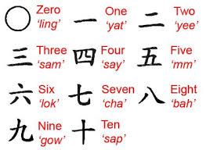
Numbers are just symbols that we use to represent the concept of quantity. Like how many fingers are being held up? 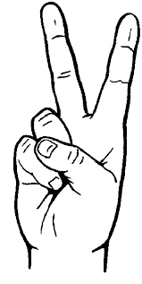

The Chinese use this symbol to represent it .

The Romans used the symbol, II, to represent it.

We use the number two to describe that quantity, we spell it “two” but we use the symbol 2 to represent it.

We use a Base Ten number system, which actually only uses ten unique symbols {0,1,2,3,4,5,6,7,8,9} called digits, and every other number is just a recycling of these ten digits. We use place value to assign a value to that digit.
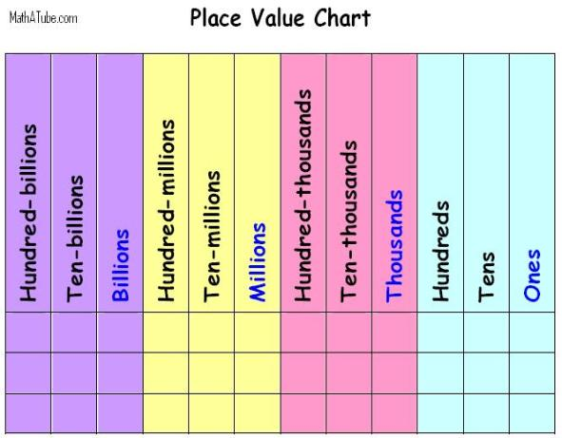
Example: write the number two hundred seventy one on the cart above
Example: Write the number fourteen million five hundred sixty thousand four hundred and ninety three
Expanded notation is the deconstruction of a number into sum of its individual parts.
For example the number 876 in expanded notation reveals the value of each digit in the number and illustrates how numbers can always be grouped or regrouped.

876 = 800+70+6

Expanded notation is meant to reveal the underlining meaning of our numbers in each place of value. With a clear understanding of expanded notation we will be better able to regroup numbers and understand the reasons for the arithmetic operations that we use in adding, subtracting, multiplying and dividing such as “carrying” and “borrowing”.

Example: Write the number 369,258 in expanded notation

Alternate bases
See https://betterexplained.com/articles/numbers-and-bases/ for another explanation of our numbers.

Our representations of numbers has been demonstrated not to be unique in terms of its symbols, but even the place values and digits we use to represent a number can be different too!

What if we were born with only two appendages and no fingers, like penguins? What might our number system look like?

What would a system that only uses two symbols or digits look like…Binary.

The thing to remember is that in any number system you have to start a set of symbols, called digits, that each uniquely represent zero, one, and perhaps other quantities that are larger than the previous number by one.

Then, where you place the digit will assign that digit its value!

Base two (binary):

There are only TWO digits in base two, they are {0,1}

Try to remember that these are the only symbols that have any meaning now. The symbol 2 is just as meaningless in binary as a number as the symbol is to us in base ten.

So all your numbers will be constructed of 1’s and 0’s, and where you place the digit will give that digit its meaning in expanded notation.

Binary Place value chart:
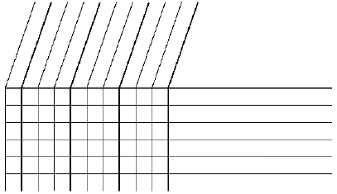

Below the illustration shows how a binary number is created by showing the place values or common groupings. It also illustrates how each number is a regrouping of place values in a expanded form.
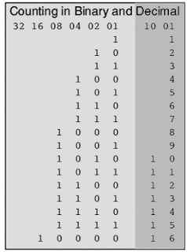

For example the number three is just one grouping of two and one grouping of 1.
So three is ${11}_{2}$, one two and one one.

In another example five is just a regrouping into groups of four and one but without any groupings of two.

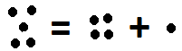
It five is ${101}_{2}$ , one group of four, no groups of two, and one group of one.

Example: Go back up to the base two place value chart on the previous page, and express the number six in binary, then below express the number six in expanded form.

Write down ten base ten numbers in the base 10 number column, then express that number in binary by placing the correct number of each groupings in the binary place value columns.
For example:
8 4 2 1
13 would be 1 1 0 1 one eight, one four, no twos and one one.

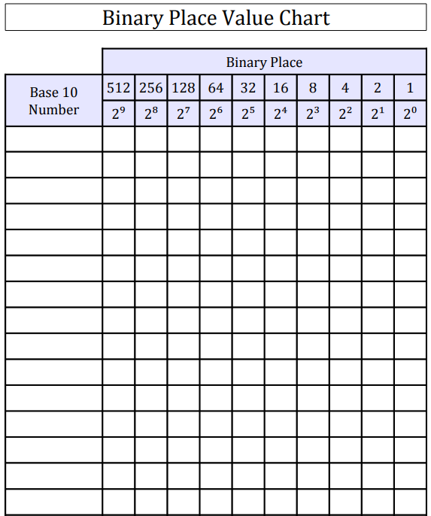

Other Bases

We can use any base number system we want. We just need the correct amount of symbols (including zero) and an appropriate place value system.

Base three

Base three uses three digits they are {0,1,2} and the place values are
…,eighty ones, twenty sevens, nines, threes, ones

Base four

Base four uses four digits they are {0,1,2,3} and the place values are

…, two hundred fifty sixes, sixty fours, sixteens, fours, ones

Base Five

Base five uses five digits they are {0,1,2,3,4} and the place values are

…, six hundred twenty fives, one hundred twenty fives, twenty fives, fives, ones

