Goals: Introduce the Integers, the concept of negative numbers.
- What are the Integers?
  - The concept of opposite being represented by “$–$“
  - Opposites of opposites, or double negatives.

- Ordering the numbers
- Absolute Values:
(Use Goals as a section header for the transition into each topic)

What are the Integers?

The Opposite of a number, “negatives” defined

The “Negative” of any number, is the number which represents the same quantity but indicates the opposite meaning of that number.

Ex: If 6 represents you “having” 6 dollars/pencils/cars
Then
-6 represents you “owing” 6 dollars/pencils/cars

Ex: If 7 represents you “earning” 6 dollars
Then
-7 represents you “spending” 6 dollars

Ex: If 2 represents you “moving to the right” for 2 places on a number line
Then
-2 represents you “moving to the left” for 2 on the same number line

The Opposite or Negative of any number, call it N, is the unique number –N. called the opposite or negative of N. It has the property of “canceling out” the original number N.
Or
For every number N, there is an opposite number –N such that
$$N+ -N=0$$

We pronounce the symbol -2 in one of two ways:
- “Negative two”
- “the opposite of two”

Recall the sets of numbers and the number line:
$0$

$N=Natural Numbers$
$\overbrace{1,2,3,4,5,6,7,8,9,10,11,12,…}$
Whole Numbers
$\overbrace{0, 1,2,3,4,5,6,7,8,9,10,11,12,…}$
$Z=Integers$
$\overbrace{…,-10,-9,-8-7,-6,-5,-4,-3,-2,-1,0, 1,2,3,4,5,6,7,8,9,10,11,12,…}$

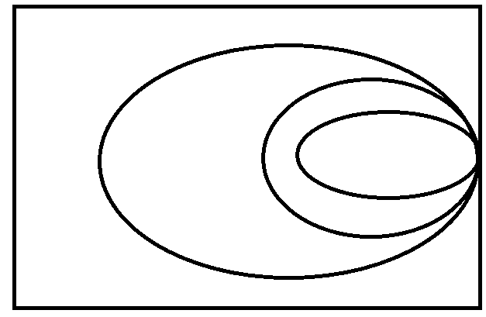

Ex: What number lies three units to the left of 1 on the number line? What is the opposite or negative of this number?

Ex: What number lies five units to the right of -8 on the number line? What is an example of how this situation could apply to our everyday lives? What is a math equation that describes that same example?

The order of the numbers.
On a number line, the number to the Left is ALWAYS Less Than any number to the right of that number.

Ex: Between the numbers 5 and negative 3, which number is less?

-3 0 5

Since -3 is left of 5 on the number line, $-3<5$

Ex: Enter the inequality symbol < or the symbol > in the box in order that the resulting inequality is a true statement.

$-4 0$ $-6 -3$ $-17 -21$ $15 -15$

Note: Positive numbers are always greater than zero.

If a number, N, is positive then

$$0<N$$

If a number, A, is negative then

$$A<0$$

Zero is neither positive nor negative.

The Opposite of Opposite, or the double negative
We have all heard of the vernacular phrase “aint got none”?

Double negatives are often confusing statements.

“I’m not going to stop” means I am going to do the opposite of stop, so continue!

“The cop didn’t tell me I couldn’t rob the bank” implies that he might have just as well told me I could rob it!

If you “aint got no money” then this implies that you do have money, since you do not have no money, and the opposite of no money is having some money.

In Math:

Opposites of opposites:
Let a, be a number, then the “opposite of the opposite of a is a”.
i.e.
$$-\left(-a\right)=a$$

Ex: Simplify

$-\left(-12\right)=$ $-\left(-1\right)=$ $-\left(-375\right)=$ $-\left(-31\right)=$

The best examples of this will come as a challenge to us when we try to subtract negative numbers in section 2.3

Future example:

$1-\left(-12\right)=$ $5-\left(-1\right)=$ $10-\left(-375\right)=$ 31$-\left(-31\right)=$

Note: It’s good to note that negative numbers were rejected as a concept all the way until only about 350 years ago. They were rejected by many of the same mathematicians that contributed to our current understanding of mathematics. Mathematicians such as John Napier (1551-1617) and Renee Descartes (1596-1650) both rejected the notion of negatives calling them defective and false. So if you struggle with them, there is a long history of very brilliant minds who also struggled with them!

Absolute Value, $\left|a\right|$
Definition: The absolute value of any number is defined as the distance that number is away from 0 on the number line.

It is crucial to note that distance is always positive. Think about running backwards, did you do the opposite of running?

Ex: Determine the value of each expression

$\left|-4\right|=$ $\left|4\right|=$ $\left|-1\right|=$ $\left|1\right|=$ $\left|-30\right|=$

Note: the absolute value does not mean the opposite of a number; that is what negatives mean. Instead it represents the quantity without its meaning of “to have” or “to owe”. That is why $\left|-4\right|=\left|4\right|$, while $-4≠4$

