Goals: Introduce Decimals, cement the concept of place value and connect it to the topic of other based numbers.
- Base Ten, its digits, and its place values.
  - How to read a decimal number
  - What is the relationship to decimals and fractions, fractions to decimals, and to other numbers
  - Using the words for a decimal to write the number as a fraction or mixed number
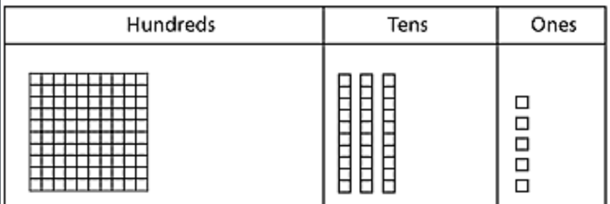
- Rounding
- Comparing decimal numbers

Our Numbers in Base Ten

To express any number in a positional system or place-value-based number system we need symbols or digits to represent certain numbers, and from there we use a positional system consisting of place values occupied by digits. The system we use is commonly referred to as a base ten number system or as the Hindu-Arabic numeral system.

Digits: We have symbols $\{0,1,2,3,4,5,6,7,8,9\}$ as the only ten symbols or digits used to make every real number.

Place Value
Place Value: Where we place each digit will assign the number its meaning. In a base ten number system each place value is a power of the base number ten.

For example:

$${10}^{6}$$ | $${10}^{5}$$ | $${10}^{4}$$ | $${10}^{3}$$ | $${10}^{2}$$ | $${10}^{1}$$ | $${10}^{0}$$ | . | $${10}^{-1}$$ | $${10}^{-2}$$ | $${10}^{-3}$$ | $${10}^{-4}$$
Millions | Hundred Thousands | Ten Thousands | Thousands | Hundreds | Tens | Ones | . | Tenths | Hundredths | Thousandths | Ten Thousandth
 |  |  |  | 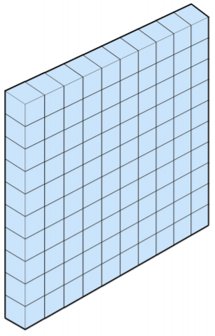 | 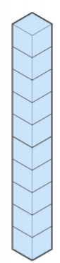 |  | .
 |  |  |  |  |  |  | .
 |  |  |  |  |  |  | .
 |  |  |  |  |  |  | .
Recall that the place values are different in different basses.
For example in base five our place values look like this

Twenty fives | Fives | Ones

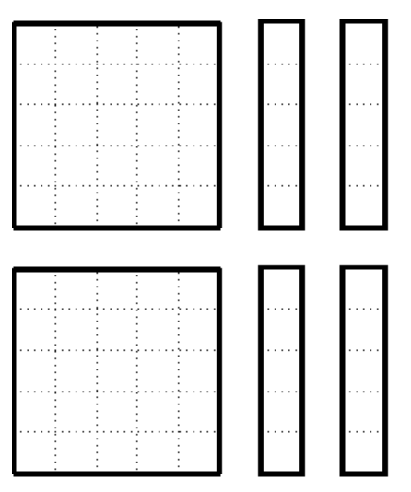

_____________ __________ ______
Express the number of objects shown above in base 5.

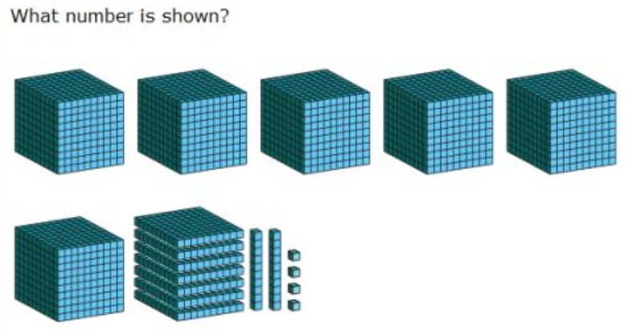
_________________________ (note, these are objects depicting base ten groups)

How to read/pronounce Decimal Numbers

$${10}^{6}$$ | $${10}^{5}$$ | $${10}^{4}$$ | $${10}^{3}$$ | $${10}^{2}$$ | $${10}^{1}$$ | $${10}^{0}$$ | . | $${10}^{-1}$$ | $${10}^{-2}$$ | $${10}^{-3}$$ | $${10}^{-4}$$
Millions | Hundred Thousands | Ten Thousands | Thousands | Hundreds | Tens | Ones | . | Tenths | Hundredths | Thousandths | Ten Thousandth
 |  |  |  |  |  |  | .
 |  |  | 1 | 1 | 1 | 1 | . | 1 | 1 | 1
 |  |  |  | 2 | 5 | 4 | . | 6 | 8
 |  |  |  |  | 6 | 5 | . | 3 | 7

1,111.111 is pronounced “one thousand, one hundred eleven AND one hundred eleven thousandths”

254.68 is pronounced “two hundred fifty four AND sixty eight hundredths”

Note the similarity between the way we say decimal numbers and mixed numbers

$254 \frac{68}{100}$

The mixed number represents a number with a whole part and a fractional part

$254 \frac{68}{100}$ 254.68

65.37 is pronounced “sixty five AND thirty seven hundredths”

The AND and the decimal point are both what separates the whole part and the fractional parts of the number.

Literally 65.37 = 6 (tens)+5(ones)+3$\left(\frac{1}{10}\right)$+$7\left(\frac{1}{100}\right)$

What is the relationship to decimals and fractions, fractions to decimals, and to other numbers

Recall how our numbers are embedded and related.
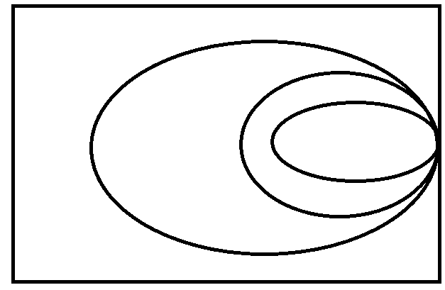

Important Fact: Decimals will either terminate or not-terminate.
Examples:
Terminating decimals: Non-Terminating Decimals:
Repeaters Non-repeaters
.5 .111111…$=.\overline{1}$ 3.14159265359…$=π$

.87 .77777…$=.\overline{7}$ 1.41421356…$=\sqrt{2}$

.1573 .232323…$=.\overline{23}$

.3333

All fractions have a very obvious “calling card” when expressed as a decimal letting you know that they are really just a fraction.

And likewise, the non-fractions are equally obvious decimals numbers, because they are the only ones that never terminate and never repeat.

Using the words for a decimal to write the number as a fraction or mixed number

123.4567 = $123\frac{4567}{10000}=\frac{1234567}{10000}$

98.763=$98\frac{763}{1000}=\frac{98763}{1000}$

253.9541=

Say the number with words and then write it down as a mixed number.
You can now just convert this mixed number to an improper fraction if you want.

Did you notice that all of the fractional parts / denominators have the same number of zeros as digits after the decimal?

Don’t forget to reduce if necessary

4.5=$4\frac{5}{10}=4\frac{1}{2}$ 56.25= 76.125=

0.98= -.35= -4.75

Rounding
Round the number to the nearest hundredth

753.2146 951.75869 4568.7951

Recall the terms:

Rounding Digit:_________________________________________________________________

Test Digit:______________________________________________________________________

The rule is: _____________________________________________________________________

Comparing Decimal Numbers
How do we know which numbers are larger?
For the examples below, use the correct symbol ($<,>,=)$ to indicate the correct relationship.

563 ___ 456 ; 427 ___ 439 ; 751 ___ 750 ; 35.123 ___ 35.023 ; 756.35489 ___ 756.32351

So, how do we know which of the numbers is larger?

And what if the numbers are negative?

-563 ___ -456 ; -35.123 ___ -35.023 ; -756.35489 ___ -756.32351

