Goals: To discuss division with decimals
- Dividing whole numbers with remainders
- Dividing with decimal numbers
- Dividing with signed numbers
- Dividing by Powers of Ten
- The Order of Operations

Dividing whole numbers with remainders

Consider the division problem $\frac{27}{2}$

Recall in chapter 4 we would complete this division number and write the quotient as a mixed number.

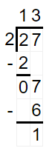 so the quotient is $13\frac{1}{2}$

But in this section we want to get a decimal answer and not a fractional answer.

In long division, just as in multiplication and addition, we have to keep track of the decimal, so when we divide we move the decimal up to “keep track” of it.
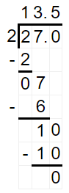 So this is another equivalent form of the answer to the same problem. Note $13.5=13\frac{5}{10}=13\frac{1}{2}$

If you are curious why moving the decimal up works let’s look at it, if not, we can just skip ahead.

We notice that in $\frac{27}{2}$, 2 does not go into 27 evenly, but it does go into 270 evenly so we can do this little trick.
$$\frac{27}{2}=\frac{270∙0.1}{2}=\frac{270}{2}∙0.1=135∙0.1$$
When we divide $\frac{270}{2}$ in long division this now divides evenly, and the 0.1 will move the decimal one place to the left, which repositions the decimal in the correct place, thereby “keeping track” of it in the answer.
Consider this one other example.
$$\frac{4.80}{2.4}=\frac{480∙0.01}{24∙0.1}=\frac{480}{24}∙\frac{0.01}{0.1}=\frac{480}{24}∙0.01∙10=20∙0.1=2.0$$

Dividing with decimal numbers

Consider the division problem $\frac{2.43}{2.5}$
The problem is that the long division algorithm works easiest if the divisor is a whole number, so what we need to do is to perform the long division on an equivalent division problem/fraction but one where the divisor is a whole number.
$\frac{2.43}{2.5}=\frac{2.43}{2.5}∙\frac{10}{10}=\frac{24.3}{25}$
But now this equivalent fraction has the benefit of having a whole number divisor, which works best for long division. All we need to do is move the decimal up to “keep track” of it, and divide as usual by ignoring the decimal.
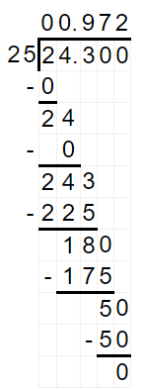
So when we divide with a decimal divisor,
- Move the decimal to the end of the divisor
- Then move the decimal in the dividend an equal number of places
This is equivalent to multiplying both the numerator (dividend) and denominator (divisor) by “the magic one” of some power of ten

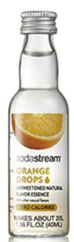
Example:
I like to make flavored mineral water by using compressed $CO_{2}$ and tap water. My favorite has an orange flavor that comes in a 1.36 oz container. For each 20 ounces of water you are supposed to add 2 drops which contains about 0.075 oz of the flavoring. How many 20 oz drinks can you make with one bottle?

Answer: The question is, “how many 0.075’s are there in 1.36?” Which is definitely what division is good at answering. Ans: $18.1\overline{3}$ or 18 drinks

Example: You score 81 points out of 90 points on an exam, calculate your grade as a percent (note percent means a number over 100)

Solution:
You need to find out what it is to get $\frac{81}{90}$ and express this number over 100. So first we divide.
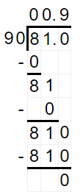 So $\frac{81}{90}=0.9$, we want this as a percent so we write it as an equivalent fraction with a denominator of 100.
$$0.9=\frac{0.9}{1}∙\frac{100}{100}=\frac{90}{100}=90\%$$

Examples:
Notice that when you divide by numbers whose only prime factors are 2’s, 5’s, or both 2’s and 5’s, the result is a terminating decimal.

Find these quotients:
$\frac{13.565}{2.5}$ $\frac{1.25}{0.04}$ $\frac{156.3}{0.5}$

But when you divide by numbers (when already reduced) whose prime factors are NOT only 2’s, 5’s, or both 2’s and 5’s, the result is a repeating decimal.

$\frac{0.3478}{0.3}$ $\frac{5.1076}{0.06}$ $\frac{4.1}{9.9}$

Dividing with signed numbers

Just as we discovered before and for the same reasons as before, the product or quotient of two numbers with the same signs will be positive, and the product or quotient of two numbers with different signs will be negative.

Like Signs: $\frac{(+)}{(+)}=+$ & $\frac{\left(-\right)}{\left(-\right)}=+$ Unlike Signs: $\frac{(+)}{(-)}=-$ & $\frac{\left(-\right)}{\left(+\right)}=-$

Underline all fractions which will produce a negative quotient
Circle all fractions which will have a quotient that is a terminating decimal
Box all fractions which will have a quotient that is a repeating decimal

Note: all these fractions are reduced

$\frac{-4}{9}$ $\frac{-32}{-2.5}$ $\frac{13}{-0.02}$ $\frac{-9.7}{-0.15}$ $\frac{0.59}{-3.5}$ $\frac{-2.91}{-0.140}$ $\frac{5.62}{-9.9}$ $\frac{-9.87}{-11}$ $\frac{-5.7}{2.5}$ $\frac{0.99}{-0.8}$ $\frac{-7.52}{3.5}$ $\frac{19}{1.25}$ $\frac{-9.75}{-3.2}$ $\frac{-32}{-2.5}$ $\frac{-32}{-2.5}$

Dividing by powers of ten

Consider: $\frac{132}{10}$ $\frac{97}{100}$ $\frac{9534}{1000}$ $\frac{9}{0.01}$
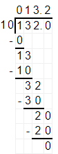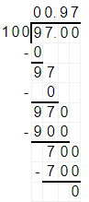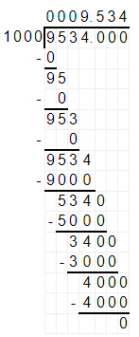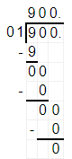

Dividing by powers of ten simply moves the decimal.

Ex: $21.34÷10$ $987.3214÷{10}^{2}$ $65.78÷{10}^{-3}$ $21.34÷100$

The Order of Operations
It’s the same list, in the same order

- Parenthesis or grouping symbols
- Exponents
- Multiplication AND Division in order of appearance from L$→$R
- Addition AND Subtraction in order of appearance from L$→$R

Examples:
Simplify the following expressions

$\frac{-5.6-7.5}{-5.05-1.5}$ $\frac{6.5\left(-1.6\right)-3.35}{-2.75}$

$\frac{46.63}{{10}^{4}}+0.2623({10}^{2})$ $\frac{-12.9-\left(-10.98\right)}{{0.5}^{2}}$

