Goals:

* We will look at a conditional statement with a conjunction and analyze its truth table, then create a logic circuit that will mimic this truth table output.
* The goal is to learn more about truth tables, logic circuits, and how the logic circuit is simply an application of the symbolic logical statement.
* You can find/use a truth table generator at: <https://web.stanford.edu/class/cs103/tools/truth-table-tool/>
* We will utilize a free online logic circuit “digital logic simulator” called logic.ly <https://logic.ly/demo>

### An Example Statement

Create an example statement in words that is equivalent to the symbolic logical statement

$$p→\left(q∧r\right)$$

Write your statement in words here: ________________________________________________________

______________________________________________________________________________________

Now go to the Stanford site for the truth table generator, copy and paste the resulting truth table below.

Now we are going to emulate the truth table values with a circuit. In order to create a circuit, we need to figure out how to make a conditional statement with a logic circuit. The way we do this is to use a logical equivalence.

We need to realize the logical equivalence of $m→n≡\sim m∨n$

We can tell these are logically equivalent by looking at their truth table values by using the Stanford site listed above.

Answer 1: **Place your answer below**:

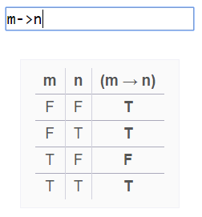

Now go to the site and generate the truth table values for “~m or n”. **Copy or write in the truth table next to the one above for (m->n).** Verify if these statements are equivalent.

Next lets recall what we learned in the book and in our [class notes for section 3.3](https://marcolsen.weebly.com/uploads/1/3/6/4/13641528/310__3.3_conditional_statements_and_circuits.pdf) on logic circuits.

This image is taken from page 4 of our class notes.

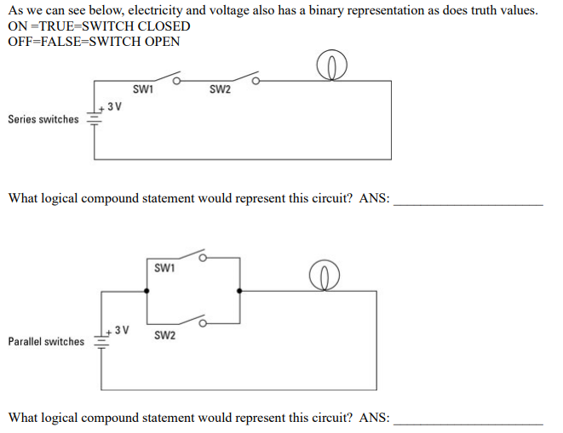

So lets sketch out what our statement $p→\left(q∧r\right)$ would look like as a circuit.

We were never shown what the circuit for $p→q$ was, so we will use the logical equivalence to help us.

Using the logical equivalence we found earlier ( $m→n≡\sim m∨n$).

Make the substitution in the above symbolic statement, this by replacing $m=p \& n=(q∨r)$

Fill in the blank making the above substitution: $m→n=p→\left(q∧r\right)≡$

____________

In terms of our circuit, we would need a negation (which reverses the state of the switch at p) in parallel with two switches called, $q$& $r$ which will be in series with each other.

To draw this circuit we will again use substitution but this time on the example of the parallel circuit.

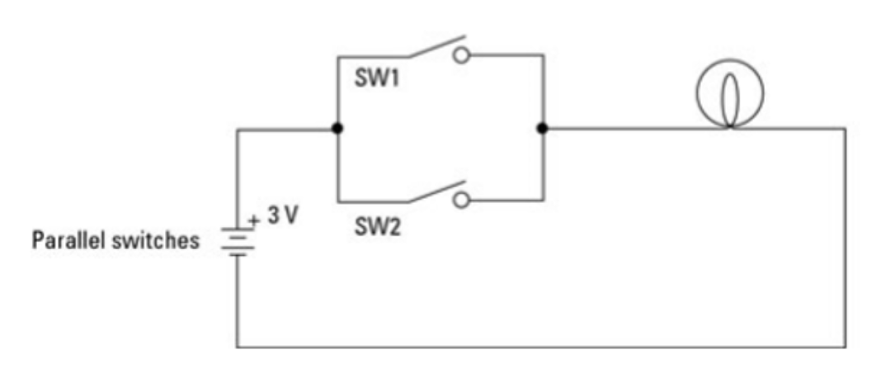

Substitute switch, SW1= $p$& SW2 = $q∧r$

And remember that $q∧r$ is the series circuit 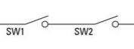

**Now construct your circuit below:**

This may seem crazy, but it is just a matter of substitution, and taking the effort and time to learn something new. If you need to, go do some google searches, do some reading on logic circuits, ask me in office hours, or a tutor. You will see with some effort, that this is not that crazy after all.

Pretty cool!

Now, we will take this to a logic circuit the simulator app logic.ly.

Like all good apps, this will be easier than the circuit design because we will just use the logic gates that other people built our circuits into these gates.

Recall from the 3.3 notes:

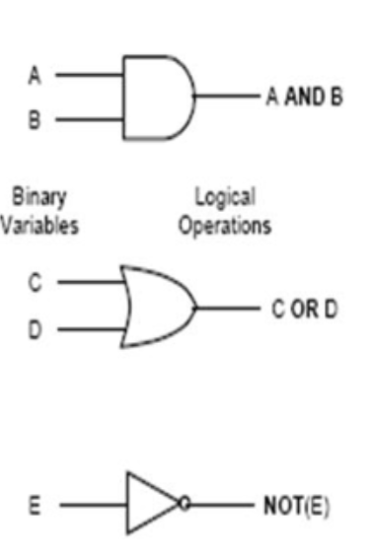

Lets take our symbolic statement $p→\left(q∧r\right)≡\sim p∨\left(q∧r\right)$ this to the site logic.ly

Think about this statement, $\sim p∨\left(q∧r\right)$, what is it really?

It is a disjunction “or” of what two statements? ____________________ or ____________________

So we have $\sim p$ OR (the conjunction “and” of $q , r$)

You are now ready to build your logic circuit using gates.

Go to <https://logic.ly/demo>

Switches will represent any statement, because they can be “on” or “off”, so they will represent our symbolic statements, $p,q,r$, which can only be classified as “true” or “false”

So grab three “Toggle Switches” (found in the “input controls”) and place them in your work area. You can label them $p, q, r$ if you like.

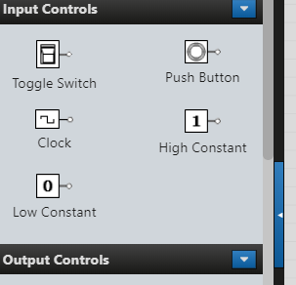

You will need three logic gates, one “NOT Gate”, one “OR Gate”, as well as one “AND Gate”.

You will find these in the “Logic Gates”

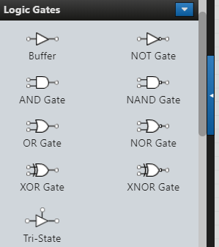

“NOT Gate” , one “OR Gate” , as well as one “AND Gate” .

Switches $q\&r$ will need to be linked to the AND Gate.

Switches $q\&r$ next to the AND Gate: To link them, click from one dot to the one you want to connect.

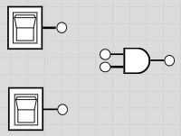 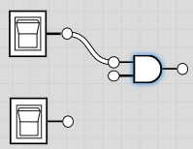 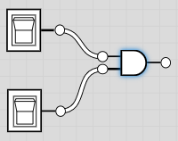

Your logic circuit is basically this below. It is two switches connected by an AND Gate, which is connected with a NOT Gate on P to an OR Gate.

$$\sim p∨\left(q∧r\right)=\left(NOT p\right) OR (q AND r)$$

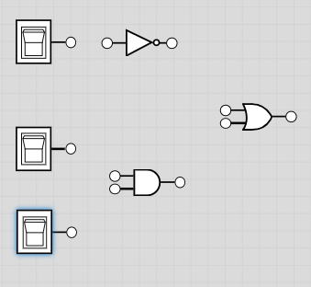

Hook up your circuit and connect a “Light Bulb” (found in “Output Controls”) to the “end” after the OR Gate. **Copy a picture of your circuit below**:

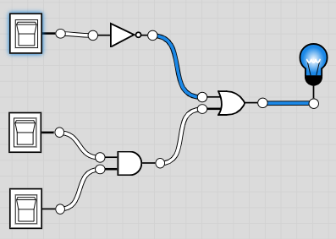

**Now copy your truth table values for your statement $p→\left(q∧r\right)$**  on page 1

and **test these five cases on your circuit**. Remember, T = on for your switch, and F = off. Fill in the table.

Does your circuit simulate the logical values of your original statement?

|  |  |  |  |  |
| --- | --- | --- | --- | --- |
| $$p$$ | $$q$$ | $$r$$ | $$p→\left(q∧r\right)$$ | $$Circuit$$ |
| T | T | F |  |  |
| T | F | T |  |  |
| T | T | T |  |  |
| F | F | F |  |  |
| F | T | F |  |  |

Write a brief reflection about what you experienced and learned with regards to the material. Please draw connecting lines to the homework, the material we are learning, and these circuits and logic gates. If you do not see any connections, then elaborate on what you do know, and what you do understand about these circuits and logic gates. Explain how they are different from each other in specific ways. Then take one last shot at trying to find any ways that they are in some way similar.