What Is A Limit
Zeno's paradox
The dichotomy paradox | “ That which is in locomotion must arrive at the half-way stage before it arrives at the goal. ” | Aristotle, Physics VI:9, 239b10
Zeno argued that it is impossible to ever reach a destination. In order to reach the nearest wall you must first travel half the distance to the wall. Again, you must also travel half that distances or one quarter of the total distance, then one-eighth, then one-sixteenth, and so on.
So any journey requires an infinite number of tasks, which Zeno maintains is an impossibility.

Defn Limit (Informal)
Let $f(x)$ be defined on an open interval about $x_{0}$, except possibly at $x_{0}$ itself. If $f(x)$ gets arbitrarily close to a number $L$ (as close as we like) for all $x$ sufficiently close to $x_{0}$, we say that $f$ approaches the limit $L$ as $x$ approaches $x_{0}$, and we write
$$\lim_{x→x_{0}}{f(x)}=L$$
which is read “the limit of $f(x)$ as $x$ approaches $x_{0}$ is $L$.

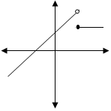
Ex: Consider these graphs of $f\left(x\right)$and determine $\lim_{x→4}{f(x)}$ for each graph.
7 7 7 7
5
2

4 4 4 4

NOTE: The limit value does NOT depend on how the function is defined at $x_{0}$.
- Apply the definition above to find $\lim_{x→2}{x^{2}}$ graphically.

Ex 3 Find the limits. $a) \lim_{x→0}{\frac{1}{x}}$ b) $\lim_{x→0}{2x}$

What are the major differences in these two functions?

What is limit at $x_{0}$ if a function $f\left(x\right)$is continuous at $x_{0}$?

Some ways limits fail to exist or evaluating limits initially produces undefined/undetermined results.
You will want to look out for functions with the following properties.
- Holes: $f\left(x\right)=\frac{(x+1)(x-1)}{(x-1)}$
- Jumps: example of a function with a jump discontinuity ($RHL≠LHL$) [Limit DNE]
  - $f\left(x\right)=\frac{1}{x}$ [Limit DNE]
- Skips: (break in your domain) $f\left(x\right)=\left\{\begin{aligned}-1, &x<0 \\ 1, &x≥1\end{aligned}\right.$
- Essential: piecewise function $\sin{\frac{1}{x}}$ when $x>0$ and $0$ elsewhere [Limit DNE]
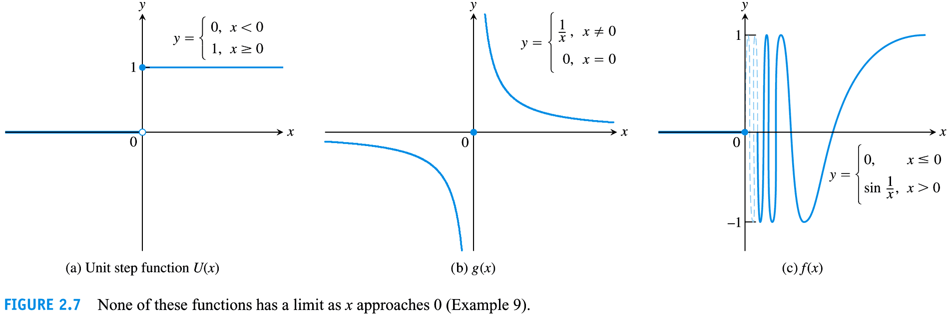
Ex 4 For the function $f$ graphed below, find the following limits or explain why they don’t exist.
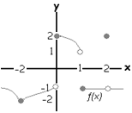
- $\lim_{x→1}{f(x)}$
- $\lim_{x→2}{f(x)}$
- $\lim_{x→-2}{f(x)}$
- $\lim_{x→0}{f(x)}$
- Does $\lim_{x→x_{0}}{f(x)}$ exist for every point $x_{0}$ in $(-2,0)$?

Ex 4 Circle the correct T or F for one point, state why for the rest of the points.

T/F If $\lim_{x→c}{f(x)}=L then f\left(c\right)=L$

T/F If $f$ is undefined at $x_{o}=c$ , then the limit of $f(x)$ as $x$ approaches $c$ does not exist.

Ex 5 (# 11 b) Given $f\left(x\right)=\frac{\left(x^{2}-9\right)}{x+3}$ , find $\lim_{x→-3}{f\left(x\right)}$ graphically.

Ex 6 Find the limits.

- $\lim_{x→1}2x+1$

- $\lim_{x→-2}\frac{x+3}{x^{2}(x-1)}$

- $\lim_{x→π}\cos{\frac{x}{2}}$

Ex 7 Find the average rate of change over the given interval.
$f\left(x\right)=\sqrt{x}-\cos{(π}x)$; $[1,9]$

The Formal Definition of a Limit
Note: Greek letters: $δ$ – delta, $ε$- epsilon
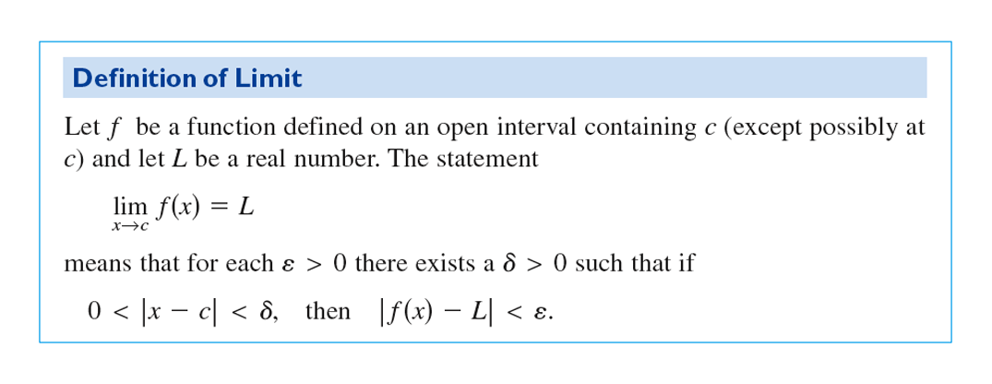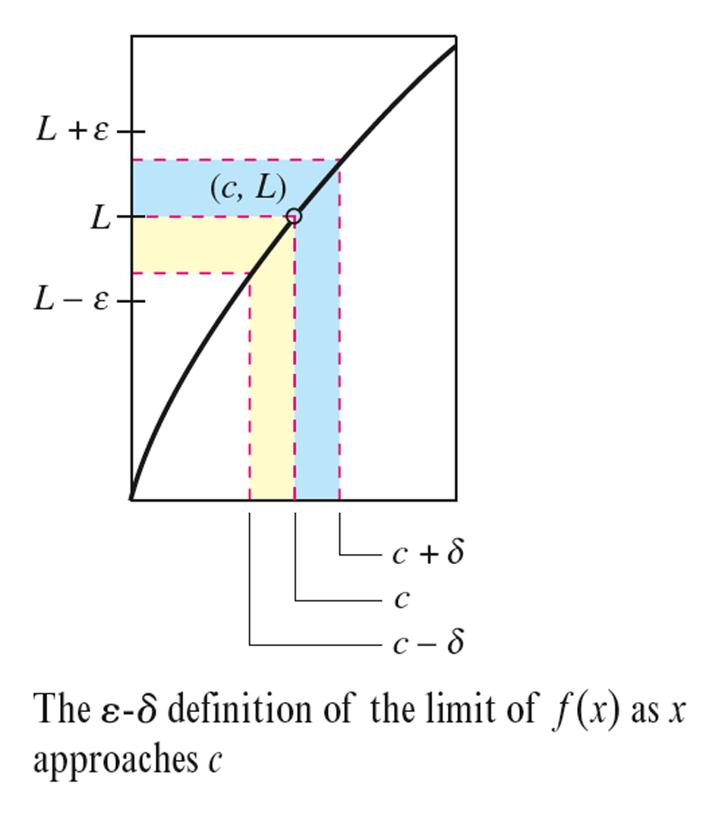
i.e. if $x→x_{o}$ , then $f(x)→L$

How do I write $x→x_{o}$ in “math” and what does $0<\left|x-x_{0}\right|<δ$ mean?

For a moment, consider this absolute value inequality, and find its solution set:

$\left|x\right|<1$

Lets think of the solution set as “the set of all x’s inside a circle or ball placed onto the x-axis at x=0, where the ball has radius of 1” or literally, “the set of all x’s whose distance from 0 is less than 1”
So visually the solution set will be the length of the x-axis containing the interval $(-1,1).$
The same x’s that are contained by a ball with radius 1 centered at x=0 on the x-axis.

Recall what the effects are of graphing a function $f\left(x\right)=x^{2}$ and $f\left(x\right)={\left(x-2\right)}^{2}$ are. The later is merely a horizontal shift of $x^{2}$ TWO places to the right.

Example: Consider the inequality $\left|x-2\right|<1$ Find its solution set and express it using the language:
The set of all x’s inside a ball of r = ________, centered on the x-axis at x = __________.
The set of all x’s whose distance from ______, is less than ______

Let us try to evolve this to a better understanding of the inequality $0<\left|x-x_{0}\right|<δ$

Examples:
Describe the inequality $\left|x-1\right|<2$
The solution set is, the set of all x’s inside a ball of r = ________, centered on the x-axis at x = __________.
The solution set is, the set of all x’s whose distance from _________ is less than ________

Describe the inequality $\left|x+3\right|<1.5$
The solution set is, the set of all x’s inside a ball of r = ________, centered on the x-axis at x = __________.
The solution set is, the set of all x’s whose distance from _________ is less than ________

Describe the inequality $\left|x-7\right|<δ$
The solution set is, the set of all x’s inside a ball of r = ________, centered on the x-axis at x = __________.
The solution set is, the set of all x’s whose distance from _________ is less than ________

Describe the inequality $\left|x-x_{0}\right|<5$
The solution set is, the set of all x’s inside a ball of r = ________, centered on the x-axis at x = __________.
The solution set is, the set of all x’s whose distance from _________ is less than ________

Describe the inequality $\left|x-x_{0}\right|<δ$
The solution set is, the set of all x’s inside a ball of r = ________, centered on the x-axis at x = __________.
The solution set is, the set of all x’s whose distance from _________ is less than ________

Describe the inequality $\left|y-1\right|<2$
The solution set is, the set of all ___’s inside a ball of r = ________, centered on the ___-axis at __ = __________.
The solution set is, the set of all y’s whose distance from _________ is less than ________

Describe the inequality $\left|f\left(x\right)+3\right|<5$
The solution set is, the set of all ___’s inside a ball of r = ________, centered on the ___-axis at y = __________.
The solution set is, the set of all f(x)’s whose distance from _________ is less than ________

Describe the inequality $\left|f\left(x\right)-L\right|<3$
The solution set is, the set of all ___’s inside a ball of r = ________, centered on the ___-axis at y = __________.
The solution set is, the set of all f(x)’s whose distance from _________ is less than ________

Describe the inequality $\left|f\left(x\right)-L\right|<ε$
The solution set is, the set of all ___’s inside a ball of r = ________, centered on the ___-axis at __ = __________.
The solution set is, the set of all f(x)’s whose distance from _________ is less than ________

What does it mean when you say $x→x_{o}$? Which x’s are you talking about?
The set of all x’s inside a ball of r = ________, centered on the x-axis at x = __________.
All the x’s that are “close” to $x_{0}$… whose distance from $x_{0}$ is small. How small? As small as you want to $δ$ to be.

If $f(x)→L$, which y’s are the ones “sufficiently close” to $f(x)$? How close?
The set of all ___’s inside a ball of r = ________, centered on the ___-axis at __ = __________?
All the f(x)’s that are “close” to L or whose distance from $x_{0}$ is small. How small? As small as you want to make $δ$.

How could you express this mathematically? __________________________
How do we resolve that this definition specifies for every $ε$ there exits a $δ$?

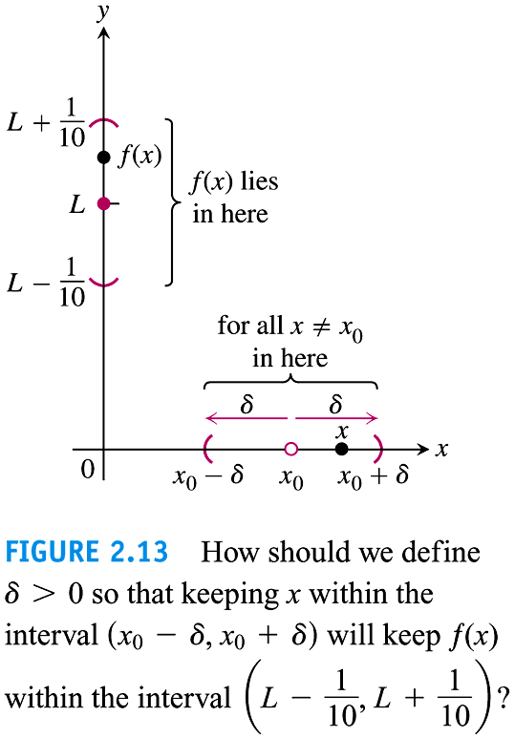

We can think of using the definition (to prove the limit is correct) as a game.
Given: $y=f(x)$ and $\lim_{x{→x}_{0}}{f(x)}=L$
You give me $ε>0$. Draw an $ε-$ball around $L$.

I’ll find a $δ>0$ that depends on your $ε$ (and of course $f(x)$ and $x_{0}$) that will “work” by drawing a $δ-$ball around $x_{0}$.
$δ$ will be chosen so that no matter what $x$ we choose in the $δ-$ball (except $x_{0}$), Every associated y-value will lie inside the $ε-$ball.

Ex 1: Let $f\left(x\right)=2x-1; L=7; x_{0}=4, ε=2$
Find an open interval about $x_{0}$ on which the inequality $\left|f\left(x\right)-L\right|<ε$ holds. Then give the value for $δ>0$ such that for all $x$ satisfying $0<\left|x-x_{0}\right|<δ$ the inequality $\left|f\left(x\right)-L\right|<ε$ holds.

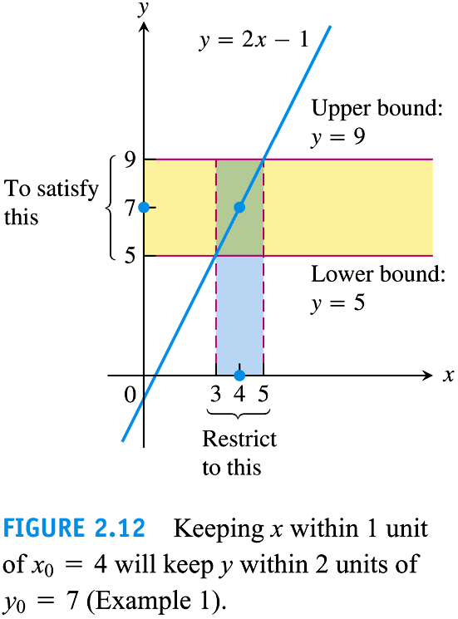

The holy grail of our “you give me an $ε>0$ and I’ll find you a $δ>0$” is to work this out in general terms, such that the $δ$ can be expressed in terms of $ε$.
Ex: Repeat previous example but do it in general for any $ε$-$δ$.
This amounts to giving a formal proof that $Lim_{x→4}2x-1=7;$

Note: $ε$-$δ$ proofs only shows the validity of a limit existing, they do not help us to FIND the limit of a function.

Ex: Give a formal proof that $Lim_{x→1}3x+2=5;$

If you want more difficult examples try these two problems below.
Ex: Give a formal proof that $Lim_{x→2}x^{2}=4;$ Go to https://www.youtube.com/watch?v=gLpQgWWXgMM for a video explanation.
For a video example of $Lim_{x→2}\frac{x+5}{8x-15}=7;$ click https://www.youtube.com/watch?v=VCqQXVIrJvQ

