*Theorem Limit Laws*

If $L,M, c,$ and $k$ are real numbers and $\lim_{x→c}{f(x)}=L$ and $\lim_{x→c}{g(x)}=M$, then

1. Sum Rule: $\lim_{x→c}{(f\left(x\right)}+g(x))=L+M$
2. Difference Rule: $\lim_{x→c}{(f\left(x\right)}-g(x))=L-M$
3. Product Rule: $\lim_{x→c}{(f\left(x\right)}∙g(x))=L∙M$
4. Constant Multiple Rule: $\lim_{x→c}{(k∙f(x)})=k∙L$
5. Quotient Rule: $\lim_{x→c}{\frac{f\left(x\right)}{g\left(x\right)}}=\frac{L}{M}, M≠0$
6. Power Rule: $\lim_{x→c}{{\left(f\left(x\right)\right)}^{r/s}}=L^{r/s}$ (If $r$ and $s$ have no common factors, $s≠0$, and $L^{r/s}$ is a real number)

Limit of a Composite Function

If $f \& g$ are functions such that $\lim_{x→c}{g\left(x\right)=L}$ and $\lim_{x→L}{f\left(x\right)=f(L)},$ then

$$\lim_{x→c}{f\left(g\left(x\right)\right)=f(\lim_{x→c}{g\left(x\right))=f(}L)}$$

*Corollary Limits of Polynomials Can Be Found By Substitution*

If $P\left(x\right)=a_{n}x^{n}+a_{n-1}x^{n-1}+…+a_{0}$ then $\lim_{x→c}P\left(x\right)=P\left(c\right)=a_{n}c^{n}+a_{n-1}c^{n-1}+…+a_{0}$

*Theorem Limits of Rational Functions Can Be Found By Substitution If the Limit of the Denominator is Not Zero*

If $P(x)$ and $Q(x)$ are polynomials and $Q(x)≠0$, then $\lim_{x→c}\frac{P\left(x\right)}{Q\left(x\right)}=\frac{P\left(c\right)}{Q\left(c\right)}$.

Hint: If $P\left(c\right)=0=Q(c)$, then $x-c$ is a factor of $P(x)$ and $Q(x)$ so can factor $x-c$ from both then cancel. Ex: $\lim_{x→1}\frac{x^{2}-x}{x-1}$

Ex 1 Find the limits.

$\lim_{x→0} 4$

1. $\lim_{h→0} \frac{\sqrt{5h+4}-2}{h}$ (\*If see , conjugate unless have diff of 2 squares, as in part c)
$\lim_{x→2}\frac{x^{2}-7x+10}{x-2}$

3. $\lim_{x→4}\frac{\left(4x-x^{2}\right)}{2-\sqrt{x}}$ (\*We see a but since there’s a diff of 2 squares, don’t conjugate)

Ex 2 Suppose that $\lim_{x→c}f\left(x\right)=3$, $\lim_{x→c} g\left(x\right)=-4 and \lim_{x→c} h\left(x\right)=DNE$ Find:

$\lim_{x→c}f\left(x\right)g(x)$

$\lim_{x→c}\left(f\left(x\right)-\frac{1}{4}g\left(x\right)\right)$

$\lim_{x→c}\frac{f\left(x\right)}{g\left(x\right)+2}$

$\lim_{x→c}f\left(x\right)h(x)$

Ex 3 Evaluate the limit $\lim_{h→0}\frac{f\left(x+h\right)-f\left(x\right)}{h}$ for $f\left(x\right)=x^{2}-3$ at $x=6$.

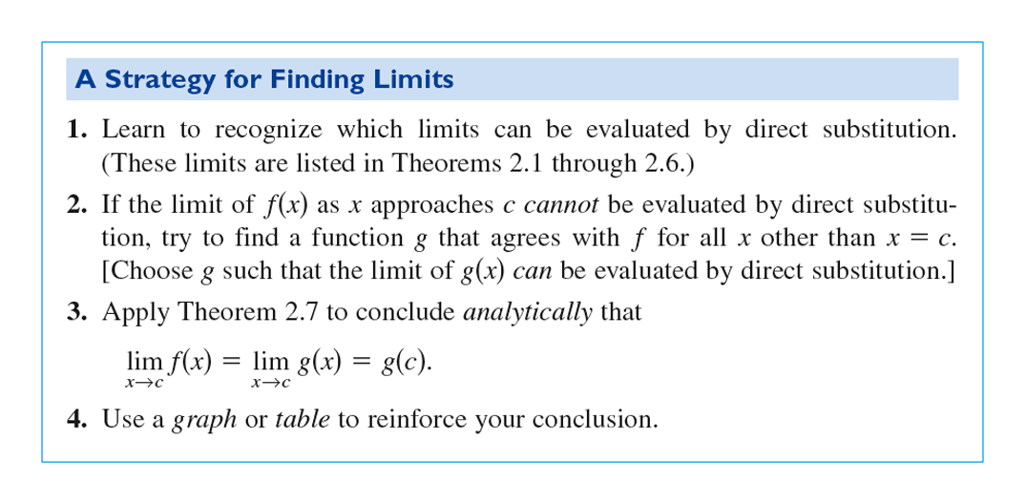

*Theorem The Squeeze/Sandwich Theorem*

Suppose that $g(x)≤f(x)≤h(x)$ for all $x$ in some open interval containing $c$,

except possibly at $x=c$ itself.

Suppose also that $\lim_{x→c}g\left(x\right)=\lim_{x→c}h\left(x\right)=L$. Then $\lim_{x→c}f\left(x\right)=L$.

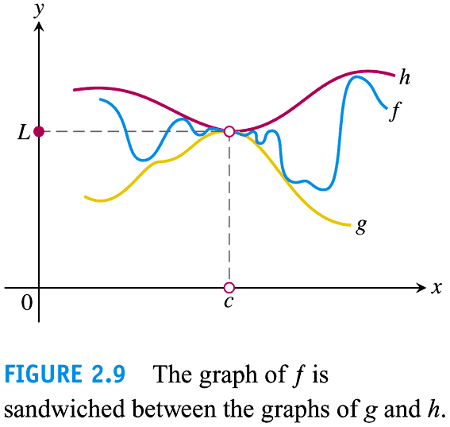

\*Useful when dealing with $\sin{x}/\cos{x}$ since $-1≤\sin{x}/\cos{x}≤1$ for all $xϵR$

Ex: Find $\lim_{x→0}{ Sin\frac{1}{x}}$

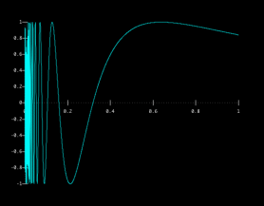Hint: Try imagining its graph. Find its limit as x-> +inf. Is $Sin\frac{1}{x}{ }$ bounded (meaning does its range have a max/min value)?



Ex: Find $\lim_{x→0}{x Sin\frac{1}{x}}$

Hint: Think what could this look like x or sin x? which one is more “dominant”? For which values of x is one more dominant? Is $Sin\frac{1}{x}$ bounded (meaning does its range have a max/min value)?

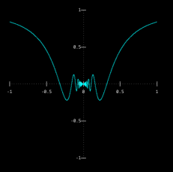If so what is it? What does this say about $x Sin\frac{1}{x}$?

*Theorem*

If $f(x)≤g(x)$ for all $x$ in some open interval containing $c$, except possibly at $c$ itself, and the limits of $f$ and $g$ both exit as $x→c$, then $\lim_{x→c}f(x)≤\lim_{x→c}g(x)$.

Note: Even if $f\left(x\right)<g(x)$ for all $xϵ\left(c-ε,c+ε\right)-\{c\}$ and $\lim_{x→c}f(x)$ and $\lim_{x→c}g(x)$ both exist, we cannot conclude that $\lim_{x→c}f\left(x\right)<\lim_{x→c}g(x)$.

Ex 4 Suppose the inequalities $\frac{1}{2}-\frac{x^{2}}{24}<\frac{1-\cos{x}}{x^{2}}<\frac{1}{2}$ hold for values of $x$ near 0. What, if anything, can we say about $\lim_{x→0}\frac{1-\cos{x}}{x^{2}}$? Give reasons for your answer.

Note: $≤is a stronger case than<$, meaning if x<2 then x $≤2$ but if x $≤2$ then it is not necessary that x<2 so squeeze theorem will apply.

Three Special limits

1. $\lim_{x→0}{\frac{Sin x}{x}=1 }$ 2. $\lim_{x→0}{\frac{1-Cos x}{x}=0 }$ 3. $\lim_{x→0}{{\left(1+x\right)}^{\frac{1}{x}}=e }$

Ex 5

$\lim_{x→0}{\frac{Sin 5x}{x} }$

1. (#74) $\lim_{x→0}{\frac{2Tan^{2} x}{x} }$
2. (#70) $\lim_{x→0}{\frac{5(1-\cos{x})}{x}}$
$\lim_{x→0}{\frac{Sin 2x}{Sin 3x} }$

3. (#30) $\lim_{x→0}{e^{-x}sinπx }$
4. (#32) $\lim_{x→1}ln\left(\frac{x}{e^{x}}\right){ }$
5. (#78) $\lim_{x→\frac{π}{4}}{\frac{1-\tan{x}}{sinx-cosx} }$

$\lim_{x→0}{x^{2}Sin\frac{1}{x} }$

$\lim_{x→0}{x^{4}Cos\frac{1}{x} }$