Ex Given the function $f$ and $g$ below, answer the following.
$$f$$
$$g$$

- Find $\lim_{x→0} f(x)$
- Find $g(3)$
- Find $\lim_{x→3} g(x)$

- Although $f$ does not have a limit at 0, we can still give some info about it’s behavior near 0 by calculating a “left-hand” and “right-hand” limit.
- $g$ is not defined to the left of $x=3$ so it does not have a limit there (see definition of limit on next page). However, it seems it should have a limit of $-2$ if we restrict ourselves to where it’s defined.
- We extend the definition of a “two-sided” limit to a “one-sided” limit.

Informal Definition of a Limit Suppose $c$ is in the domain of $f(x)$. We say that the limit of $f(x)$ as $x→c$ is $L$, written $\lim_{x→c}{f(x)}=L$ if $f(x)$ gets arbitrarily close to $L$ forall $x$ close to $c$.

In order to have a limit as $x→c$, both a left-hand and a right-hand limit must exist.

Informal Defns
$\lim_{x→c^{-}}{f(x)}=L$ means $f(x)→L$ as $x→c$ from the left side
$\lim_{x→c^{+}}{f(x)}=L$ means $f(x)→L$ as $x→c$ from the right side

Ex: (2.4.18) $\lim_{x→1^{+}}{f(x)}$ where$f\left(x\right)=\left\{\begin{aligned}x, &x≤1 \\ 1-x, &x>1\end{aligned}\right.$

Ex: (2.4.22) $\lim_{x→3^{+}}{3x-⟦x⟧}$

Ex: (2.4.26) $\lim_{x→6^{-}}{\ln{(6-x)}}$

Ex: (2.4.28) $\lim_{x→5^{+}}{\ln{\frac{x}{\sqrt{x-4}}}}$

Theorem The Existence of a Limit
A function $f(x)$ has a limit as $x$ approaches $c$ iff it has left-hand and right-hand limits there and these one-side limits are equal.
$\lim_{x→c}{f(x)}=L ⇔ \lim_{x→c^{-}}{f(x)}=L$ and $\lim_{x→c^{+}}{f(x)}=L$

Ex: $\lim_{x→0}{\sqrt{x}}$

Ex 1 Find the right- and left-hand limits. Next, find $f(c)$.
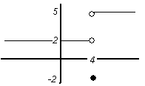
- Jump Discontinuity at $x=4$ (at $c=4$)

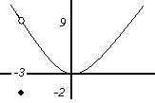
- Removable Discontinuity at $x=-3$ (at $c=-3$)

- $\left\{\begin{aligned}Sin\frac{1}{x} if x>0 \\ 2 if x≤0 \end{aligned}\right.$ when x = 0 & (at c = 2)

- $\left\{\begin{aligned}x^{2}Sin\frac{1}{x} if x≠0 \\ 0 if x=0 \end{aligned}\right.$ When x = 0 & (at c = 0)

Continuity at a Point and on an Open Interval
Why are $Sin\frac{1}{x}$, , and discontinuous. How you remedy these discontinuities?

Continuity Test
A function $f\left(x\right)$ is continuous at an interior point of its domain $x=c$ iff it meets the following 3 conditions:
- $f\left(c\right)$ exists ($c$ lies in the domain of $f$)
- $\lim_{x→c}{f(x)}$ exists ($f$ has a limit as $x→c$)
- $\lim_{x→c}{f(x)}=f(c)$ (the limit equals the function value)

Ex 1 sketch the following functions that are continuous and discontinuous.

a)$f\left(x\right)=\left[x\right]$ b)$f\left(x\right)=e^{x}$ c)$f\left(x\right)=\frac{1-x}{x-1}=\frac{-(x-1)}{x-1}$ d)$f\left(x\right)=\frac{Sinx}{x}$

Ex 2 Why are the discontinuous functions in example 1 discontinuous? Give reasons using Continuity Test.

Types of Discontinuities (in order from least worst to worst)
- Removable : $\lim_{x→c}{f(x)}$ exists but $\lim_{x→c}{f(x)}≠f(c)$ (give example)

- Jump: $\lim_{x→c^{-}}{f(x)}≠\lim_{x→c^{+}}{f(x)}$ (give example)

- (Essential) Infinite: Either LHL or RHL equals $±∞$ (give example)

- (Essential) Oscillating: oscillates too much to have a limit (give example)
(Essential discontinuities occur when either RHL or LHL DNE.)

Definition (Formal) of a Limit on a Closed Interval
In the interval $[a,b]$, if $a<x<b$ then $x$ is an interior point. $a$ and $b$ are endpoints.
A function $y=f(x)$ is continuous at an interior point c of its domain if $\lim_{x→c}{f(x)}=f(c)$.
A function $y=f(x)$ is continuous at left endpoint a or is continuous at a right endpoint b of its domain if $\lim_{x→a^{+}}{f(x)}=f(a)$ or $\lim_{x→b^{-}}{f(x)}=f(b)$, respectively.
If a function is not continuous at $c$, we say $f$ is discontinuous at $c$ and $c$ is a point of discontinuity.

Ex 3 Given graph below, answer the following:
$$f$$
- Does $f(2)$ exist?

- Does $\lim_{x→2^{-}}{f(x)}$ exist?

- Does $\lim_{x→2^{+}}{f(x)}$ exist?

- Is $f$ continuous at $2$?

- At what values of $x$ is $f$ continuous?

Note: A function is not continuous at a point unless it is an interior point. A function is called continuous if it is continuous $∀x∈Dom(f\left(x\right))$

Properties of Continuity
Theorem Properties of Continuous Functions
If the functions $f$ and $g$ are continuous $x=c$, then the following combinations are continuous at $x=c$.
- $f+g$
- $f-g$
- $f∙g$
- $k∙f$, for any number $k$
- $f/g$ provided $g(c)≠0$
- $f^{r/s}$, provided it is defined on an open interval containing $c$, where $r$ and $s$ are integers

Corollary Polynomial and rational functions are continuous. (Rational functions are continuous where they are defined.)

Theorem If $g$ is continuous at $c$ and $f$ is continuous at $g(c)$, then the composite $\left(f∘g\right)\left(x\right)=f(g\left(x\right))$ is continuous at $c$.

Ex Where is $y=\frac{1}{\left|x\right|+1}-\frac{x^{2}}{2}$ continuous? Why? (Explain with theorems.)

Ex (ex 7 pg 96): Describe the intervals on which each function is continuous:

- $f\left(x\right)=\tan\left(x\right)$

- $g\left(x\right)=\left\{\begin{aligned}Sin\left(\frac{1}{x}\right), &x≠0 \\ 0, &x=0\end{aligned}\right.$
- $h\left(x\right)=\left\{\begin{aligned}x Sin\left(\frac{1}{x}\right), &x≠0 \\ 0, &x=0\end{aligned}\right.$

The Intermediate Value Theorem
Theorem Intermediate Value Property for Continuous Functions (IVP)
A function $y=f(x)$ that is continuous on a closed interval $[a,b]$ takes on every value between $f(a)$ and $f(b)$. That is, if $y_{0}$ is between $f(a)$ and $f(b)$, then we can find $c$ in $[a,b]$ such that $f\left(c\right)=y_{0}$.
Functions that have this property are said to have the IVP.

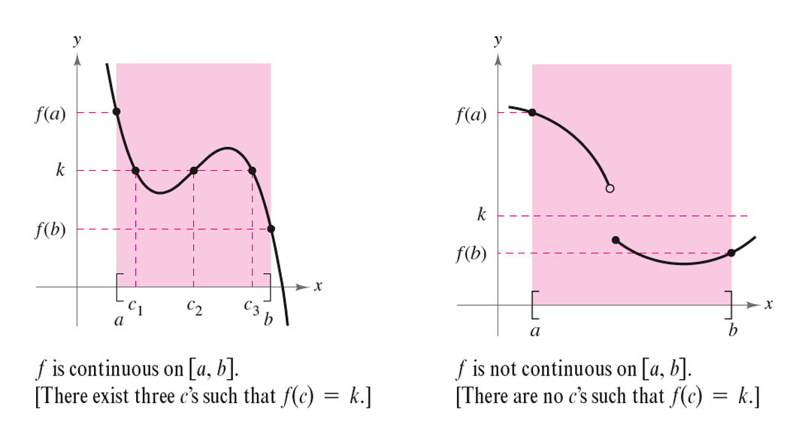
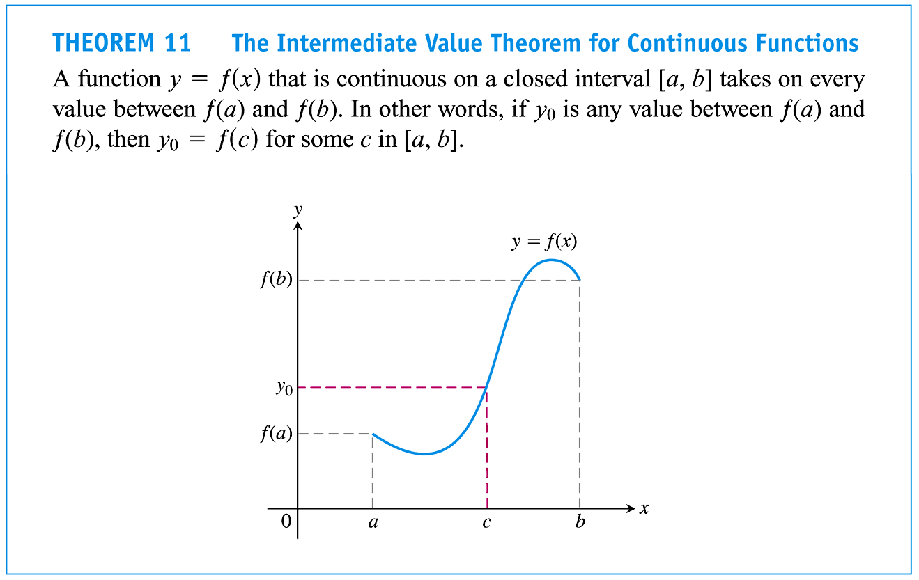

Note: As a consequence of the IVP: If $f$ is continuous on $[a,b]$ and takes on both a positive and a negative value on $[a,b]$, then it must have a root/zero.

