Derivative of a Constant Function
If $f$ has a constant value of $f\left(x\right)=c$, then $\frac{df}{dx}=\frac{d}{dx}\left(c\right)=0$.

Proof: Relies on properties of Limits

$f(x)$ $f'(x)$

Ex 2 Find the derivative of $f\left(x\right)=x$ at $x=x_{0}$.

Ex 3 Find the derivative of $f\left(x\right)=5x$ at $x=x_{0}$

Ex4 Find the derivative of $f\left(x\right)=x^{2}$ at $x=x_{0}$.

Ex 5 Find the derivative of $f\left(x\right)=3x^{2}$ at $x=x_{0}$

Ex 6 Find the derivative of $f\left(x\right)=x^{3}$ at $x=x_{0}$.

Ex 7 Ex 2 Find the derivative of $f\left(x\right)=x^{2}-7x$ at $x=x_{0}$

Guess the derivative of $f\left(x\right)=x^{n}$ at $x=x_{0}$. For $nϵN$ Ans: __________

Guess the derivative of $c∙f\left(x\right)$ Ans: _____________

Guess the derivative of $f\left(x\right)+g(x)$ Ans: ______________

Power Rule for Positive and Negative Integers
If $n$ is a positive integer, then $\frac{d}{dx}x^{n}=nx^{n-1}$.
If $n$ is a negative integer and $x≠0$, then $\frac{d}{dx}\left(x^{n}\right)=nx^{n-1}$
Note: The rule works for all $n, n≠0$ which we’ll see in Sec 3.7.

Proof (in book, see pg 128)
Proof: Hint: Relies on Limit Laws
Constant Multiple Rule
If $f$ is a differentiable function of $x$, and $c$ is a constant, then $\frac{d}{dx}\left(cf(x)\right)=c\frac{df(x)}{dx}$.

Derivative Sum Rule
If $u$ and $v$ are functions of $x$, then their sum $u+v$ is differentiable at every point where $u$ and $v$ are differentiable. At such points, we have
$\frac{d}{dx}\left(u+v\right)=\frac{du}{dx}+\frac{dv}{dx}$

Proof: Hint: Relies on Limit Laws

Note: These two rules prove that the operator $\frac{d}{dx}$ is a linear operator.

Ex 8 Find the derivative of
- $f\left(x\right)=2π+e^{2}$

- $f\left(x\right)=2πx$

- $f\left(x\right)=x-\frac{1}{3}x^{2}-\frac{1}{x}$

- $f\left(x\right)=\sqrt{x}∙\sqrt[3]{x}$

- $f\left(x\right)=\frac{4}{3}x^{3}-4x^{2}-0.1$.

Ans:$a) 0;b) 2π;c)1-\frac{2}{3}x+\frac{1}{x^{2}};d)\frac{5}{6}x^{-\frac{1}{6}};e) 4x^{2}-8x$
Ex 3 Find $f^{'}(x)$ if $f\left(x\right)=\left(x+1\right)(x-1)$. Does $f^{'}\left(x\right)=\frac{d\left(x+1\right)}{dx}∙\frac{d\left(x-1\right)}{dx}$ (this could imply the derivative of the products is the product of the derivatives!

Ex 2 Find the derivative of $y=\left(x+\frac{1}{x}\right)\left(x-\frac{1}{x}+1\right)$. (multiply out)(no product rule yet)

Derivative of the Natural Exponential Function
$\frac{d}{dx}\left(e^{x}\right)=e^{x}$ (Proof requires knowledge of $\lim_{∆x→0}{{\left(1+∆x\right)}^{\frac{1}{∆x}}}=e$)

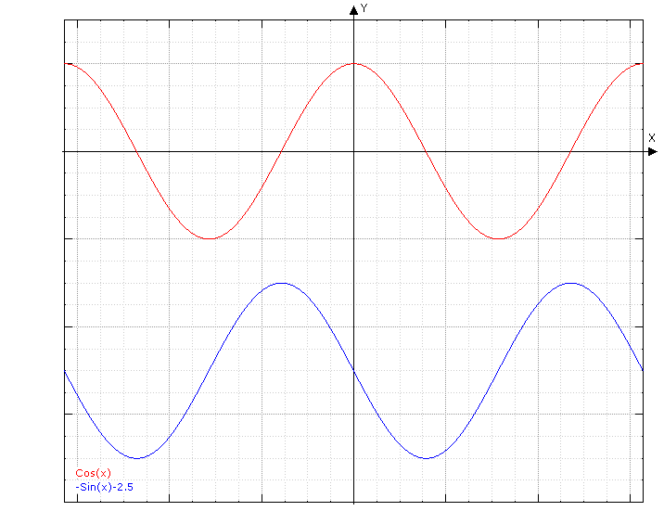
Theorem:
Pic: Note where slope is 0.
$\frac{d}{dx}\sin{x}=\cos{x}$ and $\frac{d}{dx}\cos{x}=-\sin{x}$

Proof: Picture (informal proof)
- Sine Angle Sum Identity: $\sin{(α+β)}=\sin{α}\cos{β}+\cos{α}\sin{β}$
- From Sec 2.4 example 5a: $\lim_{h→0}{\frac{\cos{h}-1}{h}}=0$

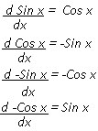
$D_{x}$
g(x) =sin x
g'(x) =cos x
g''(x) = -sin x
g''' (x) = -cosx

Polynomial functions and trig functions are smooth i.e. infinitely differentiable (where they’re defined).

Ex Let $f\left(x\right)=\frac{1}{3}e^{x}-\sin{x}+\cos{x}$ and $g\left(x\right)=\sin{x}$. Find $f^{'}(x)$. Next, find $g^{'}\left(x\right), g^{''}\left(x\right), g^{'''}\left(x\right), g^{(4)}(x)$. For what values of $n$ will $g^{\left(n\right)}\left(x\right)=\sin{x}$?

Polynomial functions and trig functions are smooth i.e. infinitely differentiable (where they’re defined).

- To think about: Give an example of a function that is not infinitely differentiable.

Note: We use the word “instantaneous” even if $x$ does not represent time.
Ex The volume of a sphere is related to its radius by the equation $V\left(r\right)=\frac{4}{3}πr^{3}$. How fast does the volume change with respect to its radius when the radius is $6 μm$?

Defn
Suppose that an object is moving along a coordinate axis line, call it the $s$-axis, where its position $s$ on that line is a function of time: $s=f(t)$
The displacement of an object over the time interval $\left[t,t+Δt\right]$ is $Δs=f\left(t+Δt\right)-f(t)$ and the average velocity of the object over that time interval is
$v_{av}=\frac{displacement}{travel time}=\frac{Δs}{Δt}=\frac{f\left(t+Δt\right)-f(t)}{Δt}$

Note: Assume $f$ is differentiable on $(a,b)$. $f$ is increasing on $(a,b)$ if $f^{'}>0$ on $(a,b)$. $f$ is decreasing on $(a,b)$ if $f^{'}<0$ on $(a,b)$. (Converse is true if we change $<$ to $≤$ and $>$ to $≥$.)
$$s=f(t)$$
$$s+Δs=f(t+Δt)$$
$$Δs$$

- To find the velocity, we take limit of average velocity as $Δt→0$.
Defn Velocity (instantaneous velocity) is the derivative of the position function with respect to time. If a body’s position at time $t$ is $s=f(t)$, then the body’s velocity at time $t$ is
$v\left(t\right)=\frac{ds}{dt}=\lim_{Δt→0}{\frac{f\left(t+Δt\right)-f(t)}{Δt}}$ .

Note: Velocity is a vector, meaning it has a magnitude AND a direction.

The speed is the magnitude or absolute value, of velocity.
$Speed= \left|v(t)\right|=\left|\frac{ds}{dt}\right|$

$$v$$
$$t (sec)$$

The rate at which a body’s velocity changes is the body’s acceleration, which is a measure of how quickly the body picks up or loses speed.

Defn
Acceleration is also a vector and is the derivative of velocity with respect to time. If a body’s position at time $t$ is $s=f(t)$, then the body’s acceleration at time $t$ is $a\left(t\right)=\frac{dv}{dt}=\frac{d^{2}s}{dt^{2}}$.
Jerk is the derivative of acceleration wrt time ($D_{t}^{3}f(t))$:
$j\left(t\right)=\frac{da}{dt}=\frac{d^{3}s}{dt^{3}}$

Ex 2 (# 4) Let $s=f(t)$ be the position function of a body moving on a coordinate line, with $s$ in meters and $t$ in seconds. $s=\frac{t^{4}}{4}-t^{3}+t^{2}, 0≤t≤3$. Find a) Find the body’s displacement and average velocity for the given time interval b) Find the body’s speed and acceleration at the endpoints of the interval c) Find when, if ever, during the interval does the body change direction?

a)$∆s=s\left(3\right)-s\left(0\right)=\left[\frac{81}{4}-27+9\right]-\left[0\right]=\frac{9}{4}m;{ v}_{avg}=\frac{∆s}{∆t}=\frac{\frac{9}{4}}{3}=\frac{3}{4}\frac{m}{s}$
$$b) v\left(t\right)=t^{3}-3t^{2}+2t→ \left|v(0)\right|=0\frac{m}{s} ;\left|v\left(3\right)\right|=6\frac{m}{s};a\left(t\right)=3t^{2}-6t+2;a\left(0\right)=2\frac{m}{s^{2}};a\left(3\right)=11\frac{m}{s^{2}}$$

c) Change direction when $v$ changes signs; $v\left(t\right)=t^{3}-3t^{2}+2t=0→t\left(t-1\right)\left(t-2\right)=0→t=0,1,2 s$
- + - +
0 1 2

Ex 3 The position of a particle is given by the equation $s=f\left(t\right)=t^{3}-6t^{2}+9t$ where $t$ is measured in seconds and $s$ in meters.
- Find the velocity at time $t$.
- What is the velocity after 2 s? After 4 s?
- When is the particle at rest?
- When is the particle moving forward (that is, in the positive direction)? Backward?
- When is the particle’s velocity increasing? Decreasing?
- Find the total distance traveled by the particle during the first 5 seconds.
- Draw a diagram to represent the motion of the particle.

