Consider the derivative:
$\frac{d\left(x+1\right)(x^{2}-x+1)}{dx}$ is this a true statement? $\frac{d\left(x+1\right)(x^{2}-x+1)}{dx}=\frac{d\left(x+1\right)}{dx}∙\frac{d(x^{2}-x+1)}{dx}$

Recall that $\left(x+1\right)\left(x^{2}-x+1\right)=x^{3}+1$

Derivative Product Rule
If $u$ and $v$ are differentiable at $x$, then so is their product $uv$, and $\frac{d}{dx}\left(uv\right)=u\frac{dv}{dx}+v\frac{du}{dx}$.
Prime notation: ${\left(uv\right)}^{'}=uv^{'}+vu'$
Function notation: $\frac{d}{dx}\left[f\left(x\right)g\left(x\right)\right]=f'\left(x\right)g\left(x\right)+g'\left(x\right)f(x)$
Pix of Product Rule on page 163.

Proof

Ex 1 (# 10) Find $w'$ by applying the Product Rule. $w=2z^{3}e^{z}$.

Since “the derivative of a product is not the product of the derivatives”, we should expect a rule for finding the derivative of a quotient since $\frac{f\left(x\right)}{g\left(x\right)}=f\left(x\right)∙\frac{1}{g\left(x\right)}$.
Derivative Quotient Rule
If $u$ and $v$ are differentiable at $x$ and if $v(x)≠0$, then the quotient $\frac{u}{v}$ is differentiable at $x$, and $\frac{d}{dx}\left(\frac{u}{v}\right)=\frac{v\frac{du}{dx}-u\frac{dv}{dx}}{v^{2}}$.
Prime notation: ${\left(\frac{u}{v}\right)}^{'}=\frac{vu^{'}-uv^{'}}{v^{2}}$
Function Notation: $\frac{d}{dx}\left[\frac{f\left(x\right)}{g\left(x\right)}\right]=\frac{g\left(x\right)f^{'}\left(x\right)-f\left(x\right)g^{'}\left(x\right)}{{\left[g\left(x\right)\right]}^{2}}$

Ex Find the derivative of $f\left(t\right)=\frac{t^{2}-1}{t^{2}+t-2}$.

Ex 6 Find the derivative of $y=\frac{\left(x-2\right)\left(x^{2}+4x\right)}{x^{6}}$. (Avoid having to use product AND quotient rule. FOIL top then rewrite as sum of 3 fractions. or could make a triple product rule but this is harder)

Ex 7 Find $y'$ if $y=\frac{\sqrt{x}-1}{x}$

Second and Higher-Order Derivatives
If $y=f(x)$ is a differentiable function, then its derivative $f^{'}(x)$ is also a function. If $f'$ is differentiable, we can differentiate $f'$ to get a new function of $x$, denoted $f''$.
So, $f^{''}=(f^{'})'$.
$f''$ is called the second derivative of f.
Notation: $f^{''}\left(x\right)=\frac{d^{2}y}{dx^{2}}=\frac{d}{dx}\left(\frac{dy}{dx}\right)=\frac{dy^{'}}{dx}=y^{''}=D^{2}\left(f\right)\left(x\right)=D_{x}^{2} f(x)$
$D^{2}$ means the operation is performed twice.
If $f''$ is differentiable, we can again differentiate to obtain the third derivative of f, denoted
$$y^{'''}=\frac{dy^{''}}{dx}=\frac{d^{3}y}{dx^{3}}=D^{3}y$$
This notion can be extended to the $nth$ derivative.
The notation used:
$y^{(n)}$ “$y$ super $n$”
$\frac{d^{n}y}{dx^{n}}$ “$d$ to the $n$ of $y$ by $dx$ to the $n$”
$D_{x}^{n}y$ “$D$ to the $n$”

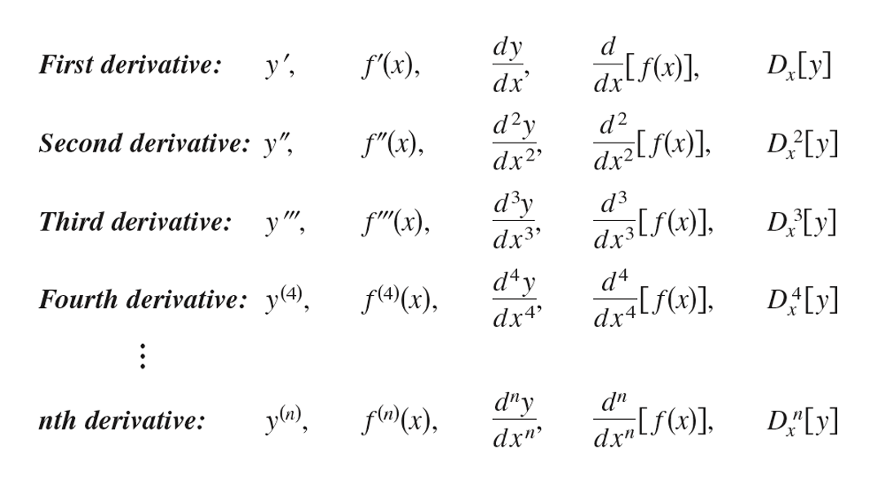

Ex 8 Find all derivatives of $f\left(x\right)=-\frac{1}{8}x^{4}+\frac{5}{6}x^{3}-3x^{2}+e$.

Ex: Find all derivatives of $f\left(x\right)=-\frac{1}{8}x^{4}+\frac{5}{6}x^{3}-3x^{2}+e$

Ex: How many derivatives will it take to get before the higher order derivative of $x^{n}$ is 0?

Derivatives of Other Trig Functions
$\frac{d}{dx}\left(\tan{x}\right)=\sec^{2}{x}$ $\frac{d}{dx}\left(\cot{x}\right)=-\csc^{2}{x}$

$\frac{d}{dx}\left(\sec{x}\right)=\sec{x}\tan{x}$ $\frac{d}{dx}\left(\csc{x}\right)=-\csc{x}\cot{x}$

Ex 2 Find each derivative.
- $y=x^{2}\cos{x}-2x\sin{x}-2\cos{x}$; find $\frac{dy}{dx}$.

- $r=\left(1+\sec{θ}\right)\sin{θ}$; find $\frac{dr}{dθ}$.

On your own:
Consider the Problem:
Is there a value of b that will make
$$g\left(x\right)=\left\{\begin{aligned}x+b, &x<0 \\ Cos x, &x≥0\end{aligned}\right.$$
Continuous at x=0? Differentiable at x=0? Explain your answer.

Ex: Verify that $f^{'}\left(x\right)=g^{'}\left(x\right)and explan the relationship between f\left(x\right)and g\left(x\right)given that;$
$$f\left(x\right)=\frac{3x}{x+2} and g\left(x\right)=\frac{5x+4}{x+2}$$

What did this problem just tell us about the two functions that have the same derivative?:

Ex: (#18) Find $f^{'}\left(x\right) \& f^{'}\left(\frac{π}{6}\right)$ if$f\left(x\right)=\frac{Sin x}{x}$

