Ex 1 Differentiate each function. Guess the derivative: Actual derivative:
- $f\left(x\right)=Sin(2x)$

- $f(x)=\sqrt{3x+11}$

- $y={\left(5x-1\right)}^{2}$

- $y=e^{x^{2}}- need new rule here$

Theorem The Chain Rule
If $f\left(u\right)$ is differentiable at the point $u=g(x)$ and $g(x)$ is differentiable at the point $x$, then the composite function $\left(f∘g\right)\left(x\right)=f(g\left(x\right))$ is differentiable at $x$ and
${\left(f∘g\right)}^{'}\left(x\right)=f^{'}\left(g\left(x\right)\right)g^{'}(x)$.
In Leibniz’s notation, if $y=f(u)$ and $u=g(x)$, then
$\frac{dy}{dx}=\frac{dy}{du}∙\frac{du}{dx}$ , where $\frac{dy}{du}$ is evaluated at $u=g(x)$.

Note: “Outside-Inside” Rule is helpful way to remember Chain Rule.
If $y=f\left(g\left(x\right)\right)=f(u)$, then $\frac{dy}{dx}=f^{'}\left(g\left(x\right)\right)∙g^{'}\left(x\right)=f^{'}(u)∙u'$.

Derivative of outside Derivative of Inside

The “outside” function is $f$ and the “inside” function is $u=g(x)$.
To take the derivative of the composite function, $f\left(g\left(x\right)\right)$, we:
“ take the derivative of the outside times the derivative of the inside.”
Note: When we differentiate the “outside” function $f$, we leave $g(x)$ alone and plug it into $f'$.

You can think of this as a unit conversion as seen in Leibniz’s notation:$\frac{dy}{dx}=\frac{dy}{du}∙\frac{du}{dx}$

- Using the Chain Rule, we see the following:
If $u$ is a function of $x$, then $\frac{d}{dx}e^{u}=e^{u}\frac{du}{dx}$.

The General Power Rule
$\frac{d}{dx}u^{n}=nu^{n-1}\frac{du}{dx}$, where $u$ is a function of $x$.

Note: Regarding the Chain Rule, practice makes perfect. Important to be solid with algebra.
Ex 2 (# 4) Given $y=f(u)$ and $u=g(x)$, where $f(u)=\cos{u}, u=-\frac{x}{3}$ find 1) find $f\left(u\right)$ 2) Find $\frac{dy}{dx}$

Ex 3 Write the function in the form $y=f(u)$ and $u=g(x)$. Then find $\frac{dy}{dx}$ as a function of $x$.
- (# 14) $y={\left(\frac{x}{5}+\frac{1}{5x}\right)}^{5}$

- (# 22) $y=e^{4\sqrt{x}+x^{2}}$

Ex 4 Find the derivative of each function. Find $y''$ for part c).
- (#49) $y=Sin^{2}(πt-2)$

- (# 60) $y=4\sin\left(\sqrt{1+\sqrt{t}}\right)$

- (# 38) $y=\left(9x^{2}-6x+2\right)e^{x^{3}}$

- (# 66) $y=\sin{(x^{2}e^{x})}$

Ex 5 (# 70) Find the value of ${\left(f∘g\right)}^{'}$ at the given value of $x$.
$f\left(u\right)=u+\frac{1}{\cos^{2}{u}}, u=g\left(x\right)=πx, x=\frac{1}{4}$

The Derivative of the Natural Logarithmic Function
Theorem Derivative of the Natural logarithmic function

$\frac{d}{dx}\ln{x}=\frac{1}{x} for x>0 \frac{d}{dx}\ln\left|x\right|=\frac{1}{x}$ or

$\frac{d}{dx}\left(\ln{u}\right)=\frac{1}{u}\frac{du}{dx}=\frac{u'}{u}, u>0$ In particular, $\frac{d}{dx}\ln{x}=\frac{1}{x}∙1$

$$\frac{d}{dx}\left(\ln\left|u\right|\right)=\frac{1}{u}\frac{du}{dx}=\frac{u'}{u}$$

Proof:

Ex 5 Find the derivative of $y$ wrt $x, t,$ or $θ$, as appropriate.
- $y=\ln{\frac{10}{x}}$

- $y=\ln{kx}, k constant$

- $y=\ln{(t^{3/2})}$

- $y={\left(\ln{x}\right)}^{3}$

- $y=t^{2}\ln{3t}$

- $y=\ln\left(1+\ln\left(\ln{x}\right)\right)$

- $y=\ln\left(\frac{\sqrt{\sin{θ}\cos{θ}}}{1+2\ln{θ}}\right)$(Recall: $\ln\left(xy\right)=lnx+ln y$ and $\ln\left(\frac{x}{y}\right)=lnx-lny \& Sin 2x=2Sinx Cosx$)

Bases Other than e
Definition of Exponential function to Base $a$

If $a$ is a positive real number ($a≠1$) and $x$ is any real number, then the exponential function to the base $a$ is denoted by $a^{x}$ and is defined by
$$a^{x}=e^{\ln\left(a\right)x}$$
If $a=1, then y=1^{x}$ is the constant function $y=1$.

Definition of Logarithmic Function to Base $a$

If $a$ is a positive real number ($a≠1$) and $x$ is any real number, then the logarithmic function to the base $a$ is denoted by $\log_{a}{x}$ and is defined by
$$\log_{a}{x}=\frac{\ln{x}}{\ln{a}}$$

Theorem Derivatives for Bases other than e

$\frac{d}{dx}a^{u}=a^{u}\ln{a}\frac{du}{dx}$ In particular, $\frac{d}{dx}a^{x}=a^{x}\ln{a}$

$\frac{d}{dx}\log_{a}{u}=\frac{1}{\ln{a}}∙\frac{1}{u}\frac{du}{dx}$ In particular, $\frac{d}{dx}\log_{a}{x}=\frac{1}{x\ln{a}}$

Proof: First proof$Uses the fact that \lim_{h→0}{\frac{a^{h}-1}{h}=\ln{a }}$

Ex 6 Find the derivative wrt to the independent variable.

- (# 78) $y=\log_{3}{r}∙\log_{9}{r}$ (Use Change of Base – change to base $e$)

- (# 86) $y=3\log_{8}\left(\log_{2}{t}\right)$ (Use Change of Base – change to base $e$)

- $y=7^{3x}$

A Brief Discussion on Parametric Equations (Book does not cover this section until later)
Given a curve in 2-space as in Figure 3.29
Describing this curve can be difficult, especially if the curve cannot be described by a
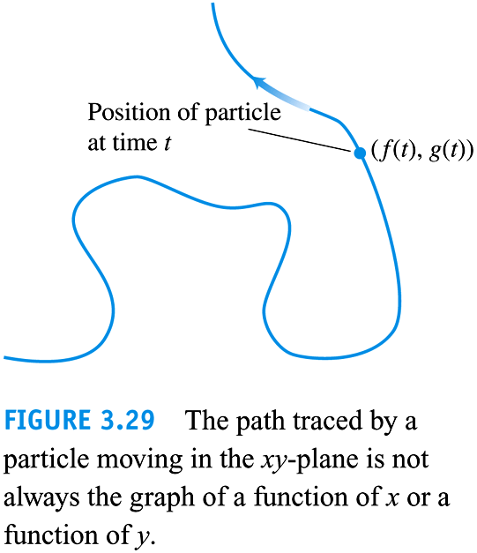
Function. To remedy this, we can use Parametric Equations to describe the curve.
Def: Parametric Curve
If $x and y$ are given as functions
$x=f\left(t\right) \& y=g(t)$
Over an interval of t-values (i.e. on domain of t) then any point $(x,y)$ in 2-D can be
defined by the equivalent point $(f\left(t\right),g\left(t\right))$ and in this format the curve is a
parametric curve. The equations are Parametric Equations for the curve.

A physical example of parametric equations is and etch-a-sketch.
Think of how an etch-a-sketch works. One knob is the parametric equation for the x direction, the other knob is the parametric equation for the y direction. To move the sketcher you must independently rotate (t) the knobs.

Then the position of the sketch is a function of the x-knob and the y-knob.

Ex: Mathematically describe a circle centered at the origin with radius=1 using only one variable.

What we need to do is to use a single variable to describe every point on the circle. We will use the hour hand of a clock moving counter clock wise as the idea. The variable will be the angle of the hour hand.

From Trig recall that any point on a unit circle can be described by the angle the radius makes with the positive x axis.
$(rcosθ,rsinθ)$

This is the general idea. So.
The curve described by
$$x^{2}+y^{2}=1$$

Can be described by the parametric equations, $x=1∙Cosθ$ and $y=1Sinθ$ for $0≤θ≤2π$
To check we plug in our parametric equations into the equation:
$$x^{2}+y^{2}={\left(Cosθ\right)}^{2}+{\left(Sinθ\right)}^{2}=1$$

Ex: Mathematically describe an ellipse centered at the origin with vertical radius of 2 and horizontal radius of 3.
I.E. Describe the curve
$$\frac{x^{2}}{9}+\frac{y^{2}}{4}=1$$
By using parametric equations

Let $x=3Cosθ$ and $y=2Sinθ$ for $0≤θ≤2π$
Then
$$\frac{x^{2}}{9}+\frac{y^{2}}{4}=\frac{{\left(3Cosθ\right)}^{2}}{9} +\frac{{(2Sinθ)}^{2}}{4}=\frac{9Cos^{2}θ}{9} +\frac{4Sin^{2}θ}{4}=Cos^{2}θ+Sin^{2}θ=1$$

Ex: The position $p(x,y)$ of a particle moving in the xy-plane is given by the equations and parameter interval

$x=\sqrt{t};y=t$ for $t≥0$
Identify the path traced by the particle and describe the motion.

$y=t={\left(\sqrt{t}\right)}^{2}={\left(x\right)}^{2}$ So the parametric equations are describing the right half of a parabola w/ vertex at (0,0)

Derivatives of Parametric Curves:

A parameterized curve, $x=f\left(t\right) \& y=g(t)$ is differentiable at $t$ if $f \& g$ are differentiable at $t$
Derivatives of Parametric Curves:

A parameterized curve, $x=f\left(t\right) \& y=g(t)$ is differentiable at $t$ if $f \& g$ are differentiable at $t$, and is given by:

$\frac{dy}{dt}=\frac{dy}{dx}∙\frac{dx}{dt}→$

Provided that all three derivatives exist and $\frac{dx}{dt}≠0$.

$$\frac{dy}{dx}=\frac{\frac{dy}{dt}}{\frac{dx}{dt}}$$

Parametric Formula for $\frac{d^{2}y}{dx^{2}}$:
If all the equations
$x=f\left(t\right)and y=g\left(t\right)$define y as twice-differentiable function of x, then at any point where $\frac{dx}{dt}≠0,then$
$\frac{d^{2}y}{dx^{2}}=\frac{\frac{dy'}{dt}}{\frac{dx}{dt}}$

