Warm-Up Problems (work with your neighbors, 5-10 min.)

- A)If you have a right triangle with sides x & y, express the hypotenuse, h, in terms of x and y.
B)If x=3 and y=5 find the length of the hypotenuse (Hint: Think Pythagorean Theorem)

- A) If you have a triangle, which is not necessarily a right triangle, and you know two sides and the angle which subtends these sides, how can you find the third side of the triangle? (Hint: check the back page in your book and think about the trigonometric Law of ____________).
B) If one side, a, is 2, the other side b, is 1, and the angle they subtend is 120°, find the third side c.

a b

c

3) 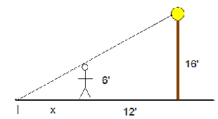
For the diagram above, use similar triangles to determine the length of the persons shadow.

Recall: Derivatives describe instantaneous rates of change. We take derivatives using power rule, product/quotient rule, chain rule, and implicit differentiation.

Purpose: To introduce and gain intuition about Related Rates.

What are Related Rates? Problems that have an equation relating two or more things which change over time, where we are interested in finding the rate of change (derivative) of one of the functions over time.

Examples:
1) Observer tracking a missile flying overhead, any object in motion relative to some observer, Changes in voltages/resistances in electric circuits, Rates of differential volumes as a substance fills a non standard container.

2) Boyles Law
The bicycle pump/hydraulics phenomenon (log splitter) (Boyle’s Law):
$$P∙V=T$$

Ex 1: 3.7.27: A 25ft. ladder is leaning against the wall of a house. If the base of the ladder is pulled away from the wall at a rate of $2 ft/sec$
- How fast is the top of the ladder moving down the wall when its base is 7,15,24 ft from the wall?

The most commonly used relationships we will focus on:
- Given or known relationships (Boyle’s Law, Newton’s Second Law of Motion (F=ma), Einstein’s famous relativity equation , etc…)
- Pythagorean Theorem
- Similar Triangles
- Trigonometric relationships
- Geometric shapes and their equations
The 6 step plan to solving related rates problems (short version):

- Read the instructions
- Sketch a diagram, label the constant values, the for the things that are changing, place a variable to represent the changing (do not write in the values for the changing variables until after step 5!)
- In a box, place three headings: 1) Constants, 2) Changing, 3) Find.
- Under the title of “constants”, label all the constant values which do not change in the problem.
- Under the title of “changing”, assign variables to all places where the values are not always the same, (hint, if the problems states “find blah blah when $x=7m and\frac{dx}{dt}=4 m/s$ then $x$ is not a constant; if it were then $\frac{dx}{dt}$ would be 0).
- Under the title “find”, write down the unknown rate or variable you are being asked to find with a ? next to it. write down the unknown rate you are looking for with a question mark next to it.
- Find the governing equation relating the problem to as few of the unknown values as possible and be sure to include the variable which will create the rate you were asked to find.
The trick is to try to minimize the unknown variables while still including the one variable which will produce the rate you are looking for after you take your derivative.
Sometimes you will need to find secondary relationships in order to find values for variables that you were unable to avoid or get rid of.
Look for known mathematical relationships (similar triangles, Pythagorean Theorem, trigonometric relationships, etc.)
- Take the derivative of both sides of the governing equation with respect to time. Warning: Differentiate and then substitute the boxed numbers for the variables. If you reversed the order you would just be differentiating constants (which would yield 0).
- Now that you took the derivative, substitute the values given in the problem and solve for the unknown rate. If you still have a function of more than just the unknown, then go back to your related equations (or find another one) and solve for the missing values. Box your Answer.

Ex 2: (Example from engineering dynamics using a trigonometric relationship)

Problem Statement: A robotic arm is part of an assembly line which places CD’s into their jewel cases. The arm is attached atop of a 1m post standing vertically from its platform base. The arm is 2 m long and, for simplicity, rotates up and down in a vertical plane. The angular velocity , , of the robotic arm which rotates at a speed of rad/sec at a time when the angle between the post and the arm is radians and the in air distance from the platform base to a CD being moved into its jewel case is $\sqrt{7}$ m. Find the speed of the CD at this instant relative to the base of the post.
__________________________________________
Solution:
- 3)
- b=2m

$θ$ c
a= 1m

Ex 3: (example from physics/chemistry/engineering involving a relationship given in the problem statement.)

Problem statement:
Boyle’s Law states that when a sample of gas is compressed at a constant temperature (adiabatically), the pressure, P, and the volume, V are governed by the equation$P∙V=T$ where T (temp) is held at a constant. Suppose that at a certain instant the volume is 400 cm³ and when the pressure is 80 kPa the pressure is decreasing at a rate of 10 kPa/min. At what rate is the volume increasing at this instant?
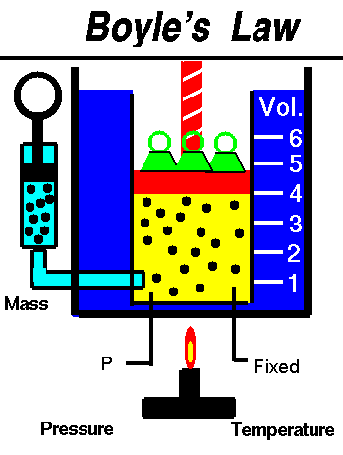
____________________________________
Solution:

- Read the Problem.

2) Sketch a picture

3) Box the constant, changing, and value you wish to find.
Warning: Do not substitute in the values until after you have taken the derivative of both sides!! If you substitute first you will be differentiating constants. Oh No!!

4) Find the governing equation. Note: this example requires no other related equations and also P & V are variables (so product rule will be required!)

5) Take the derivative of both sides with respect to time, t.

6) Now substitute the known changing values. Note: Now and only now does the problem become a function of the only unknown,

We can check the units to be sure the answer makes sense (dimensional analysis).

CHECK THE UNITS TO BE SURE THE ANSWER IS IN $cm^{3}$/min.

MORE EXAMPLES TO FOLLOW ILLUSTRATING THE USE OF SIMILAR TRIANGLES AND THE PATHAGOREAN THEOREM.
Ex 4 Suppose that the radius $r$ and height $h$ of a cone are related to the cone’s volume $V$ by the formula $V=\frac{1}{3}πr^{2}h$.
- How is $\frac{dV}{dt}$ related to $\frac{dh}{dt}$ if $r$ is constant?
- How is $\frac{dV}{dt}$ related to $\frac{dr}{dt}$ if $h$ is constant?
- How is $\frac{dV}{dt}$ related to $\frac{dr}{dt}$ and $\frac{dh}{dt}$ if neither $r$ nor $h$ is constant?

Ex 5 How rapidly will the fluid level inside a vertical cylindrical tank drop if we pump the fluid out at the rate of $2000 L/min$? Assume that the tank has radius $r$ and height $h$ measured in meters. Next find how rapidly the level drops if $r=2 m$. Note that $1m^{3}=1000L$.
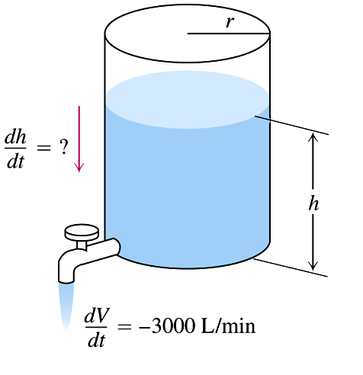

3)

Ex 5 Coffee is draining from a 6” high by 6”diameter conical filter into a 6” diameter cylindrical coffeepot at the rate of $10 in^{3}/min$.

- How fast is the level in the pot rising when the coffee in the cone is $5 in$ deep?

- How fast is the level in the cone falling then?
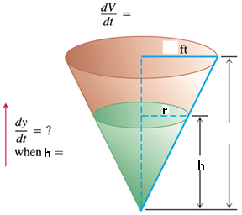

d

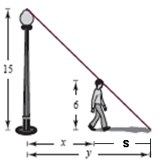
Ex 6 (3.7.35) A man $6 ft$ tall walks at a rate of $5 ft/sec$ away from a streetlight that is $15 ft$ above the ground. When he is $10 ft$ away from the base of the light,
Check out a video of this problem being solved at:
http://www.youtube.com/watch?v=kBfSwZAUoJM&feature=related

- At what rate is the tip of his shadow moving (relative to the pole)?
- At what rate is the length of his shadow changing?

First: At what rate is the tip of his shadow moving (relative to the pole)?

This is asking for $\frac{dy}{dt}$

b) Second: At what rate is the length of his shadow, s, changing when he is $x=10 ft$ from the base of the light?
We are being asked to find $\frac{ds}{dt}$.

Ex 7: If two resistors with resistances $R_{1}\& R_{2}$ are connected in parallel, as in the figure, then the total resistance $R$, measured in ohms $Ω$, is given by
$$\frac{1}{R}=\frac{1}{R_{1}}+\frac{1}{R_{2}}$$

If $R_{1}\& R_{2}$ are increasing at rates of $0.3\frac{Ω}{s} \& 0.2\frac{Ω}{s}$ respectively, how fast is $R$ changing when
$R_{1}=80Ω \& R_{2}=100Ω$
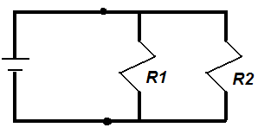

Ex 8: An airplane is flying in a 2-D plane with a camera. The airplane is flying at $450 km/hr$ at a constant altitude of $5 km$, , and is approaching the camera mounted on the ground. Let $θ$ be the angle at which the camera is pointed. How fast must the camera rotate to keep the plane in view when $θ=\frac{π}{3}$?

c a
$θ$

b

(Answer: 67.5 rad/hr)
Ex 9 (If time permits/In-Class) A particle moves from right to left along the parabolic curve $y=\sqrt{-x}$ in such a way that its $x-$coordinate (measured in meters) decreases at a rate of $8 m/sec$. How fast is the angle of inclination $θ$ of the line joining the particle to the origin changing when$x=-4$?
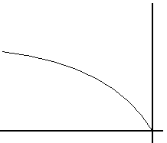

$y=\sqrt{-x}$

$θ$

