*Strategy for Graphing $y=f(x)$*

1. Find/plot key points, such as intercepts.
2. Identify any asymptotes.
3. Identify the domain of $f$ and any symmetries the curve may have.
4. Find $y'$ and $y''$.
5. Find the critical points of $f$, and identify the function’s behavior at each one.
6. Find where the curve is increasing/decreasing.
7. Find the points of inflection, if any occur, and determine the concavity of the curve.
8. Sketch the curve by plotting key points, asymptotes, and intervals of inc/dec minding concavity.

Ex Analyze and sketch a graph of the function. Label any intercepts, relative extrema, points of inflection, and asymptotes.

1. 4.6.10 $f\left(x\right)=\frac{x^{2}+1}{x^{2}-9}$

Local Max: _________________

Local Min: __________________

Absolute Max: _______________

Absolute Min: _______________

I.P.(s): ______________________

Open Int. of inc on $f(x)$: _______

1. 4.6.16 $f\left(x\right)=\frac{x^{2}+1 }{x}$

Local Max: _________________

Local Min: __________________

Absolute Max: _______________

Absolute Min: _______________

I.P.(s): ______________________

Open Int. of inc on $f(x)$: _______

1. 4.6.42 $h\left(x\right)=\frac{10}{2+3e^{-x/2}}$ given $h^{'}\left(x\right)=\frac{15e^{x/2}}{{\left(2e^{x/2}+3\right)}^{2}}, \&h^{''}\left(x\right)=\frac{-15e^{x/2}(2e^{x/2}-3)}{2{\left(2e^{x/2}+3\right)}^{3}}$

Local Max: _________________

Local Min: __________________

Absolute Max: _______________

Absolute Min: _______________

I.P.(s): ______________________

Open Int. of inc on $f(x)$: _______

1. 4.6.34 $f\left(x\right)=x^{4}-8x^{3}+18x^{2}-16x+5$ which = 0 when $x=1,5$





Local Max: _________________

Local Min: __________________

Absolute Max: _______________

Absolute Min: _______________

I.P.(s): ______________________

Open Int. of inc on $f(x)$: _______

1. 4.6.53 $f\left(x\right)=2x-\tan{x}; -\frac{π}{2}<x<\frac{π}{2}$

Local Max: _________________

Local Min: __________________

Absolute Max: _______________

Absolute Min: _______________

I.P.(s): ______________________

Open Int. of inc on $f(x)$: _______

Ex (Thomas 4.5.63) (if time) The sketch of the graphs of $f^{'}=x^{2}$ and $f^{''}=2x$ on the same graph. Approximate the graph of $f$, given that the graph passes through the point $P$.

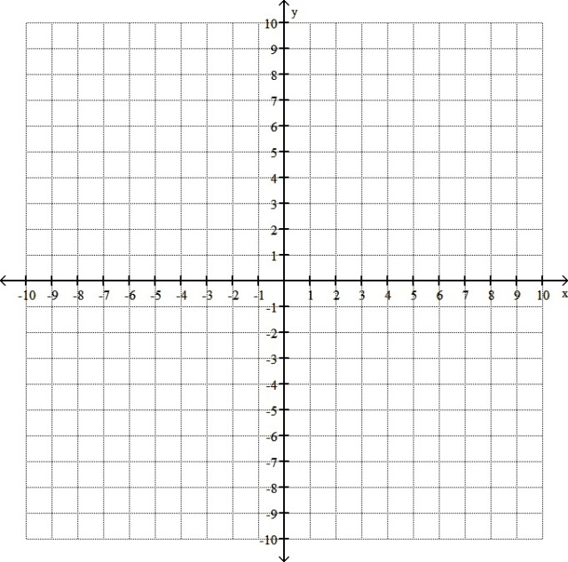

Ex Sketch a function with the following properties:

$f$ is defined everywhere

$f^{'}\left(x\right)=0$ when $x=3$

$f^{'}\left(x\right)=undefined$ when $x=1,5$

$f^{'}<0$ on $\left(-∞,1\right);(3,5)$

$f^{'}>0$ on $\left(1,3\right);(5,∞)$

$f''\left(x\right)≠0$

$f''\left(x\right)=undefined$ when $x=1,5$

$f^{''}<0$ on $(1,5)$

$f^{''}>0$ on $\left(-∞,1\right);(5,∞)$