* Algebra can get messy in this section
* Note: [Wolfram Demonstrations](../../Wolfram%20Demonstrations) and [Desmos](https://www.desmos.com/) can be very useful in this section

To optimize means to **minimize** or **maximize** some aspect of something. Examples include minimizing the surface area of a can (to minimize cost) or maximizing profit.

Ex: 4.7.4 Find two positive numbers whose product is 196 and sum is a minimum.

Guidelines for Solving Applied Minimum and Maximum Problems

1. Identify all *given* quantities and quantities *to be determined*. If possible, make a sketch.
2. Write an **Optimization equation** which describes the thing that is to be maximized or minimized. (the inside cover has many geometric formulas that may be helpful)
3. Create/find the **Constraint equation**, and relate/reduce the variables in the optimization equation down to a single variable.
4. **Substitute** the constraint equation into the optimization equation. You should now have one equation of a single variable.

Note: the feasible domain of this equation, (the values of the variable which make sense in the problem)

Note: graphing this equation can be a useful visualization in finding its max/mins.

1. **Take the derivative** of the substituted equation and find its local max and mins.

Ex 1 ~4.7.9 Show that among all rectangles with an 10-m perimeter, the one with the largest area is a square.

Click [here](../../Wolfram%20Demonstrations) for the Wolfram Demonstrations “maximizing the area of geometric figures of fixed perimeter”

Ex 2 ~4.7.2 An open box of maximum volume is to be made from a square piece of tin 3 feet on a side, by cutting equal squares from the corners and turning up the sides, find the maximum volume that can be created.

Click [here](../../Wolfram%20Demonstrations/Calc%20I%20Maximize%20the%20volume%20of%20a%20box%20made%20from%20a%20sheet%20of%20tin.nb) for the wolfram demonstration “tin box with max volume” (use multiplier of 3)



Ex 3 ~4.7.20 A Farmer has 200 m of fence available and would like to fence off a rectangular area along his 200m long barn. What dimensions would produce the maximum area and what is that maximum area?

Click [here](../../Wolfram%20Demonstrations/Calc%20I%20maximize%20the%20area%20made%20by%203%20sided%20fence.nb) for the wolfram demonstration “greatest fenced area along a barn”

Ex 4 ~4.7.35 Find the volume of the largest right circular cone that that can be inscribed in a sphere of radius 3.

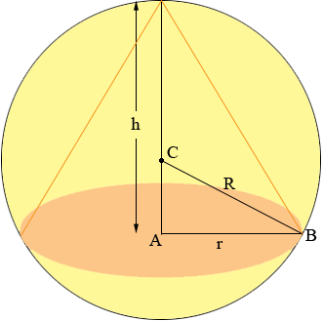 Click [here](../../Wolfram%20Demonstrations/Calc%20I%20maximize%20a%20cone%20in%20a%20sphere.nb) for the demonstration “max volume and SA of geometric solids in scribed in a sphere”

Ex 5 What are the dimensions of the lightest open-top right circular cylindrical can that will hold a volume of $1000 cm^{3}$ (1 L) assuming a fixed material type? Compare your result here with Example 2 in book.

Click [here](../../Wolfram%20Demonstrations/Calc%20I%20Minimizing%20The%20SurfaceArea%20O%20fA%20Cylinder%20With%20A%20Fixed%20Volume.cdf) to see demonstration using different numbers “min the SA of cylinder with fixed vol.”

Ex 6 ~4.7.27 A rectangle is bounded by the first quadrant and the semicircle $y=\sqrt{16-x^{2}}$. What length and width should the rectangle have so that its area is a maximum?

 Click [here](../../Wolfram%20Demonstrations/Calc%20I%20maximize%20a%20rectangle%20under%20the%20curve.nb) for demonstration “Max rectangular area under different curves”

Ex 7 What values of $a$ and $b$ make $f\left(x\right)=x^{3}+ax^{2}+bx$ have

1. a local maximum at $x=-1$ and a local minimum at $x=3$?
2. a local minimum at $x=4$ and a point of inflection at $x=1$?

Ex 8: 4.7.43 A wooden beam has a rectangular cross section of height h and width w. The strength S of the beam is directly proportional to the width and the square of the height. What are the dimensions of the strongest beam that can be cut from a round log of diameter 24 in. Hint: $S=kh^{2}w,$ where k is the proportionality constant and would account for the particular strength properties for particular types of wood.

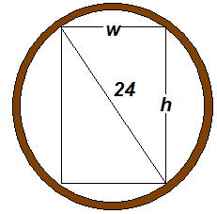

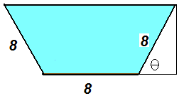Ex 9: 4.57.56 An irrigation canal has cross section that is a isosceles trapezoid for which all sides are 8 ft. Determine the angle of elevation of the sides such that the area of the cross section is a maximum.