Last Section we took a look at antiderivatives. Now we venture off to the other side of our endeavor; Area’s. However, this path will take us quickly to places that are seemingly unrelated to our goal of discovering the Fundamental Theorem of Calculus, (FTC). This seemingly tangential route will last only a few sections, and when we are done we will have not only a firmer understanding of the concept behind the FTC. On this journey we will learn sigma notation as a necessary language upon which we will build our pathway; one that may help you become more literate in other theories used in various disciplines of the sciences. It is on a winding path that we will slowly work our way towards our big finally. Be patient, and try not to feel too compelled to rush to the end of our path, because as Robert Pirsig once brilliantly wrote:

Mountains should be climbed with as little effort as possible and without desire. The reality of your own nature should determine the speed. If you become restless, speed up. If you become winded, slow down. You climb the mountain in an equilibrium between restlessness and exhaustion. Then, when you’re no longer thinking ahead, each footstep isn’t just a means to an end but a unique event in itself. *This* leaf has jagged edges. *This* rock looks loose. From *this* place the snow is less visible, even though closer. These are things you should notice anyway. To live only for some future goal is shallow. It’s the sides of the mountains which sustain life, not the top…

Do not rush, take your time and enjoy the journey, because once its over, all you have is the memories.

## Area

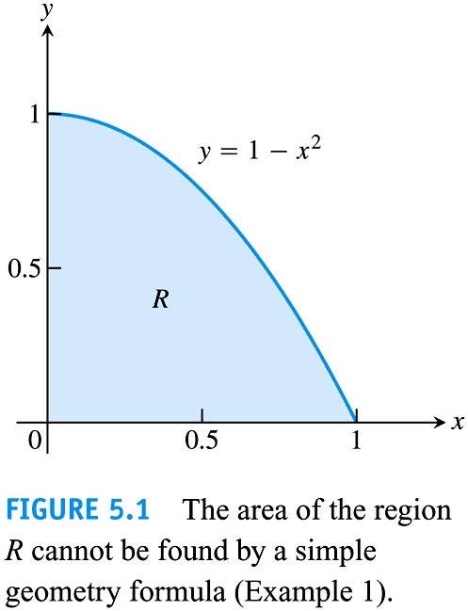Method of exhaustion was famously used by Archimedes (287-212 B.C.) This method was employed to calculate the areas of curved features such as a circle. The area of this circle was never actually calculated but the value of the area was trapped by the area of increasingly numbered regular polygons circumscribed around the outside of the circle, and by the area of increasingly numbered regular polygons inscribed around the inside of the circle.

The circumscribed polygons were an upper bound for the actual area because they were always overestimations of the circles area. The inscribed polygons were a lower bound for the actual area because they were always underestimations of the circles area.

By taking the limit of the areas of the polygons, we will find the actual area of the circle.

How might we approximate the area of the region R?

One way is to approximate the curve as being the sum of rectangles.

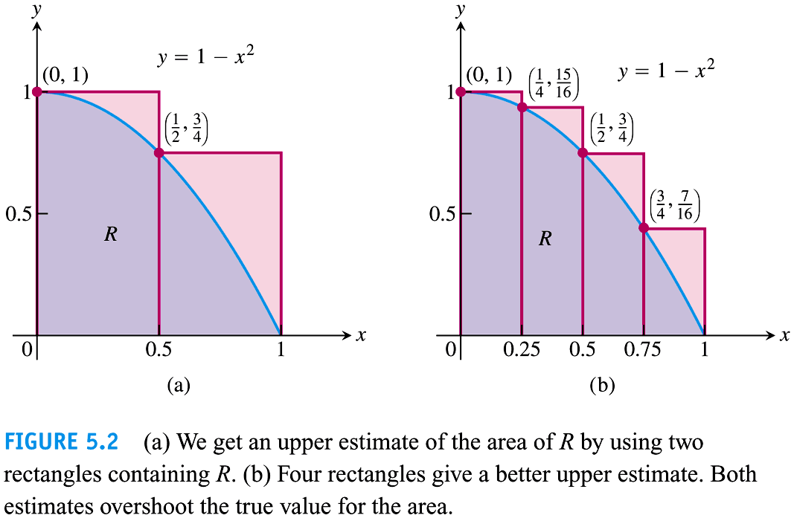

Judging by the picture approximation (a) and (b) are both **upper sums** because they are overestimations of the actual value of R, and it may make sense that the more smaller rectangles we use, the closer/smaller the overestimation will be to R.

Ex: Find R by calculating what we will call **the upper sum** (the area of the rectangles that overestimates the area) in figure (a); for ease lets use rectangles with uniform width.

Now Find R by calculating **the upper sum** in figure (b).

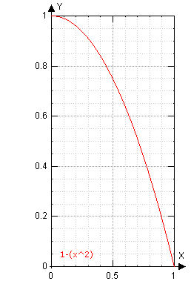Since these upper sums are over estimations lets calculate **the lower sum** of R for figures (a) and then (b).

(a)

(b)

Now consider, if 4 rectangles make better approximations than 2, then what is better than 4?

Lets try using the upper sum to find R by using 16 rectangles with uniform width.

It should be becoming clear that we are in desperate need of some nice notation that will alleviate the hassle of writing these sums; soon we will find some. First lets consider if there are any other ways to approximate the area:

We may look further at these in section 5.6 or you can look at them on your own.

Midpoint Rule: By using the midpoint in each $∆x$ interval, the height of each rectangle is both an upper and a lower sum which leads to a better approximation then before.

Trapezoidal Rule: Instead of using rectangles we can use trapezoids, which may be an upper sum or a lower sum depending on the curve.

Simpsons Rule:

Uses a formula that calculates the area under a parabola. This formula works based on using three points (which creates two sub-intervals). Simpson’s rule adds up the areas under many of these parabolas to create an approximation of the area under the desired curve. This fact requires you to use an even number of intervals (which has an odd number of endpoints) to use Simpson’s rule.

# Finite Sums and Sigma Notation

In general:

$$\sum_{k=1}^{n}{a_{k}}=a_{1}+a_{2}+a_{3}+…+a_{n-3}+a_{n-2}+a_{n-1}+a_{n}$$

where

Sigma (Summation) Notation Practice

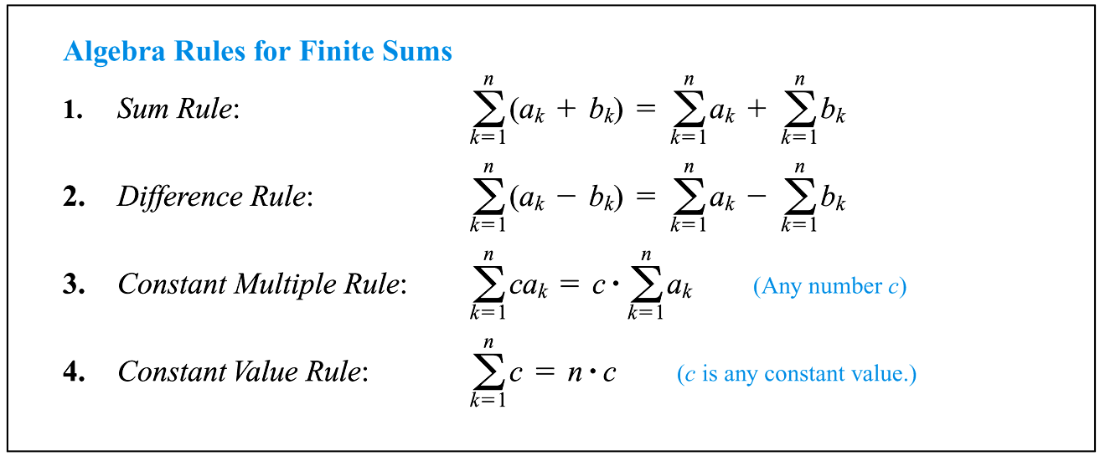Expand each sum.

1) $\sum_{j=1}^{5}{3j}$

2) $\sum_{k=1}^{7}{k^{2}-3}$

3) $\sum_{k=1}^{∞}{3j}$

4) $\sum_{k=1}^{n}{2k+5}$

5) $\sum_{k=1}^{84}{6k^{2}-3}$

6) $\sum_{k=1}^{4}{3k-4}$

The little Carl Fridrick Guass once to the astonishment of his primary school teacher completed the seemingly impossible task of adding the first 100 natural numbers in only a few moments. Consider this sum:

$$1+2+3+4+5+6+7+8+9+10+…+97+98+99+100$$

For such sums it seems quite appropriate to develop a notation that will save us the intolerable cruelty and boredom associated with writing the entire sum by hand. This notation is called Sigma Notation and in this case looks like this: $$\sum_{k=1}^{100}{k}$$

Theorem: Summation Formulas for finite sums

1. 2.

3. 4.

Ex: Find the sum of first 10 perfect square numbers.

This means given the function $f\left(x\right)=x^{2}$, find

$\sum_{k=1}^{10}{f(k)}=1^{2}+2^{2}+3^{2}+…+7^{2}+8^{2}+9^{2}+{10}^{2}=$

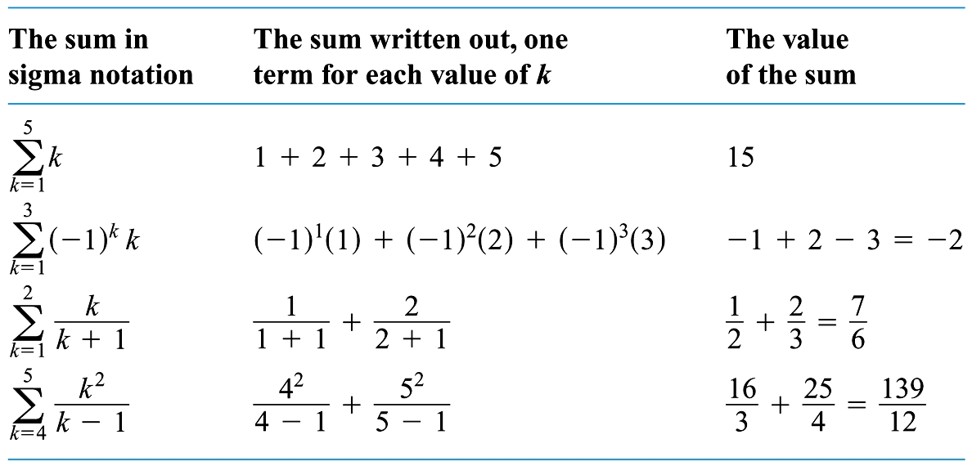 Write each sum using sigma notation, then find each sum. (you will likely want to use a calculator for “sum”)

1. 11+22+33+44 =
2. 2+5+8+11+14+...
3. 11(1) + 11(2) + 11(3) + …+11(291)
4. [4(1)+3]+[4(4)+3]+[4(9)+3]+…+[4(900)+3]
5. 4(1) + 4(8) + 4(27) + …+4(1000)
6. [7(1)+2]+[7(2)+2]+[7(3)+2]+…+[7(328)+2]

$\frac{1}{100}{\left(\frac{1}{100}\right)}^{2}+\frac{1}{100}{\left(\frac{2}{100}\right)}^{2}+\frac{1}{100}{\left(\frac{3}{100}\right)}^{2}+…+\frac{1}{100}{\left(\frac{100}{100}\right)}^{2}$

$-3+2+7+…+572$

$\left[2\left(1\right)-3\right]+\left[2\left(2\right)-3\right]+\left[2\left(3\right)-3\right]+…+\left[2\left(113\right)-3\right]$

$\frac{1}{100}{\left(\frac{1}{100}\right)}^{3}+\frac{1}{100}{\left(\frac{2}{100}\right)}^{3}+\frac{1}{100}{\left(\frac{3}{100}\right)}^{3}+…+\frac{1}{100}{\left(\frac{100}{100}\right)}^{3}$

Use upper and lower sums to approximate the area of the region using the given number of subintervals (of equal width)

Ex 1. 5.2.27. $y=\sqrt{x}$ on [0,1] using 5 subintervals

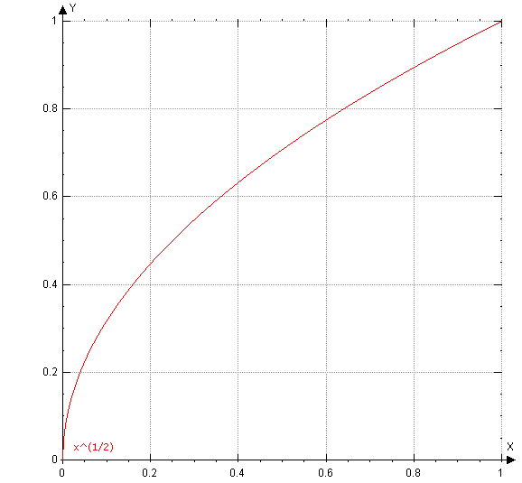Upper Sum (over estimation) Lower Sum (Under Estimation)

Ex 2 : $y=1-x^{2}$ on [0,1] Use 4 equally spaced sub intervals

Upper Sum (over estimation) Lower Sum (Under Estimation)

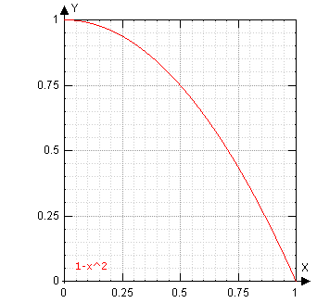 

These areas are ok, but we could get a better approximation of the actual area under the curve if we had more rectangles (which means more subintervals)

Write the upper sums from the previous examples using sigma notation.

Now rewrite the upper sums so that there are not just 5 or 4 subintervals but for the general case of n subintervals.

Now express the sum in Ex 2, on the last page, as a finite sum, $s(n)$.

If we need more subintervals, infinitely more, our approximate areas will approach the actual area. In the case of derivatives we employed this task to the trusty LIMIT. Lets use it again. Now what do we want to take the limit of and what will the index approach?

Take the limit of $S(n)$ as $→∞$. What do we get?

Find a formula for the sum of n terms. Use the formula to find the limit as $n→∞$

Ex 3: 5.2.39 $Lim_{n→∞}\sum_{i=1}^{n}{\frac{16i}{n^{2}}}$ Ex 4: 5.2.40 $Lim_{n→∞}\sum_{i=1}^{n}{\left(\frac{2i}{n}\right)\left(\frac{2}{n}\right)}$

Use the limit process to find the area of the region between the graph of the function and the x-axis over the given interval. Sketch the region.

Ex 5: 5.2.48 $y=3x-4, [2,5]$



Ex 6: 5.2.52 $y=1-x^{2}, \left[-1,1\right]$