Riemann Sums
We have already discussed the idea of a Riemann Sum, it is the idea that to find the area under a curve you must add up a bunch of rectangles. Previously we only considered partitioning up our $x$ interval into uniform widths. Now we consider a more general case of non-uniform width.
Def: The interval $[a,b]$ can be subdivided into a set of n subintervals. Let the end points of these subintervals be $x_{0},x_{1},x_{2},…,x_{n-1},x_{n}$ , then the set
$$P=\{x_{0},x_{1},x_{2},…,x_{n-1},x_{n}\}$$
Where $a=x_{0}<x_{1}<x_{2}<…<x_{n-1}<x_{n}=b$
Is called a partition of $[a,b]$
These subintervals are $\left[x_{0},x_{1}\right],\left[x_{1},x_{2}\right],…,[x_{n-1},x_{n}]$ and the kth subinterval of P is
$\left[x_{k-1},x_{k}\right]$ for $k∈Z$ where $1<k<n$

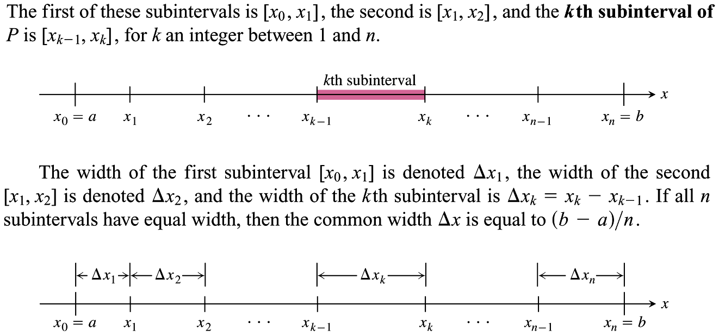
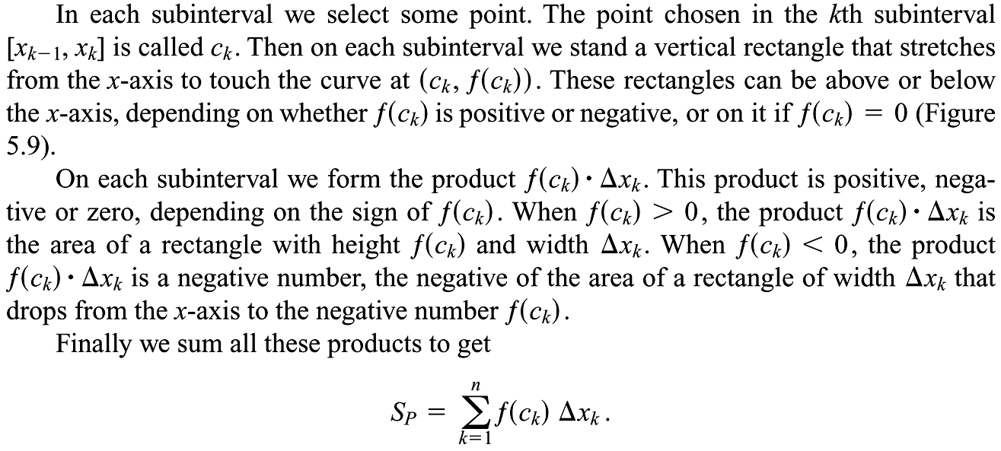
$S_{p}=\sum_{k=1}^{n}{f\left(c_{k}\right)Δx_{k}}$ is called a Riemann Sum of f on the Interval [a,b] Note: There are many such sums, depending on the partition we choose; hence the subscript $P$.

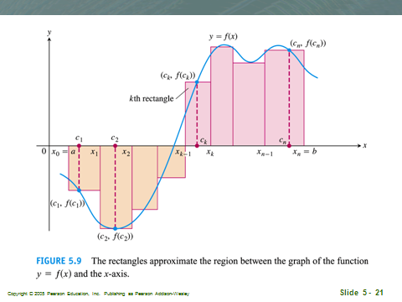
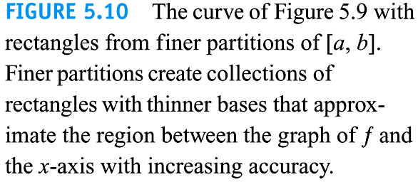
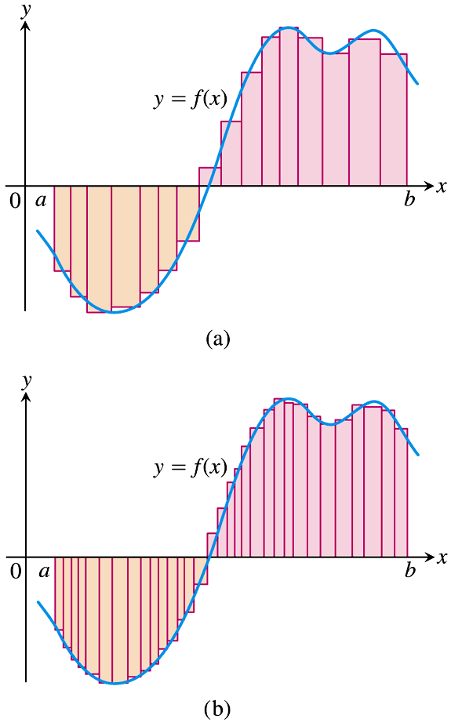
There is a problem here. Can you guess what it is? Hint: How can you be sure that if you increase the number of rectangles that it will actually make the ALL the interval widths smaller?

If we increase the number of rectangles to infinity as we had previously discussed in class will this necessarily give us a close approximation of the area under the curve? Can you find a way to increase the number of subintervals to infinity and yet it will not become a close approximation to the area under the curve?

What if we take only the smallest subinterval and break it into a series of subintervals where each new subinterval is half of the old one? Then we will have an infinite number of subintervals yet the sum of the rectangles will not necessarily approach the area under the curve.
What can we do to fix this problem?
Ans: find the largest subinterval in the partition and shrink it down to two smaller subintervals. Reassess and reiterate until the partition become broken down to very small subintervals.
Def: The Norm of a partition P, written $\left\|P\right\|$, is the largest of all the subinterval widths.

Note: If the norm of a partition is a very small number, then the interval MUST be cut up into very small subintervals since even the largest of these subintervals is very small!
We do know that the area we are approximating exists and IS SOME finite number, call it I. We are sure that it has something to do with a limit, and that we need to shrink all our subinterval widths to zero.
We now note that if we shrink only one subinterval over and over and over that this will not create the desired effect. Why? Ans: Because it leaves bigger subintervals untouched.
How might we fix this? Hint: It has something to do with the Norm of P ,$\left\|P\right\|$.
Ans: Cut up the biggest subinterval into two new subintervals. Then look for the next biggest subinterval and cut it up.
If we found the norm of P and cut up this one largest subinterval, then our biggest subinterval would be smaller. This would give us a new partition and a new Norm. Now what?
Ans: Keep going with this, just keep repeatedly cutting up each new norm until we can insure that even the largest subinterval is sufficiently small.
This will be the end-all move, it is the “crane kick” to our Karate Kid, the Hitorie Hanso Sword to our Kill Bill Vol. II, the Luke Skywalker to our original Star Wars Trilogy, the atom bomb to our WWII, it is the final move which we will use to earn our place in the big tournament, or the big series of sword fights, or our path to defeating the dark side, or to our devastating and ruthless attacks that will let us sit down to peace talks.
Drum Roll….
$$\lim_{\left\|P\right\|→0}{S_{p}=\lim_{\left\|P\right\|→0}\sum_{k=1}^{n}{f\left(c_{k}\right)Δx_{k}}}$$
Now we can be sure that the Riemann Sum will approach the actual area under the curve, I. But this is not the big surprise, it is merely the machinery that will get us there.
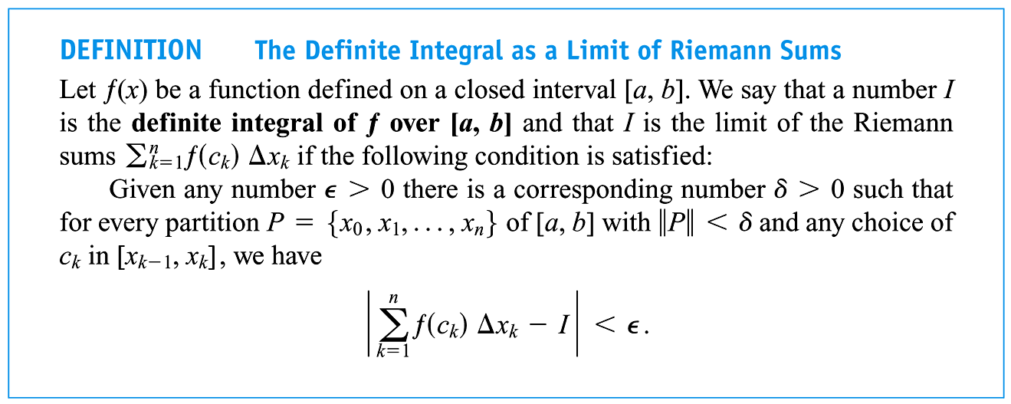
How close can we get?
Ans: As close as we want; within $ε$ even.

In other words:
$$I=\lim_{\left\|P\right\|→0}{S_{p}=\lim_{\left\|P\right\|→0}\sum_{k=1}^{n}{f\left(c_{k}\right)Δx_{k}}}$$
If this limit exists, we say that the function/curve, $f(x)$, is integrable and that the integral of the function exists.
If we satisfy the definition of a definite integral then we can say the definite integral exists.
Writing the Reimann sum notation can be cumbersome, and for that reason I would like to introduce a new notation: We will call this the definite integral, and intuitively understand that it represents the area between the function $f(x)$ and the $x-axis$. This statement is not entirely correct, but we will go over that in a bit.
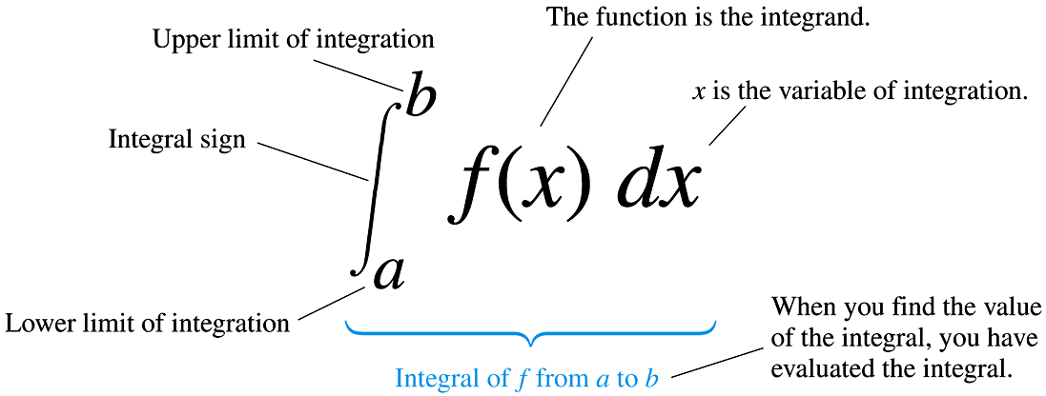

Just like with the derivatives being the limit of the difference quotient existing in order for a function to be differentiable, there was a condition that the function needed to meet to insure it was differentiable, namely it needed to be continuous AND smooth.
So…What conditions must exist so that the function be integrable?
- We have a continuous function
or
- We have a non-continuous function that has a finite number of discontinuities

Theorem: Continuity Implies Integrability
If a function $f$ is continuous on the closed interval [a,b], then $f$ is integrable on [a,b]

Ex: Find the definite Integral: Compute using their graphs

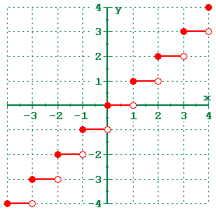
- $\int_{0}^{3}{2x dx}$
- $\int_{0}^{3}{\left\lfloor x\right\rfloor dx}$
- $\int_{0}^{3}{\left|x-1\right| dx}$

Functions that do not meet the above two conditions are not integrable
Ex: Find the definite integral:
Let $f\left(x\right)=\left\{\begin{aligned}1, &if x is rational \\ 0, &if x is irrational\end{aligned}\right.$ then find: $\int_{0}^{1}{f\left(x\right)=}$
Note: it is a fact that between every two rational numbers there is an irrational number.

Find the following definite integrals:
Ex1) $\int_{1}^{5}{2 dx}$

Ex2) $\int_{0}^{5}{\frac{1}{2}x dx}$

Ex3) $\int_{-2}^{5}{\left|x\right| dx}$

Ex4)$\int_{0}^{5}{\sqrt{25-x^{2}} dx}$

Ex5)$\int_{-1}^{1}{(2-\sqrt{1-x^{2}}) dx}$

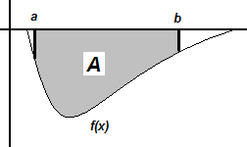

How could we get $\int_{a}^{b}{f\left(x\right)dx<0}$ ans: $\int_{a}^{b}{\underbrace{f\left(x\right)}dx<0}$
Neg.
Ex6)$\int_{1}^{6}{-4 dx}$

Ex7)Given the graph find the definite integral and the area of the shaded region:
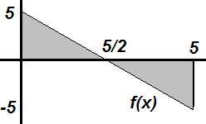
$\int_{0}^{5}{f\left(x\right)dx=}$

Note: The area does not always correlate to the value of the definite integral. However, to find the area, we can do it manually by breaking up the definite integral into smaller pieces and ignoring the negative sign since geometrically it is simply telling us it is below the x-axis.
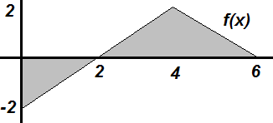
Ex8)Given a) Find $\int_{0}^{6}{f\left(x\right)dx=}$

b) Find the total area between $f(x)$ and the x-axis:

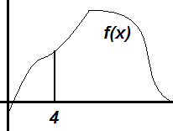
Ex9) $\int_{4}^{4}{f\left(x\right)dx=}$

$$\int_{π}^{π}{Sin x dx}=$$

Question: If $\int_{2}^{5}{g\left(x\right)dx=10}$, does this mean the area under the curve is 10 ${units}^{2}$?
Ans:

Ex10) If $\int_{2}^{5}{g\left(x\right)dx=10}$ then $\int_{2}^{5}{2g\left(x\right)dx=}________$
Question: Is there another way to make $\int_{a}^{b}{f\left(x\right)dx<0}$ but with $f\left(x\right)>0 ∀x∈[a,b]$?
Ans:
Ex11) $\int_{5}^{1}{2 dx}$
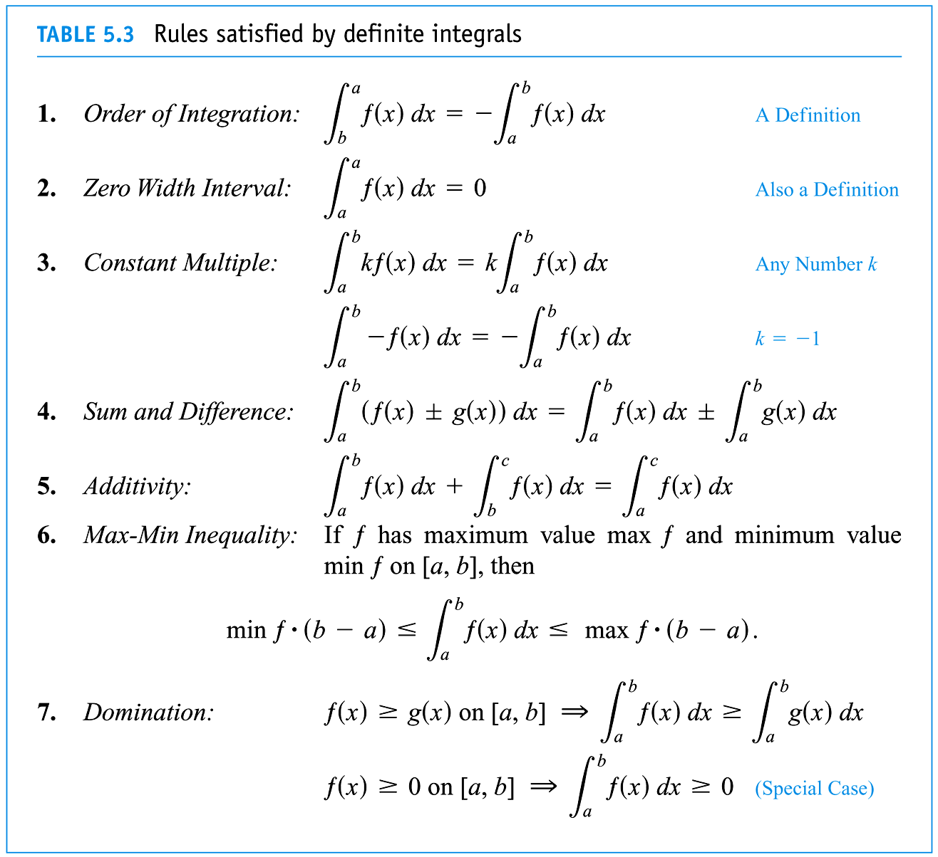
So let’s generalize what we just learned.

Ex 7 Given $\int_{4}^{7}{f(x)dx}=10$ and $\int_{4}^{7}{g(x)dx}=-3$, find
- $\int_{4}^{7}{2f(x)dx}$

- $\int_{4}^{7}{\left(f\left(x\right)-g\left(x\right)\right)dx}$

- $\int_{7}^{4}{g(x)dx}$

- $\int_{4}^{5}{f(x)dx}+\int_{5}^{7}{f(x)dx}$

- $\int_{4}^{7}{8dx}$

- $\int_{4}^{7}{\left(8-2g\left(x\right)\right)dx}$

- $\int_{4}^{5}{\left[g\left(x\right)\right]dx}+\int_{5}^{4}{\left[g\left(x\right)\right]dx}$

- $\int_{4}^{7}{{\left[f\left(x\right)\right]}^{2}dx}$

Draw some possible graphs for $g(x)$ on $[4,7]$

