In 3.1 we learned what a system of equations is and what a solution to a system is. We then discussed how to find a solution graphically as well as considered the three possibilities that can arise from a system of linear equations. In this section we will continue to practice looking for solutions. We will focus on the Substitution Method and the Elimination Method.

Recall:
Def: The solution to a system of equations is the value of the unknowns that makes ALL equations true.

Substitution Method

Consider the system of equations:
- $y-2x=1$
- $2x+y=9$

Each equation is a relation, that describes important information about how y is defined based upon what x is.
Each equation is similar to a sex cell. Within the cell there are 23 Chromosomes just as within the equation there are variables. Each cell has a unique relationship based on its chromosomes, just as equations do with their variables.
When creating a new zygotes (fertilized eggs) the sperm cell takes its 23 chromosomes and infuses its genetic information into an egg which has its own 23 chromosomes to make a zygote which is a new cell that has one complete set of 46 chromosomes. So this new cell has both the genetic information from the sperm and the egg.
This is exactly the same notion as with substituting equations.

We solve one equation for a single variable and infuse all its information into the second equation.
The result is a single new equation that has all the mathematical information of both equations, but has the great advantage of only having one variable.
Solving this equation will give us the value of that one variable which satisfies both equations.
All that is left is to plug this value into either original equation to find the value of the other variable at that common point.

Note: These equations have different slopes, so we know this is a consistent system (one solution)

First: Solve one equation for a single variable.
- $y=2x+1$
Now Box, it because we will use this equation later!

Second, Substitute this equation into the other equation to get a final equation that has all the info of the entire system.
- $2x+\left(2x+1\right)=9→4x+1=9→4x=8→x=2$

Third, Plug it back into any of the original equations (if any works then the one we boxed works, and it is all ready to tell us what y is if we plug in an x).

- $y=2\left(2\right)+1=5$

So the solution is $(2,5)$, to be sure we should plug it into both equations to check.

Ex: Find the solution to the systems:
- $3y+x=4$ $(1,1)$
$$x=2y-1$$
- $m-2n=16$ $\left(2,-7\right)=(m,n)$
$$4m+n=1$$
- $t=4-2s$ Same slopes, different t-intercepts: Inconsistent system NO SOL!
$$t+2s=6$$
- $a-2b=3$ Same slopes, same a-intercepts: Dependent system: Infinite SOL!
$$3a=6b+9$$

Elimination Method

This Method hinges on the fact that you can add or subtract any two equations and the third equation will be another equality but one that is filled with the info from the prior two equations.

Use Scale idea: Scale 1: Sasquatch = 6 Bulimic Circus Clowns
+ Scale 2: 1 English tourist = 3 happy meals

Final Scale: Sasquatch & English Tourist = 6 Bulimic Circus Clowns & 3 Happy Meals

Biological analogy
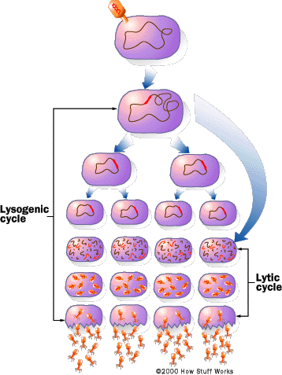
Once inside the host cell, some viruses, such as herpes and HIV, do not reproduce right away. Instead, they mix their genetic instructions into the host cell's genetic instructions. When the host cell reproduces, the viral genetic instructions get copied into the host cell's offspring.
The host cells may undergo many rounds of reproduction, and then some environmental or predetermined genetic signal will stir the "sleeping" viral instructions. The viral genetic instructions will then take over the host's machinery and make new viruses as described above. This cycle, called the lysogenic cycle, is shown in the accompanying figure.
Because a virus is merely a set of genetic instructions surrounded by a protein coat, and because it does not carry out any biochemical reactions of its own, viruses can live for years or longer outside a host cell. Some viruses can "sleep" inside the genetic instructions of the host cells for years before reproducing. For example, a person infected with HIV can live without showing symptoms of AIDS for years, but he or she can still spread the virus to others.

Math Analagy: 1) $2x+3y=7$
+ 2) $3x-3y=3$

3) $5x+0y=10→x=2$
From here we finish like in the subtraction method. Plug into any original equation to find $y=1$

Solution: $(2,1)$

I DO: Ex: 1) $9x-2y=3$
2) $3x- y=6$
Sol:
$(-3,-15)$

I DO: Ex: 1) $5x-7y=-16$
2) $2x+8y=26$
Sol:
$(1,3)$

Ex: Find the solution by elimination method.
a) 1) $5x-9y=7$ $\left(\frac{1}{2},-\frac{1}{2}\right)$
2) $7y-3x=-5$
b) 1) $x+2y=7$ $No Sol$
2) $0=4-x-2y$
c) 1) $3a-12b=9$ $\left(-\frac{3}{11},-\frac{9}{11}\right)$
2) $4a-5b =3$
d) 1) $2x-9y=7$ $Infinite Sol$
2) $\frac{2}{3}x-3y=\frac{7}{3}$

