In 4.3 we discussed what an absolute value equations as well as inequalities involving absolute values. In this section we will continue to look at linear inequalities with two variables.

Defn A linear inequality in two variables is just like a standard linear equality but with the = replaced by an inequality sign.
Or
A linear inequality in two variables is an inequality that can be written as $Ax+By>C$ or $Ax+By<C$ or $Ax+By≥C$ or $Ax+By≤C$, where A, B, and C are real numbers and A and B are not both zero.

Consider the solution sets to these:

$$y=2x+1$$
$$y<2x+1$$
$$y≤2x+1$$
What is the difference in the solution sets?
Graph each separately.

General Procedure:
- To graph the linear inequality rewrite it so that you can easily graph the line y <> mx+b then graph the line as though the inequality were an equality.
- Make the line dashed if it was a < or > symbol and solid if it were $≤or≥$.
- Then plot a test point and if that point makes the inequality true, shade towards the point, if it is false then shade the other side of the line.

(Write steps as work through example 1.)

Ex 1 Graph each region.
- $y>-3x+2$
- $2x-y≥1$
- $x+y<0$
- $x<3$
- $3y+2≥0$

e d c b a

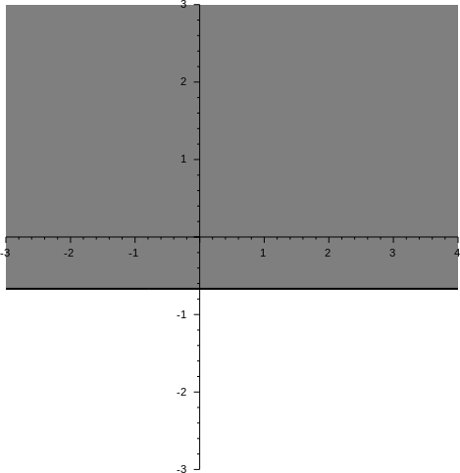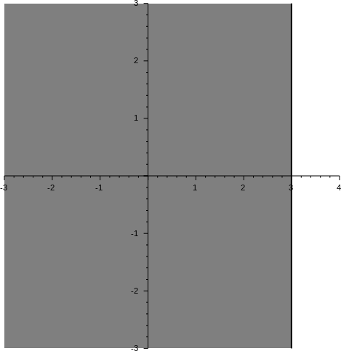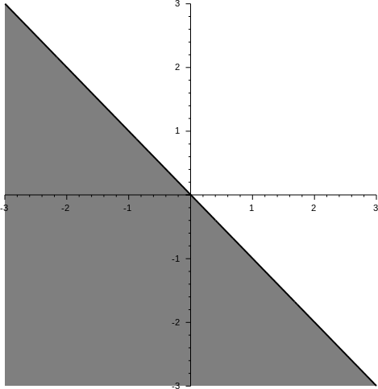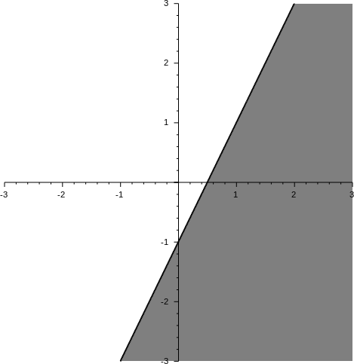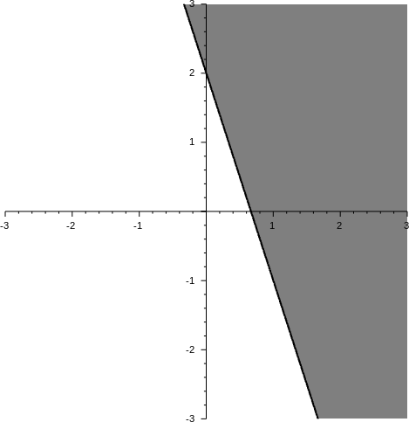
Ex: Graph the system of inequalities.
- $y<x$
$$y>-x+1$$
- $y≥-2$
$$y≥x+3$$
- $y-2x≥1$
$$y-2x<3$$
- $2y-x≤2$
$$y-3x≥-4$$
$$y≤4$$

d c b a

