Recall the Principal of Square Roots and how we used them for solving quadratic equations

## The Principle of Square Roots.

The Principal of Square Roots

For any real number k, if $x^{2}=k,$ then

$$x=±\sqrt{k} which is to say x=\sqrt{k} or x=-\sqrt{k}$$

Ex: Solve the quadratic equation $x^{2}+1=0$

$$x^{2}=-1→ x=±\sqrt{-1}$$

Up to know this equation had no solution, or rather that its solution was not a real number. But if we consider the unimaginable number that when you multiply it by itself it gives you a negative, then this equation would have a solution.

Enter The Number *i*

The Number *i*, is an imaginary number, which means it is not a real number!

$i$, is the unique number for which $i=\sqrt{-1}$ and $i^{2}=-1$

Note:

$$i=\sqrt{-1}$$

$$i^{2}=-1$$

$$i^{3}=-\sqrt{-1}$$

$$i^{4}=1$$

Ex: Solve $4x^{2}+9=0$

Ex: if a) $x^{2}+9=0$ and b) $4x^{2}+9=0$ then find x.

$x^{2}+9=0→ x^{2}=-9→x=±\sqrt{-9}=±\sqrt{9}\sqrt{-1}=±\sqrt{9}i=±3i$

$4x^{2}+9=0→x==±\sqrt{-9/4}=±\sqrt{9/4}\sqrt{-1}=±\sqrt{9/4 }i=±\frac{3}{2}i$

These solutions are called:

The union of the set of all imaginary numbers and the set of all real numbers is the set of all **complex numbers**.

The following are examples of imaginary numbers:



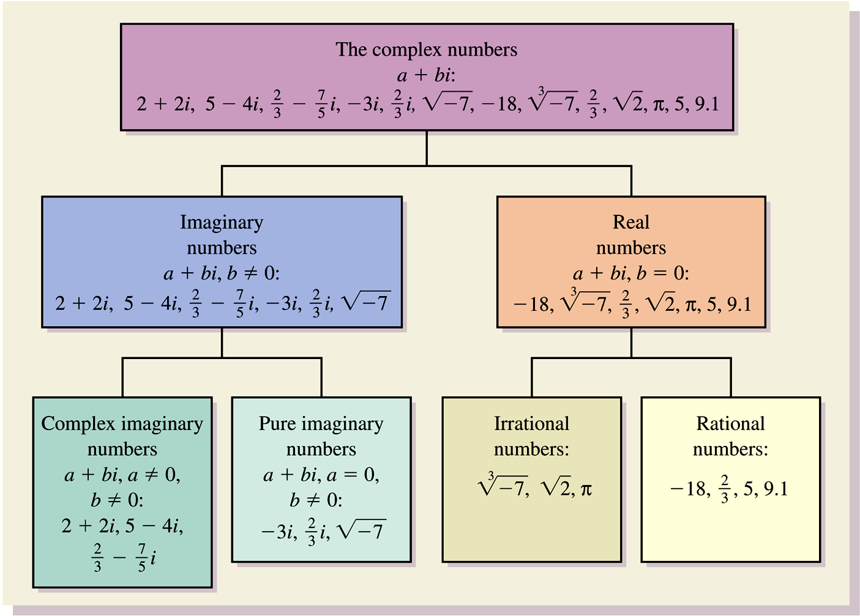

## Adding and Subtracting Complex numbers.

Since the complex numbers include the real numbers (which means every real number IS A COMPLEX NUMBER) the complex numbers include all of the properties of the real numbers, like the commutative, associative, and distributive properties.

Due to this fact ADDING AND SUBTRACTING COMPLEX NUMBERS IS JUST LIKE COMBINING LIKE TERMS. You add all the real parts with the real parts and the purely imaginary parts with the purely imaginary parts.

Ex: Add or subtract and simplify the following:



## Multiplication

To multiply square roots of negative real numbers, we first express them in terms of *i.*

Ex: Multiply and simplify. When possible, write answers in the form *a* + *bi*.



Solution:



Simplifying powers of *i* can be done by using the fact that *i* 2 = –1 and expressing the given power of *i* in terms of *i* 2. Consider the following:

Ex: Simplify $i^{23}$

We will use the conjugates of complex numbers for division and simplifying complex numbers

Ex: Find the conjugate of each number.



## Division of Complex numbers

Conjugates are used when dividing complex numbers. The procedure is much like that used to rationalize denominators.

Ex: Divide and simplify to the form *a* + *bi*.



Solution

