Def: The graph of all quadratic equations is the U-shaped curve called a **parabola**.

Def: The **Vertex** of any parabola is the so called “turn around point”. It is the place where the parabola reaches its maximum or minimum value.

Def: All parabolas are symmetric about the vertical line that passes through the vertex. This lime is called the **axis of symmetry**

## The Graph of $f\left(x\right)=ax^{2}$

Graph: $f\left(x\right)=2x^{2}$ And



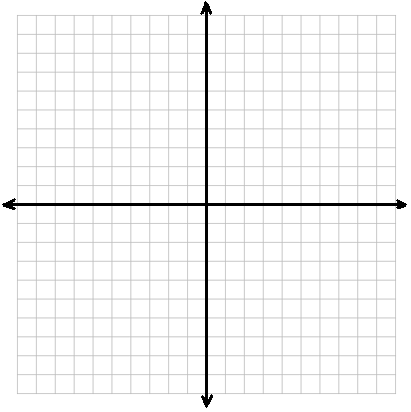Consider the following functions. Graph each on the same graph:

$f\left(x\right)=x^{2}$

$g\left(x\right)=2x^{2}$

$h\left(x\right)=4x^{2}$

$m\left(x\right)=\frac{1}{2}x^{2}$

$n\left(x\right)=\frac{1}{4}x^{2}$

$f\left(x\right)={-x}^{2}$

$g\left(x\right)=-3x^{2}$

$h\left(x\right)=-\frac{1}{10}{ x}^{2}$

All of these graphs have been of the form $f\left(x\right)=ax^{2}$ where $a$ is in $R$.

What do you notice about the direction of the graph if $a$ is positive?_________________

The parabola points upward

The parabola flips upside down

What if $a$ is Negative? ____________________

They get steeper

What do you notice happens to the graphs if $a$ gets bigger?_____________________________

They get wider

What do you notice happens to the graphs if $a$ is a positive proper fraction?

$$f\left(x\right)=100x^{2}$$

_______________________

Given the graph of $f\left(x\right)=10x^{2}$ come up with a function that is steeper/narrower.

$$f\left(x\right)=\frac{1}{4}x^{2}$$

 __________________

Given the graph of $f\left(x\right)=\frac{1}{2}x^{2}$ come up with a function that is wider/flatter.

$$f\left(x\right)=-x^{2}$$

 __________________

Given the graph of $f\left(x\right)=4x^{2}$ come up with a function that is upside down. __________________

Ex: Find examples of functions that could create the following graphs.

$$f\left(x\right)=x^{2}$$

$$f\left(x\right)={4x}^{2}$$

$$f\left(x\right)=\frac{1}{4}x^{2}$$

$$f\left(x\right)=-x^{2}$$

$$f\left(x\right)=-x^{2}$$

## The Graphs of $f\left(x\right)=a{\left(x-h\right)}^{2}$

Let us look at quadratic functions that are perfect squares. By doing so, we will notice that the parabola looks very similar to the graphs of $f\left(x\right)=ax^{2}$ but with a rigid transformation (sliding the parabola around on the coordinate plane like a game of “pin the tail on the donkey”).

First let us consider what this will look like if $a=1$

Ex: Graph $f\left(x\right)={\left(x-2\right)}^{2}$

Consider the Table:

|  |  |  |  |
| --- | --- | --- | --- |
| Function: | Vertex | x-value of vertex | y-value of vertex |
| $$f\left(x\right)=x^{2}$$ | $$(0,0)$$ | 0 | 0 |
| $$f\left(x\right)={\left(x-2\right)}^{2}$$ | $$(2,0)$$ | 2 | 0 |
| $$f\left(x\right)={\left(x+3\right)}^{2}$$ | $$(-3,0)$$ | -3 | 0 |
| $$f\left(x\right)={\left(x-7\right)}^{2}$$ | $$(7,0)$$ | 7 | 0 |
| $$f\left(x\right)={\left(x+8\right)}^{2}$$ | $$(-8,0)$$ | -8 | 0 |

Think about the graph of $f\left(x\right)=x^{2}$

What is the value of x, that corresponds to the vertex?________________

What will the value of y be for that value of x? ___________________

Now think about the graph of $f\left(x\right)={\left(x-2\right)}^{2}$

What is the value of x, that corresponds to the vertex?________________

What will the value of y be for that value of x? ___________________

Based on these two examples what does the x value of the vertices have to do with the equations?

The x value of the vertex will make the thing we are squaring 0.

_________________________________________________________________________________

Summary:

## The Graph of $f\left(x\right)=a{\left(x-h\right)}^{2}+k$

Recall that if you graph a function $g\left(x\right)$, then the graph of $g\left(x\right)+3$ will be the same as $g(x)$ but shifted up by 3.

Sketch the following graphs:

$f\left(x\right)=x^{2}+1$

$f\left(x\right)=x^{2}-2$

$f\left(x\right)={-2x}^{2}+1$

$f\left(x\right)={(x+1)}^{2}-3$

$f\left(x\right)={3(x-1)}^{2}+2$

$f\left(x\right)={-(x-4)}^{2}-3$

$f\left(x\right)=x^{2}+2x+1-3$