/100 Name__________________ Raw Score:

THE RULES: Submitting this exam implies you understand the rules.

**No Calculators or electronic devices allowed**! You must **show all work on this exam** (not on scratch paper)for full credit. You **may not use** any **aides** or **materials** other than a **pencil** and **materials given to you by the instructor.** SIMPLIFY ALL ANSWERS!!

1. (2 pts) Use completing the square to find the vertex form of $f\left(x\right)=4x^{2}-8x-1$

**Answer: ____________________**

1. 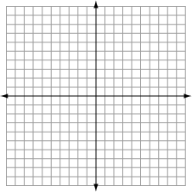 (8 pts) Graph $f\left(x\right)=x^{2}+4x-2$ on the graph provided & Fill out the table below

|  |  |  |
| --- | --- | --- |
| Vertex |  | |
| $x-$ intercepts |  |  |
| $y-$ intercept |  | |
| Domain of $f(x)$ |  | |
| Range of $f(x)$ |  | |
| Discriminate of $f(x)$ |  | |
| Set of all $x$’s such that $f\left(x\right)≤0$ |  | |

1. (2 pts) Find a quadratic function that fits the set of data points. $\left(0,-2\right);\left(1,4\right);(-1,-4)$

**Answer: _____________________**

1. (4 pts) Find all $x$-intercepts for the function (real and imaginary) $f\left(x\right)=x^{4}-1$

$x-intercepts (write as ordered pairs):$

**________________________________________**

1. (4 pts) Find all real solutions to **only** the problems below which are equations:

a) $x-8\sqrt{x}-9$

b) ${\left(x-1\right)}^{2}-8\left(x-1\right)-9$

c) $x^{-2}-8x^{-1}-9=0$

**Solution(s): ____________________________**

1. (3 pts) Graph & label each of the following in the space below:

$f\left(x\right)=2x^{2} ; g\left(x\right)=5x^{2} ;h\left(x\right)=\frac{1}{5}x^{2}$

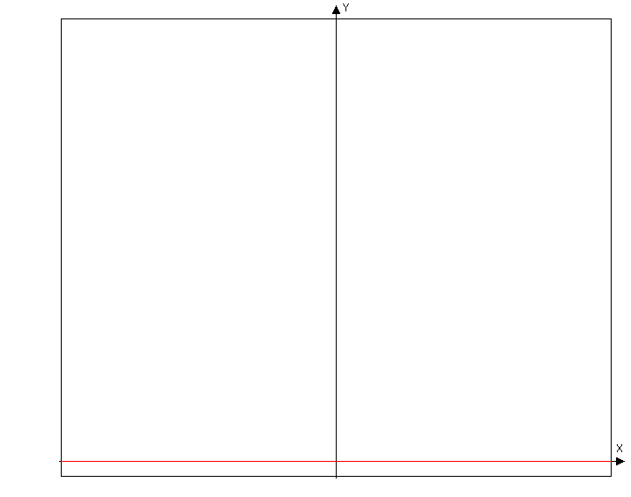

$$y_{3}$$

$$y_{2}$$

$$y_{1}$$

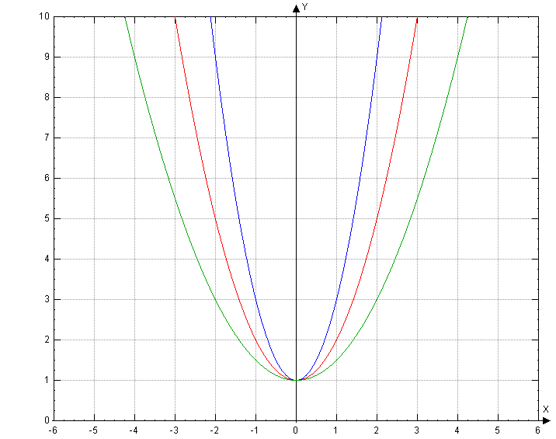

1. (2 pts)Find appropriate equations for the graphs $y_{1}, y_{2},y_{3}$

$y_{1}=$

$y_{2}=$

$y_{3}=$

**________________**

**________________**

**________________**

1. (3 pts) Find the inverse, , of the function which one-to-one. Use proper notation.

$f\left(x\right)=\left|x-2\right|+4$ $f\left(x\right)=\frac{1}{x-2}+4$

1. (2 pts.) Rewrite each exponent statement into Logarithm form. (translate)

a) $6^{4}=1296$ b) $5^{-2}=.04$

1. (2 pts.) Rewrite each logarithm statement into exponent form. (translate)

a) $\log\left(.01\right)=-2$ b) $\ln\left(x\right)=3$

1. (6 pts) Graph the functions:

$f\left(x\right)=\ln\left(-x\right) \& g\left(x\right)=-ln⁡(x)$

on the same graph. Correctly label the graphs, include all “important points”, and the equations of any asymptotes.

1. (4 pts.) Graph the following functions on the same graph grid. Be sure to label the “important points” and label all asymptotes.

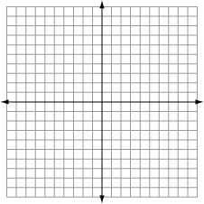

List the Domain of $f(x):$

__________

List the Range of $g\left(x\right):$

__________

1. Given the following functions, answer each question:

  

a) (1 pt) g(f(2)) =

b) (3 pts) Verify that $g(x)$ and are inverses using composition. (find $g\left(g^{-1}\left(x\right)\right) and g^{-1}(g\left(x\right))$)

c) (1 pt) Find the range of.

d) (1 pt) Find the domain of.

1. (5 pts.) Each of the given functions involves a single shift (left, right, up, or down) or a single reflection (x-axis or y-axis.) Write the letter that matches the change to each of the base functions (some letters could be used more than once, and some will not be used at all)

 _____ (A) up

 _____ (B) down

 _____ (C) left

 _____ (D) right

 _____ (E) reflection across the x-axis (upside down)

(F) reflection across the y-axis

1. (4 pts) Solve each equation. Box your solution.

a)  b) 

c)  d) 

1. (6 pts.) Evaluate each expression.

a) $π^{0}=$ d) $\ln\left(-1\right)=$

b) $\log{(\sqrt[3]{10})}=$ e) $\log\left(10,000\right)=$

c) $\log_{17}{{(17}^{8})}$ = f) $\log_{4}{(8)}=$

1. (5 pts.) Indicate whether each statement is True or False (T or F).

$2^{(\log_{2}{7}+\log_{2}{x)}}=7+x$

$\ln\left(x\right)-\ln\left(2\right)=\frac{\ln\left(x\right)}{\ln\left(2\right)}$

_____

_____

_____ 

_____ 

______ 

1. (6 pts.) Solve each logarithm equation. (You must show your work.)

a) $\log_{7}{(x+1)}+\log_{7}\left(x-1\right)=\log_{7}{8}$ b) $\log{x}+\log{(x-3)}=1$

1. (2 pts.) Solve the given compound interest problem for ***t***. You will need to use a common or natural logarithm to do this. (leave your answer in exact form)

$225=75∙e^{3∙t}$

1. (2 pts) If a radioactive element (let’s call it “Tom”) has a half-life of 111 years. Find the decay constant, k, (in exact form) required to half the amount of “Tom” present in a very old, yet surprisingly well preserved bagel. Recall $P=P_{o}∙e^{k∙t}$