Exam Score /120 Raw Score:

|  |  |  |
| --- | --- | --- |
| Class Meeting | Date: | Name: |
| TH |  |  |

**Use pencil. No notes or calculators allowed.**

**You must show all work on this exam in order to receive full credit. Cheating is fortunately punishable by public flogging, or a round number, 0, (I pick).**

1. (7 pts) Let $f\left(x\right)$ be a function of x and let $f^{-1}(x)$ ­be its inverse function.

Also let $f\left(1\right)=2, f\left(2\right)=3, f\left(3\right)=4,and f^{-1}\left(5\right)=4$

Find the following:

1. The domain of $f(x)=$ the _____________________ of $f^{-1}\left(x\right)$
2. 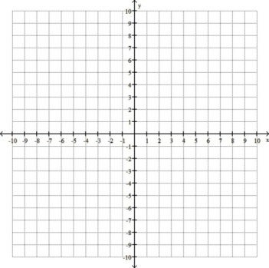 $f\left(2\right)=$



$f^{-1}\left(3\right)=$



$f\left(4\right)=$ $g\left(x\right)$



$f(f\left(1\right))$__________
3. ___________
4. __________
5. =

$f(f\left(f\left(1\right)\right))$ __________
6. =___________
7. **True** or **False $f^{-1}\left(x\right)=\frac{1}{f\left(x\right)}$**

(Circle one)

Problem 2

1. (7 pts) Let $g\left(x\right)$ be given by the graph
2. Is $g\left(x\right)$ a function? ________ What led you to this conclusion? ________________________________________
3. Is $g\left(x\right)$ one-to-one? ________ What led you to this conclusion? _______________________________________
4. Will $g^{-1}(x)$ be a function? _________
5. Sketch and label $g^{-1}(x)$ on the same graph as $\left(x\right)$.
6. (4 pts) Let $h(x)$ be the graph of any function.
   1. What happens to the graph of $h(x)$ if you graph $h\left(x\right)+1$? __________________________________________
   2. What happens to the graph of $h(x)$ if you graph $h\left(-x\right)$? ____________________________________________
   3. What happens to the graph of $h(x)$ if you graph $-h\left(x\right)?$

____________________________________________
   4. What happens to the graph of $h(x)$ if you graph $h\left(x+1\right)$? __________________________________________
7. 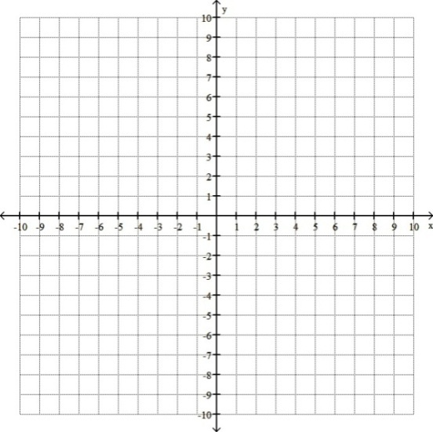(8 pts) For the quadratic function $g\left(x\right)=-x^{2}-2x+8$, find the vertex and all intercepts.

(You may wish to use the vertex formula OR complete the square to find the vertex.)

Next, graph the function. Label (on the graph) the vertex and all intercepts.

Vertex:

$x$____________

-intercept(s):

$y$____________________

-intercept:____________

1. (8 pts) Evaluate the following:

$\log_{123}{(1)=}$

$\log_{123}{(123)}$
   1. _________
   2. =

$\log_{8}{64}$ _________
   3. =

$\log_{123}\left(\sqrt{123}\right)=$



$\ln\left(e^{3}\right)=$



$log⁡(.001)$ ___________
   4. __________
   5. ___________
   6. =

$\log_{123}\left(0\right)=$

 ____________
   7. __________
2. (3 pts)Solve for $x$. $\left|x+8\right|=\left|2x-6\right|$ (Hint: How many answers does $\left|x\right|=3$ have?)

Ans: _____________

1. (5 pts) Consider the system of non-linear equations:

$$y=2x-6$$

$\frac{x^{2}}{36}+\frac{y^{2}}{36}=1$

1. This system consists of a _____________ and a(n) _____________. Because of this fact, there will be at most________ solutions to this system.
2. The solution(s) to this system are ______________________________________. If there are no solutions state why.
3. (4 pts) Consider the system of linear equations:
 $$y=1$$

 $$y=-2x+1$$

 1. This system consists of a _____________ and a(n) _____________. Because of this fact, there will be at most________ solutions to this system.
   2. The solution(s) to this system are ______________________________________. If there are no solutions state why.
4. (2 pts)Solve the following equation for $x$. $3x^{2}+14x+3=-1+4(x+1)$

Ans: ________________________

1. (2 pts) Solve for x (simplify your answer). $x^{2}-12x+26=0$

Ans:________________

1. (4 pts) Solve for x. Be sure to check your solution(s). $\sqrt{2x+1}+5=2x$

$x=$

________________________

1. (2 pts) Solve the quadratic inequality. You may, but are not required to, use the provided number line for your solution.

$2x^{2}+3x≤27$

Solution: _______________________ or

1. (2 pts) Solve for $y$. Note: You have not solved for $y$ if it shows up on both sides of your equation.

$$x=\frac{5y+1}{y-3}$$

$y=$

_______________

1. (4 pts) Solve for the variable and check your solutions. If there is no solution, state so.

$$\frac{1}{2x+3}+\frac{12}{4x^{2}-9}=\frac{2}{2x-3}$$

Ans: _______________________

1. (2 pts) Multiply and simplify completely. $\frac{3x^{3}y}{x^{2}+7x+12}∙\frac{x^{2}+8x+15}{6xy^{2}}$
2. $\frac{{x^{2}(x}^{2}+8x+15)}{{2y(x}^{2}+7x+12)}$ B) $\frac{x^{2}}{2y}$ C) $\frac{x^{-3}}{2y^{-2}}$ D) $\frac{x^{2}\left(x+1\right)(x+15)}{2y\left(x+1\right)(x+12)}$ E) $\frac{x^{2}(x+15)}{2y(x+12)}$ F) $\frac{x^{2}(x+5)}{2y(x+4)}$
3. (2 pts) Divide and simplify completely. $\frac{b^{2}+6b-16}{b^{2}+16b+64}÷\frac{b^{2}+3b-10}{b^{2}-25}$

Ans: ___________________

1. (2 pts) Add and simplify completely. $\frac{4}{y^{2}+11y+30}-\frac{4}{y^{2}-36}$

Ans: ____________________

1. (4 pts) Find the inverse of the function. $f\left(x\right)=\sqrt[3]{\frac{1}{2}x-1}$

$f^{-1}\left(x\right)=$_______________________ State **if and why $f^{-1}\left(x\right)$** is or is not a function:

Ans: **YES/NO** bec.____________________________________________________________________________________

1. (2 pts) Solve for $x$. Leave answers in exact form. $3^{3x+1}=81$

$x=$

_________________

1. (2 pts) Solve for $x$. Leave answers in exact form. $3^{x}=14$

$x=$

_________________

1. (3 pts) Solve for $x$. Leave answers in exact form. $\ln{e^{x^{2}}=100}$

$x=$

_________________

1. (2 pts) Solve for $x$. Leave answers in exact form. $\log_{3}{(x+3)}=\log_{3}(6x-2)$

$x=$

_______________

1. (4 pts) Solve for $x$. Leave answers in exact form. Hint: Recall that the domain of $\log_{b}\left(x\right)$ consists of only positive numbers.

$\ln{(x)}+\ln\left(3x-\frac{2}{x}\right)=0$

$x=$

________________

1. (8 pts) Examine each of the following graphs. **(I)** Does the graph represent a function? **(II)** Does the graph represent a one-to-one function? Circle the appropriate responses. **(III)** find the equation of all asymptotes if they exist (write none if none exist) **(IV)** Find the equation of the graph.

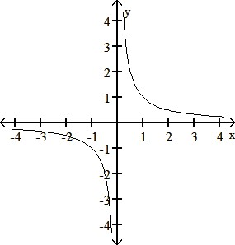 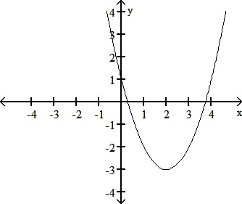

**(I)** Function Not a function **(I)** Function Not a function

**(II)** One-to-one Not One-to-one **(II)** One-to-one Not One-to-one

**(III)** Eqn of Asymptote(s): ________________ **(III)** Eqn of Asymptote(s): ________________

**(IV)** Eqn of graph: ___________________ **(IV)** Eqn of graph: ___________________

23) Choose **2** of the following 3 problems to complete. Please indicate which two you’d like graded.

1. To make a weak solution of 40 liters of 15.5% acid, a lab technician will use some premixed solutions: one is 8% acid and the other is 20% acid. How many liters of each type should he use to obtain the desired solution?
2. Lucinda invested $7000 in mutual funds and bonds. The mutual funds earned 12% simple interest. The bonds earned 8% simple interest. At the end of the year, she had earned $740 in interest. How much had she invested at each rate?
3. In the summer it takes Bob 12 hours to paint the barn. It takes his young son 18 hours to paint the barn. How many hours would it take if they both worked together?

Choice ___ :__________________________ Choice ___ :__________________________

1. Graph the solution set of $f\left(x\right)>x^{2}$.
2. If a ball is thrown into the air with an initial speed of 32 ft/sec from a height of 16 feet below sea level, then the height of the ball relative to sea level is given by $h\left(t\right)=-16t^{2}+32t-16$.
   1. What is the peak height of the ball, and what time will it reach this peak height?
   2. How long will it take the ball to hit the ground at sea level?
3. What is the difference between an function, equation, and an expression?
4. Simplify the following (rationalize any denominators)
   1. $\sqrt{-16x^{2}y^{4}z^{5}}$ b) $\frac{2}{\sqrt[3]{2}}$ c) $\frac{1+2i}{3-4i}$ d) $\sqrt[4]{32x^{4}y^{7}z^{13}}$
5. List two functions which are one-to-one and two that are not. ______________________. How can you tell if a graph of a function is one-to-one?
6. Use long division or synthetic division to find the quotient: $\frac{x^{3}-1}{x-1}$
7. Find the equation of a line passing through the points $\left(1,1\right)\& (2,3)$ in point slope form.
8. Start with the standard form of a quadratic equation and from this, derive the quadratic formula.

For questions 32-39, use the following functions. Rationalize all denominators. Use “i” notation for imaginary numbers.

   

  

1. Find the domain of $k(x)$
2. Find the range of $f(x)$
3. Find the domain of $h(x)$
4. Evaluate $g(p(2)$
5. Which function(s) is(are) not one-to-one.
6. Which function(s) when evaluated at 5 is irrational?
7. Evaluate and simplify problems a-c: a) $p(x+h)-p(x)$ b) $\frac{4}{f\left(-2\right)}$ c) $\frac{g}{w}(0)$ d) find $h^{-1}\left(x\right)$
8. Find all values of x for which a) $p\left(x\right)=w(x)$ b) $k\left(x\right)=0$ c) $k\left(x\right)=1$ d) $h\left(x\right)=-\frac{1}{49}$ e) $w\left(x\right)=2$

Rewrite the logarithmic equation in exponential form and rewrite the exponential equation in logarithmic form



$7^{x}=19$

$\log_{3}\left(a\right)=127$

Evaluate:

$\log_{2}{0}$

$\log_{2}{\frac{1}{64}}$

$lne^{2\backslash 3 }$

$\log{\frac{1}{1000}}$

1. Suppose that a flare is launched upward with an initial velocity of 112 ft/sec from a height of 40 ft. Its height in feet,  , after t seconds is given by .

(a) How high will the flare be after 1 second?

(b) When will the flare reach its maximum height?

(c) When will the flare hit the ground?