Practice Exam

Use pencil. No notes or calculators allowed.

**Show your work**. Simplify all final solutions.

1. (6 pts.) Graph the solution to each set on a number line.

a) 

b) 

c)  and 

d)  or 

e) 

2. (3 pts.) Graph the solution to the system 3. (2 pts.) Graph the given function. Plot 5

of linear inequalities. precise points on the graph. (1sq = 1unit)

 

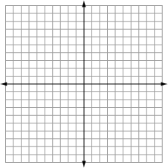 

4. (3 pts.) Solve each absolute value equation.

(a) 

(b) 

5. (4 pts.) Given  and  , evaluate the following. **Simplify the result**.

a) Find.

b) 

c) 

6. (4 pts.) State the domain of each function.

a)  b)  c) 

D:_______________ D: ______________ D: _____________

7. (5 pts.) Solve each absolute value inequality. Graph your solution on a number line.

a) 

b) 

c) 

8. (7 pts.) Factor each expression completely. If the expression does not factor, indicate that it is *prime*.

a)  d) 

b)  e) 

c)  f) 

9. (5 pts.) Solve for all values of x:

a)  b)  c) 

10. (4 pts.) Suppose that a flare is launched upward with an initial velocity of 16 ft/sec from a height of 96 ft. Its height in feet, after ***t*** seconds is given by: .

You must include the units of measurement in your solutions.

a) Find the height of the object after 2 seconds.

b) How many seconds will it take the object to hit the ground? (Show your work.)

11. (2 pts.) Let. Find all values of ‘***x***‘ such that .

12. (1 pt.) Circle the expression that is simplified.   

13. (2 pts.) Write the function for each graph in the space provided. Use proper notation.

a) ___________________ b) _____________________

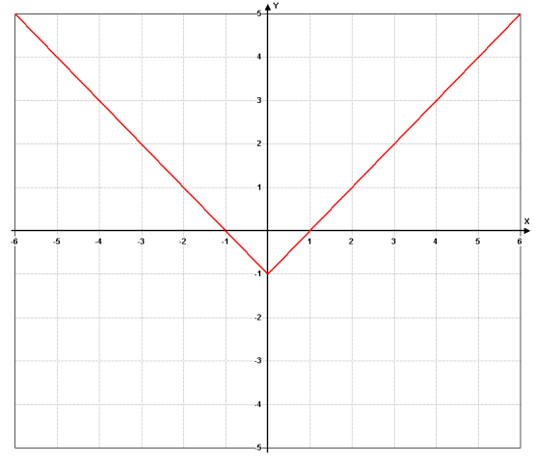 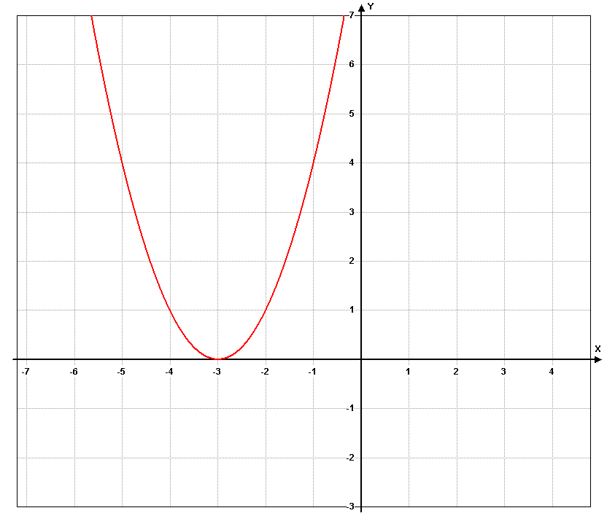

14. (3 pts.) Answer each True/False question. Circle **T** for true or circle **F** for false.

a) T F The inequality  has no solution.

b) T F The point  is a solution to .

c) T F .

15. (3 pts.) Perform the operation and reduce the result:



16. (2 pts.) Reduce the complex fraction:



17. (4 pts.) Find the quotient by long division and synthetic division.



(a) Long Division (b) synthetic division

18. (2 pts) Find the quotient: 

19. (1 pt.) Show that  is a factor of .

20. (1 pt.) Circle all fractions that do **not** reduce.

    

21. (2 pts.) Graph the function using the methods taught in class. (one square = one unit)





22. (6 pts.) Write the function for each graph. (Use function notation.)

a) ___________________ b) _________________ c) __________________

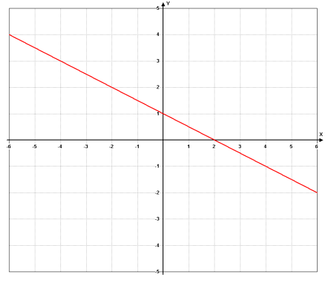 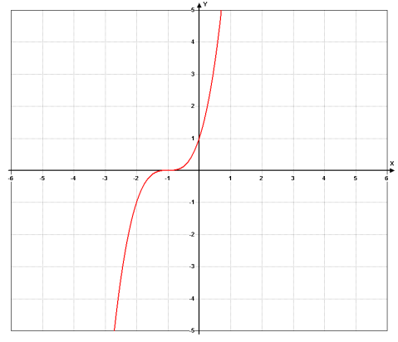 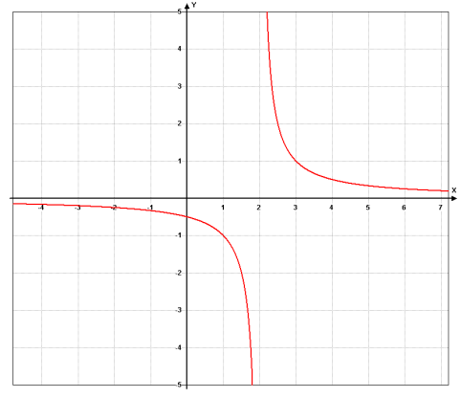

d) ___________________ e) _________________ f) __________________

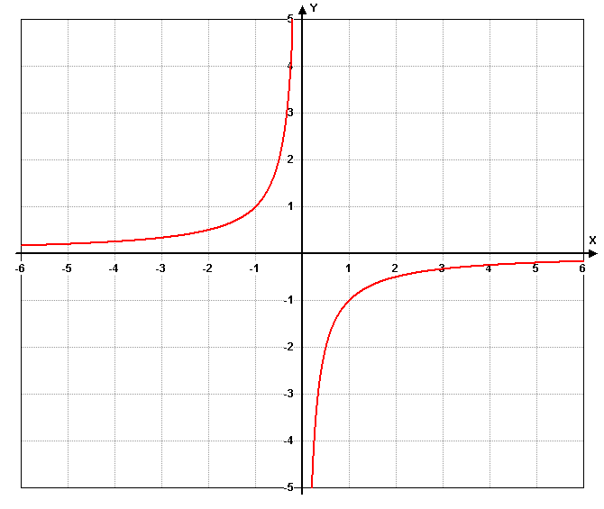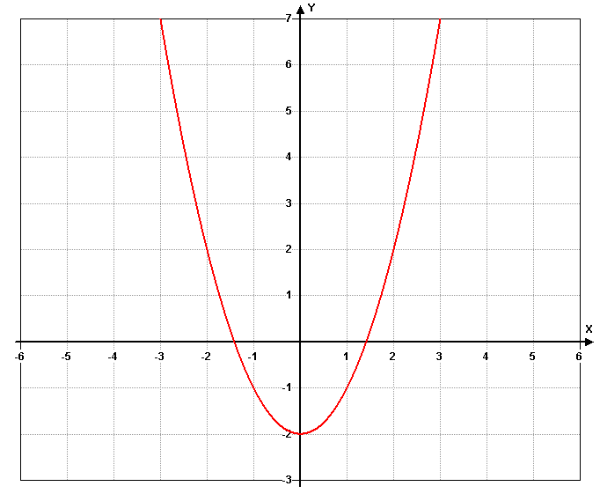 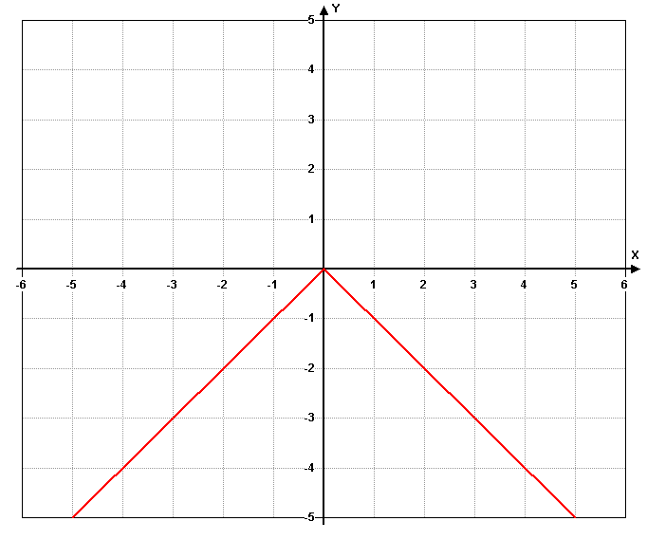

23. (4 pts.) Given the function , evaluate and reduce each of the following.

a) 

b) 

(set up and reduce)

24. (5 pts.) Given the following functions, answer each question. Reduce all expressions.

 

a) State the domain of g(x).

d) Find 

25. (3 pts.) Answer each of the following.

a) List a function with the domain of all Real numbers.

b) The rational function for this chapter has boundary lines. What are these called?

c) The work for a synthetic division is shown.

Write the division problem and the quotient for this problem.



______________________ _______________ = ____________________________