Goals:
- Multiplication as repeated addition and properties of multiplication
  - Commutative Property of Multiplication
  - Associative Property of Multiplication
  - Multiplication by 1 and by 0
- The multiplication algorithm and alternate methods
  - Japanese line method, using the distributive property, mental tricks, Napier’s bones, lattice (box method)
- Division of Whole numbers
  - Definitions (dividend, divisor, quotient) Meaning (repeated subtraction)
  - Is division commutative, associative?
  - Dividing by 0
- The division algorithm and other methods (partial quotients)

Multiplication as repeated addition and properties of multiplication
Symbols we use: $×, ∙ , ( )( )$
Examples: $3×2, 3∙2 , (3)(2)$

Def: A factor is a number and or variables that are being multiplied.
Def: A product is the result from a multiplication, or
an expression that identifies factors to be multiplied.

In the example $3×2=6$
$3×2$ is a product, that product is 6, but the 3 & 2 are called factors. So 3 & 2 are factors of 6.

How would you count chairs in a room, by adding or by multiplying?

We use multiplication in place of repeated addition because it is the same thing!

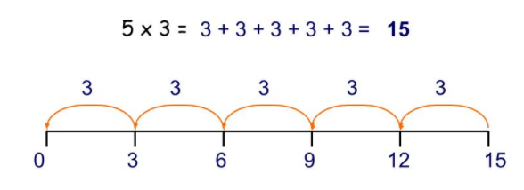

Properties of Multiplication
The Commutative Property of Multiplication states that the ORDER in which you multiply does not matter.
Or
If $a,b$are numbers,
Then
$$a∙b=b∙a$$

Example: $3∙2=2∙3$ or $\begin{matrix} & \\ & \\ & \end{matrix}=\begin{matrix} & & \\ & & \end{matrix}$ no matter how you order the desks, it’s the same number of them.

The associative property of multiplication states that the way you GROUP your factors does not change the product.
Or
If $a,b,c$are numbers,
Then
$$a∙(b∙c)=(a∙b)∙c$$

Example: $$2∙(3∙4)=(2∙3)∙4$$
Two sets of 12 is the same as six sets of 4.

Multiplying by 1: leaves the number unchanged
$$1∙5=one set of 5=5$$

Multiplying by 0: the product is always 0.
$$0∙5=no sets of 5=(nothing, i.e). 0$$

The Distributive property of multiplication (over addition) (the ideas is to fairly share with everyone)
Pass out the operation of multiplication evenly through the entire parenthesis.

If $a,b,c$are numbers, and $a∙(b+c)$
Then
$$a∙\left(b+c\right)=a∙b+a∙c$$

The multiplication algorithm and alternate methods

27 why do we do it like this, where does the 4 come from and why does it go above the 2?
x6

$$27 x 6 = \left(20+7\right)∙6=$$

Or $$27 x 6 = \left(30-3\right)∙6=$$

Or $$27 x 6 = \left(10+10+7\right)∙6=$$

So many ways to do it!

Mental math, try the homework problems in your head without writing anything or very much down (and don’t use the same old method we were taught in grade school)

Japanese Line Method

$3∙2$ $13∙12$

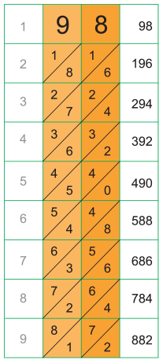
Napier’s Bones (see Handout)

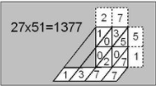
Lattice Method 1 2
See handout in note packet
1

3

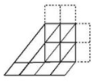
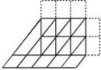

Division of Whole numbers
$Type equation here.$What is division?
$24÷6=4$ $\frac{24}{6}=4$ How many 6’s are there in 24?
24 is called the divisor (the number being divided)
6 is called the dividend (the number doing the dividing)
4 is called the quotient (the result of the division process)

Repeated Subtraction
Opposite of multiplication
Is it commutative, associative?
How do we check it?

Dividing by 0

The division algorithm and other methods (partial quotients)
How do we do it?
Standard method Method of partial quotients (works great if you need to essentially guess the correct answer)

128$÷8$ $108÷12$

