Goals:
- Multiplication as repeated addition and properties of multiplication
  - Commutative Property of Multiplication
  - Associative Property of Multiplication
  - Multiplication by 1 and by 0
- The multiplication algorithm and alternate methods
  - Japanese line method, using the distributive property, mental tricks, Napier’s bones, lattice (box method)
- Division of Whole numbers
  - Definitions (dividend, divisor, quotient) Meaning (repeated subtraction)
  - Is division commutative, associative?
  - Dividing by 0
- The division algorithm and other methods (partial quotients)

Multiplication as repeated addition and properties of multiplication
Symbols we use: $×, ∙ , ( )( )$
Examples: $3×2, 3∙2 , (3)(2)$

Def: A factor is a number and or variables that are being multiplied.
Def: A product is the result from a multiplication, or
an expression that identifies factors to be multiplied.

In the example $3×2=6$
$3×2$ is a product, that product is 6, but the 3 & 2 are called factors. So 3 & 2 are factors of 6.

How would you count chairs in a room, by adding or by multiplying?

We use multiplication in place of repeated addition because it is the same thing!

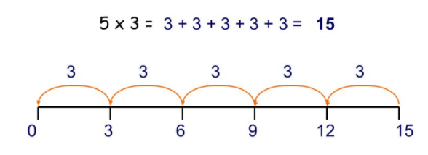

Properties of Multiplication
The Commutative Property of Multiplication states that the ORDER in which you multiply does not matter.
Or
If $a,b$are numbers,
Then
$$a∙b=b∙a$$

Example: $3∙2=2∙3$ or $\begin{matrix} & \\ & \\ & \end{matrix}=\begin{matrix} & & \\ & & \end{matrix}$ no matter how you order the desks, it’s the same number of them.

The associative property of multiplication states that the way you GROUP your factors does not change the product.
Or
If $a,b,c$are numbers,
Then
$$a∙(b∙c)=(a∙b)∙c$$

Example: $$2∙(3∙4)=(2∙3)∙4$$
Two sets of 12 is the same as six sets of 4.

Multiplying by 1: leaves the number unchanged
$$1∙5=one set of 5=5$$

Multiplying by 0: the product is always 0.
$$0∙5=no sets of 5=(nothing, i.e). 0$$

The Distributive property of multiplication (over addition) (the ideas is to fairly share with everyone)
Pass out the operation of multiplication evenly through the entire parenthesis.

If $a,b,c$are numbers, and $a∙(b+c)$
Then
$$a∙\left(b+c\right)=a∙b+a∙c$$

The multiplication algorithm and alternate methods

27 why do we do it like this, where does the 4 come from and why does it go above the 2?
x6

The goal of these examples is to use the distributive property to help you to do two digit multiplication easier in your head.

Example: Use the distributive property to find the following products.

$$27 x 6 = \left(20+7\right)∙6=$$

Or $$27 x 6 = \left(30-3\right)∙6=$$

Or $$27 x 6 = \left(10+10+7\right)∙6=$$

So many ways to do it!

Mental math, try the homework problems in your head without writing anything or very much down (and don’t use the same old method we were taught in grade school)

Japanese Line Method
We can use lines to help us represent multiplication. Watch these videos to see a demonstration.
Link to multiplication using lines. 1st video, 2nd Video, 3rd video, 4th Video
Example of 11x12 using the line method
The vertical orange lines separate place value.
Count the intersection points on each side of the orange lines:
The resulting number is the product!

Try these examples below.

$3∙2$ $13∙12$

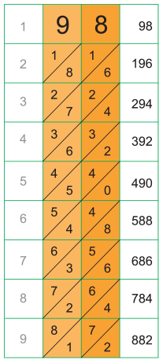
Napier’s Bones (see Handout)
Around 1614 Scottish Mathematician invented an early “calculator” for performing
Single digit multiplication on any multi digit number. It reduced multiplication
down to a series of simple addition problems, where numbers in the same diagonal
add to make the digit in the answer.
See the following links for how to use Napier’s bones:
Napier's Bones, 1st Video, 2nd Video, 2. lattice method video
- Link to Napier's Bones Wolfram Demonstrations CDF

Lattice Method
This is a slight modification of Napier’s Bones. It is like two stacked Napier’s bones multiplication which can be used to perform multi-digit multiplication on other multi-digit numbers.
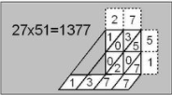
Also, watch this video demonstrating the method:

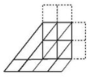
Example: use the tables below to find 32x26 and 214 x 32
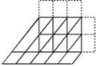

Division of Whole numbers
$Type equation here.$What is division?
$24÷6=4$ $\frac{24}{6}=4$ How many 6’s are there in 24?
24 is called the dividend (the number being divided)
6 is called the divisor (the number doing the dividing)
4 is called the quotient (the result of the division process)

How is can division be thought of as Repeated Subtraction, show an example:

How can division be thought of as the opposite of multiplication, show and example:

How do we check if a division problem is correct?

Is division commutative Yes/ No, Is division associative Yes/No? Give an example of each justifying your answers.

Can you divide by 0?
Explain why you can or cannot divide by 0:

The division algorithm and other methods (partial quotients)
How do we do it? Method of partial quotients (works great if you
Standard method need to essentially guess the correct answer)

Watch this video on the method of partial
Quotients: video1, video2

Do the below division problem using Use partial quotients to perform this division:
Standard long division.
$128÷8$ $108÷12$

