**Name: \_\_\_\_\_\_\_\_\_\_\_\_\_\_\_\_\_\_\_\_\_\_**

**Instructor: \_\_\_\_\_\_\_\_\_\_\_\_\_\_\_\_\_\_\_**

**Term: \_\_\_\_\_\_\_\_\_\_\_\_\_\_**

* General Guidelines and Grading
  + Throughout the semester there will key concepts that will be included in this notebook. A table of contents with page numbers will be kept and updated in class. The notebook will be scored on a 100 point basis.
  + Notebooks will be graded COMPETITIVELY(see note below) based on the following

1. Quality
2. Accuracy
3. Organization
4. Neatness
5. Completeness

Note: Competitively implies those notebooks following the five criteria above “best” will receive the highest scores.

* + The notebook will be checked at various points during the semester. Points will be awarded each time the notebook is checked. These dates will be announced in class.
  + You will have a chance to correct and alter your notebook and resubmit it for a final time. It will be graded one last time based on correctness, neatness, and usability for future classes.
    - This notebook should be your BEST work. As a general guideline anyone in a Trigonometry course (or beyond) should to be able to read and understand your material.
    - The notebook will at this point be graded on a competitive scale.
    - If you choose to redo any pages of the notebook (recommended) please include the graded page in front of EACH corrected page so that I can view your old work and your revised work on a page by page basis. Otherwise just include the non-corrected page.
    - Only exceptionally correct, useable, and visually impressive notebooks will receive full credit.

Table of Contents Name: \_\_\_\_\_\_\_\_\_\_\_\_\_\_\_\_\_\_\_\_\_ Final Score:\_\_\_\_

|  |  |  |  |  |  |
| --- | --- | --- | --- | --- | --- |
|  | **Topic** | **Page** | **Due Date** | **Score** | **Ready for final submission** |
| A | [Define sine and cosine](#Define) | 3 |  |  |  |
| B | [Define tangent, cotangent, secant, cosecant using sine, cosine](#define_tangent) | 3 |  |  |  |
| C | [Trigonometric Table](#trig_table) | 4 |  |  |  |
| D | [Sign for each trig function’s value](#signs_of_functions) | 5 |  |  |  |
| E | [Doman and range of functions](#dom_rg_of_fxns) | 5 |  |  |  |
| F | [Inverse Trig Function Restrictions](#inv_trig_restrictions) | 5 |  |  |  |
| G | [Unit circle](#Unit_circle) | 6 |  |  |  |
| H | [Graph y=sin x and y = csc x on same set of axes over interval [-2π, 2π]](#Graph_sin_CSC). | 7 |  |  |  |
| I | [Graph y = cos x and y = sec x on same set of axes over interval [-2π, 2π]](#Graph_COS_SEC). | 7 |  |  |  |
| J | [Graph y = tan x & y = cot x over interval [-2π, 2π]](#Graph_Tan). | 8 |  |  |  |
| K | [Graph y = cos(4x) and on same set of axes over at least one period for each function](#Graph_COs4x). | 9 |  |  |  |
| L | [Graph over at least one period. Give domain and range](#Graph_sin23x). | 10 |  |  |  |
| M | [Graph  and on same set of axes over at least one period](#Graph_3sin2x). | 10 |  |  |  |
| N | [Prove Difference Identity for Cosine. Include sketch](#Prove_diff_id_cos). | 11 |  |  |  |
| O | [Prove remaining sum and difference identities for Cosine, Sine and Tangent](#Prove_remaining_id) | 12 |  |  |  |
| P | [Write identities](#write_each_id) | 13 |  |  |  |
| Q | [Prove Fundamental Identities (quotient, Pythagorean, negative angle)](#Prove_fund_id) | 14 |  |  |  |
| R | [Prove law of sines and cosines](#Prove_law_sin_cos) | 15 |  |  |  |
| S | [Graph y = tan-1(x)](#_Graph_y_=_1) | 16 |  |  |  |
| T | [Graph y = sec-1(x)](#_Graph_y_=) | 17 |  |  |  |
| U | [Graph remaining inverse trig functions](#graph_remain_4_inv_trig). | 18 |  |  |  |

**[Define sine and cosine](#TOC)**. Label triangle below using $θ$, x, y and r. Be sure to indicate if it is a right triangle.

**[Define tangent, cotangent, secant, cosecant using sine, cosine](#TOC)**, as well as by using the terms “opposite”, “adjacent”, “hypotenuse”, and thirdly, as well as in terms of $θ, x, y$ and $r$ as referenced above.

**[Trigonometric Table](#TOC)**

Complete the Trigonometric Table.

|  |  |  |  |  |  |  |  |  |  |
| --- | --- | --- | --- | --- | --- | --- | --- | --- | --- |
| Deg | Ref | Quadrant | Radians | cos θ | sin θ | tan θ | sec θ | csc θ | cot θ |
| -90 |  |  |  |  |  |  |  |  |  |
| -60 |  |  |  |  |  |  |  |  |  |
| -45 |  |  |  |  |  |  |  |  |  |
| -30 |  |  |  |  |  |  |  |  |  |
| 0 | 0 |  | 0 | 0 | 1 |  |  |  | 0 |
| 30 | 30 |  |  |  |  |  |  |  |  |
| 45 | 45 |  |  |  |  |  |  |  |  |
| 60 | 60 |  |  |  |  |  |  |  |  |
| 90 | 90 |  |  |  |  |  |  |  |  |
| 120 | 60 |  |  |  |  |  |  |  |  |
| 135 | 45 |  |  |  |  |  |  |  |  |
| 150 | 30 |  |  |  |  |  |  |  |  |
| 180 | 0 |  |  |  |  |  |  |  |  |
| 210 | 30 |  |  |  |  |  |  |  |  |
| 225 | 45 |  |  |  |  |  |  |  |  |
| 240 | 60 |  |  |  |  |  |  |  |  |
| 270 | 90 |  |  |  |  |  |  |  |  |
| 300 | 60 |  |  |  |  |  |  |  |  |
| 315 | 45 |  |  |  |  |  |  |  |  |
| 330 | 30 |  |  |  |  |  |  |  |  |
| 360 | 0 |  |  |  |  |  |  |  |  |

# Signs of Functions

# Fill in the [**sign for each trig function’s value**](#TOC)**:**

|  |  |  |  |  |  |  |  |  |
| --- | --- | --- | --- | --- | --- | --- | --- | --- |
| Quadrant | X axis (adj side) | Y axis (opp side) | $$Sin(θ)$$ | $$Csc(θ)$$ | $$Cos(θ)$$ | $$Sec(θ)$$ | $$Tan(θ)$$ | $$Cot(θ)$$ |
| 1 | + | + |  |  |  |  |  |  |
| 2 | - | + |  |  |  |  |  |  |
| 3 | - | - |  |  |  |  |  |  |
| 4 | + | - |  |  |  |  |  |  |

# **[Domains and ranges of functions](#TOC)**

Fill in each blank

|  |  |  |
| --- | --- | --- |
| Function | Domain | Range |
|  |  |  |
|  |  |  |
|  |  |  |
|  |  |  |
|  |  |  |
|  |  |  |
|  |  |  |
|  |  |  |
|  |  |  |

## **[Inverse Trig Function Restrictions](#TOC)**

Fill in restrictions ***on the domain of each*** of the listed ***functions*** so that the inverse of each will itself be a function. Then fill in the corresponding range for each.

|  |  |  |  |  |  |  |
| --- | --- | --- | --- | --- | --- | --- |
|  |  |  |  |  |  |  |
| Domain |  |  |  |  |  |  |
| Range |  |  |  |  |  |  |

## **[Unit Circle](#TOC).**

For each ‘key’ point on the unit circle, include the degrees, radians, and coordinates of the associated points.

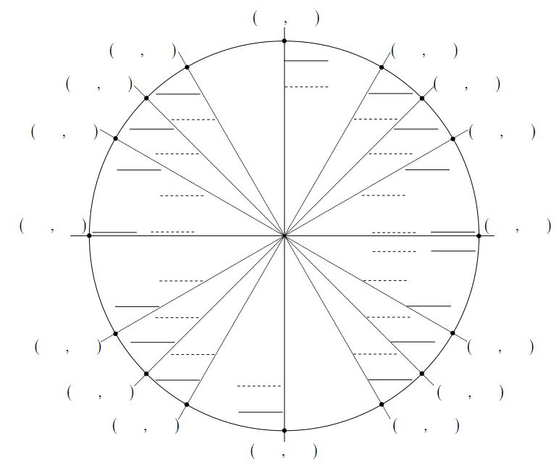

**[Graph $y = sin x$ and $y = csc x$ on same graph over interval [-2π, 2π].](#TOC)** Choose appropriate scale and label. Give the domain and range of each function. Show asymptotes for the $y = csc x$ graph.

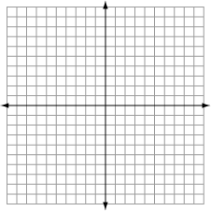

**[Graph y = cos x and y = sec x on same graph over interval [-2π, 2π]](#TOC)**. Choose appropriate scale and label. Give the domain and range of each function. Show asymptotes for the y = sec x graph.



**[Graph y = tan x over at least 2 periods](#TOC)**. Choose appropriate scale and label. Give the domain and range. Show asymptotes.



**[Graph y = cot x over at least 2 periods](#TOC)**. Choose appropriate scale and label. Give the domain and range. Show asymptotes.



**[Graph y = cos(4x) and](#TOC) $y=-3+cos⁡(4x+π)$**  on same set of axes over at least one period for each function.

## graph_paper_1up**[Graph over at least one period](#TOC). Give domain and range.**



****[**Graph  and on same set of axes over at least one period**](#TOC)**.** Show asymptotes for the cosecant graph.

**[Prove the difference identity for cosine](#TOC).**

Prove: . Include all necessary figures in your sketch below.

## **[Prove the remaining sum and difference identities for sine, cosine, and tangent](#TOC).**

1. 
2. 
3. 
4. 
5. 

**[Write in each identity](#TOC)**.

|  |  |  |  |  |  |  |
| --- | --- | --- | --- | --- | --- | --- |
| Pythagorean Identities | | Quotient Identities | | Reciprocal Identities | | |
| $$Sin^{2}θ+Cos^{2}θ=$$ | | Tan θ = Sin θ/ Cos θ | | $$Sinθ=$$ | | $$Cscθ=$$ |
| $$Tan^{2}θ+1=$$ | | Cot θ = Cos θ/ Sin θ | | $$Cosθ=$$ | | $$Secθ=$$ |
| $$1+ Cot^{2}θ=$$ | |  | | $$Tanθ=$$ | | $$Cotθ=$$ |
| Reflective Identities | | | Negative Angle Identities | | | |
|  |  | |  | |  | |
|  |  | |  | |  | |
|  |  | |  | |  | |

|  |  |  |  |
| --- | --- | --- | --- |
| Co-function Identities | | | Angle Sum/ Difference Identities |
| $$Sin\left(π/2-θ\right)=$$ | $$Cos\left(π/2-θ\right)=$$ | | $$Sin\left(α±β\right)=$$ |
| $$Csc\left(π/2-θ\right)=$$ | $$Sec\left(π/2-θ\right)=$$ | | $$Cos\left( α±β\right)=$$ |
| $$Tan\left(π/2-θ\right)=$$ | $$Cot\left(π/2-θ\right)=$$ | | $$Tan\left(α±β\right)=$$ |
| Double Angle Identities | | Power Reducing Identities | Half Angle Identities |
|  | |  |  |
|  | |  |  |
|  | |  |  |
|  | |  |  |
|  | |  |  |

[**Prove these Fundamental Identities**](#TOC).



$Tanθ= \frac{Sinθ}{Cosθ}$

${Sin}^{2}{θ}+ {Cos}^{2}{θ}=1$

${Sec}^{2}{θ}= {Tan}^{2}{θ}+1$

Negative angle identities (show sketch to right)

**[Derive/Prove the laws of sines and cosines](#TOC)**. (Include the related diagram.)

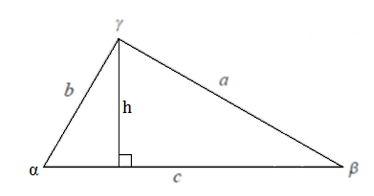 Prove only one law of cosines but list all three.)

## **[Graph y = tan](#TOC)[-1](#TOC)[(x)](#TOC):**

Give the domain and range of y = tan-1(x). Hint: Refer to y = tan x.

Domain: \_\_\_\_\_\_\_\_\_\_\_\_\_\_ Range: \_\_\_\_\_\_\_\_\_\_\_\_\_\_

Graph $y=\tan^{-1}{(x)}$ as follows. Label “y” axis in radians.

1. Fill out table 1 below
2. Fill out table 2 below by filling in the corresponding points for $y=\tan^{-1}{(x)}$
3. Plot the corresponding points and graph $y=\tan^{-1}{(x)},$ show asymptote(s) & label the points.

Table 1. Table 2.

|  |  |
| --- | --- |
|  |  |
|  |  |
|  |  |
|  |  |
|  |  |
|  |  |
|  |  |
|  |  |
|  |  |
|  |  |

|  |  |
| --- | --- |
|  |  |
|  |  |
|  |  |
|  |  |
|  |  |
|  |  |
|  |  |
|  |  |
|  |  |
|  |  |

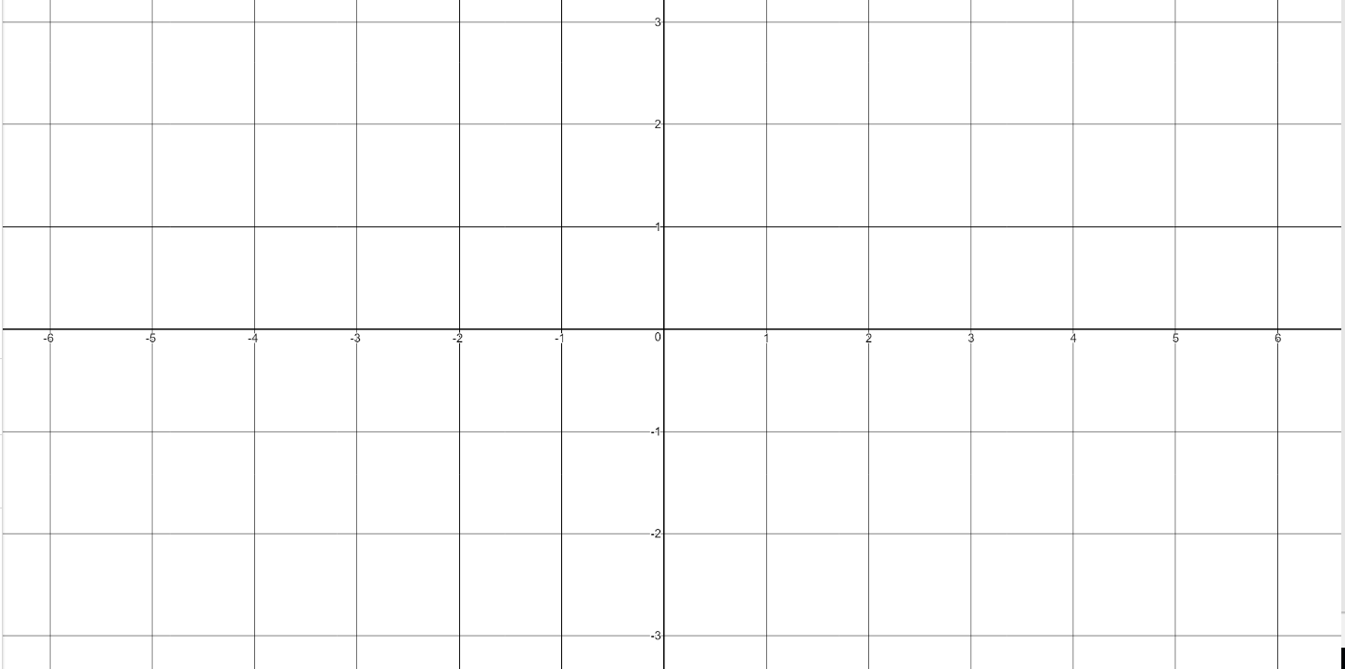

## **[Graph y = sec](#TOC)[-1](#TOC)[(x)](#TOC):**

Give the domain and range of y = sec-1(x). Hint: Refer to y = sec x.

Domain: \_\_\_\_\_\_\_\_\_\_\_\_\_\_\_\_\_\_\_\_\_\_ Range: \_\_\_\_\_\_\_\_\_\_\_\_\_\_\_\_\_\_\_\_

Graph $y =\sec^{-1}{(x)}$ (arcsec(x)) as follows. Label “y” axis in radians.

1. Fill out table 1 below
2. Fill out table 2 below by filling in the corresponding points for $y=arcsec(x)$
3. Plot the corresponding points and graph $y=\sec^{-1}{(x)}, s$ how asymptote(s) & label the points.

Table 1. Table 2.

|  |  |
| --- | --- |
|  |  |
|  |  |
|  |  |
|  |  |
|  |  |
|  |  |
|  |  |
|  |  |
|  |  |
|  |  |

|  |  |
| --- | --- |
|  |  |
|  |  |
|  |  |
|  |  |
|  |  |
|  |  |
|  |  |
|  |  |
|  |  |
|  |  |

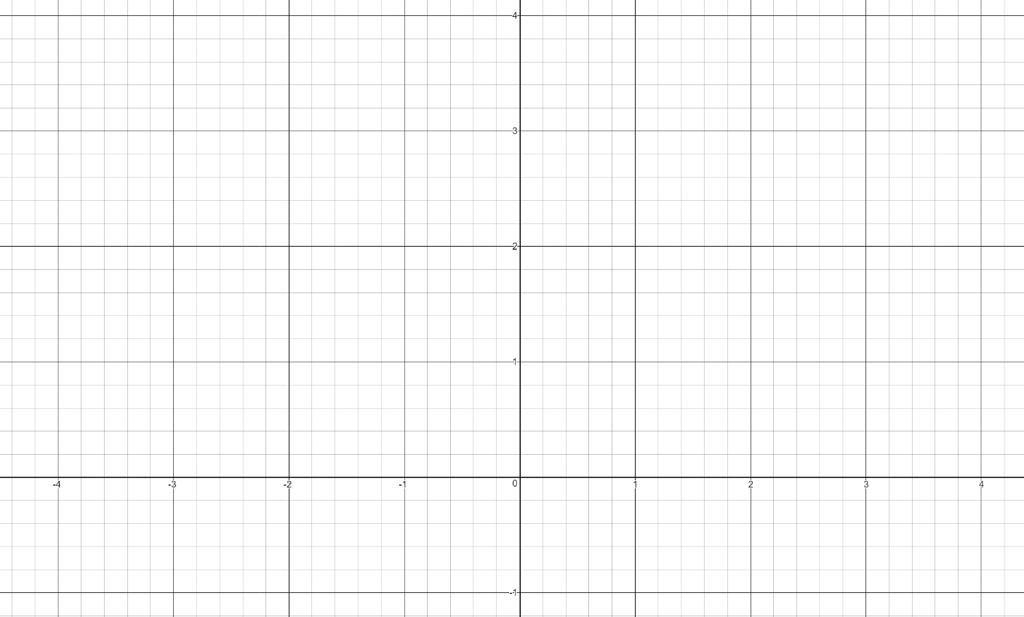

**[Graph the remaining 4 inverse trig functions](#TOC)**. Show any asymptotes. Scale axes. Label points. Give domain and range of each.



|  |  |  |  |  |
| --- | --- | --- | --- | --- |
| $$Sin^{-1}θ$$ | |  | $$Cos^{-1}θ$$ | |
| Domain: | Range: | Domain: $\left[-1, 1\right]$ | Range: $\left[0,π \right]$ |
| $$Csc^{-1}θ$$ | | $$Cot^{-1}θ$$ | |
| Domain: | Range: | Domain | Range: |

