**Math 400** Review of Previous Material: __________________________

This problem set is a good representation of some of the key skills you should have when entering this course.

Based on the course work leading up to Calculus, you should be able to make significant contributions to each of the problems. With limited review, you should be able to answer virtually all of the problems given. Use this document to help identify areas of weakness you might have and also to guide you in how to better prepare for the course.

Do not use calculators.

Here are some recommended resources:

Calculus and Pre-Calculus textbooks.

Notes and assignments from your previous courses.

Khan Academy (online resource): <https://www.khanacademy.org>

Desmos (online graphing utility): <https://www.desmos.com/>

Visual Calculus (has Pre-Calculus too): <http://archives.math.utk.edu/visual.calculus/>

YouTube: you know the address ☺ Searching may take time but there is a lot available.

1) **Key Vocabulary:** These are terms that you should be able to define. You should also be able to provide examples of each of these on graphs.

Function: Odd/Even functions:

One – to – one: Maximum/Minimum:

Intercepts: Increasing/Decreasing:

Roots or Zeros: Inverse of a Function:

2) Write the function for each graph: If the graph is exponential or logarithmic, base ‘***e***’ must be used.

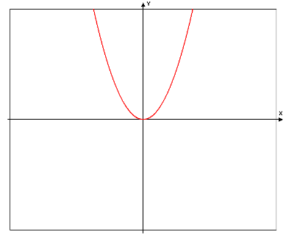 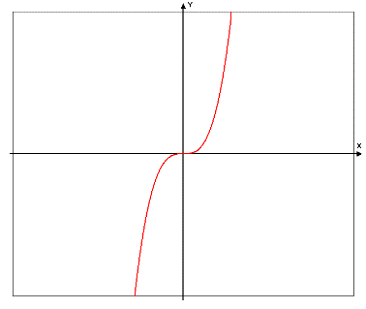 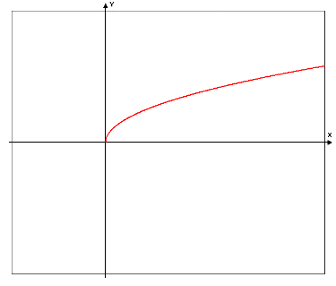 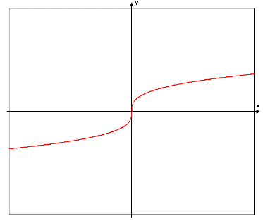

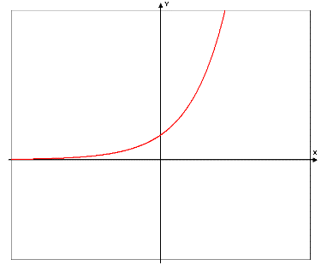 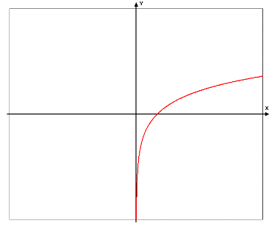 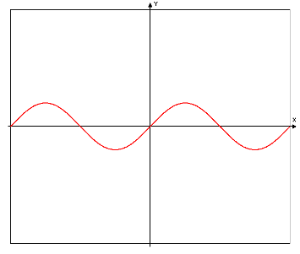 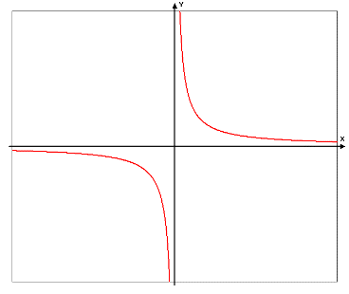

3) Circle each even function and put a *box around each odd* function:

    

   

   

4) Below, a partial function graph is given. You will need to complete the graph so that it is an even function in the first grid and an odd function in the second grid.

Finish the ‘even’ function. Finish the ‘odd’ function.

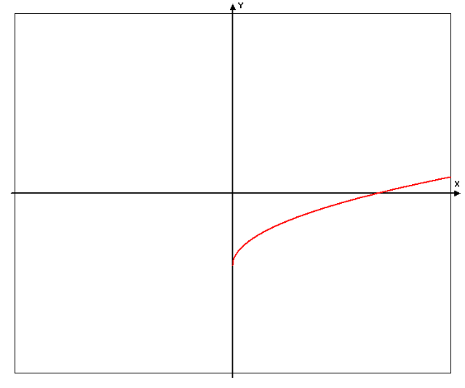 

5) Sketch each graph on the grids provided. For all trigonometric functions, label the scale on both the *x* and *y* axis.

  

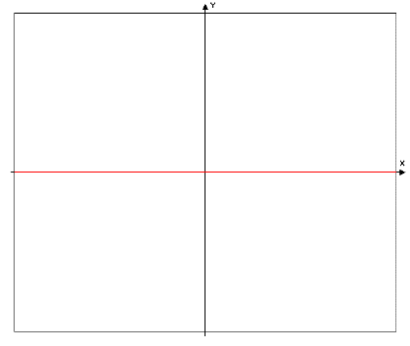  

  

  

  

  

  

  

5) continued

  

  

  

  

  ***or***  

Greatest Integer function

  

  

  

6) Graph each piecewise function.

 

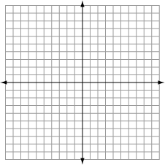 

7) Sketch the Inverse of the given function on the same graph.

Also, sketch the line of reflection for the inverses.

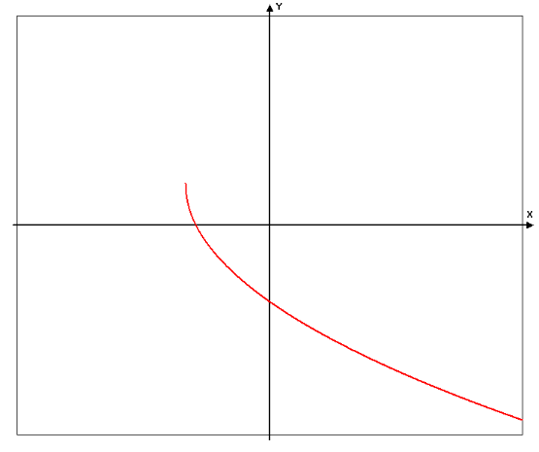

8) Write each of the following expressions in the form  where ‘*p*’ is a real number.

Examples:        

 = =

= = =

= = =

9) Given the list of functions, answer the following. Use interval notation for the domain and range problems.

  

Domain of *f*. Range of *f*.

Domain of *g*. Range of *g*.

Domain of *h*. Range of *h*.

 



Evaluate and simplify



Evaluate and simplify

10) Let  represent a function. For each of the following, describe the transformation to the graph.

Example:  The graph of the function is translated *3 units to the left*.

 _______________________________________

 _______________________________________

 _______________________________________

 _______________________________________

10) (continued)

 _______________________________________

 _______________________________________

 _______________________________________

11) Evaluate each expression. The solutions should not involve logarithmic expressions.

= =

= 

= 

 = 

12) Solve each equation for x such that there are no logarithms in your final answer.

  

13) List the domain and range for each function. (Use interval notation.)

 

D: D:

R: R:

14) Answer each true/false question. (Circle T for true or F for false.) If false, rewrite the right had side to make it a true statement.

T F  T F 

T F  T F 

T F 

15) Solve each equation. Use natural logarithms (*ln*) only. Give exact answers (no calculators).

  

16) Evaluate each trigonometric function. Solutions should be exact (no calculator). You are expected to be able to evaluate these without any help items.

   

   

   

  

  

17) Evaluate each of the given trigonometric expression using the given information and an appropriate trigonometric identity.

If  and is in Quadrant I, evaluate:

 

 

 

18) Expand each sum. The first 4 terms and the last term must be shown. *Do Not Simplify*. See the example.

Example:  = 





19) Write the sum using sigma notation.

11(1) + 11(2) + 11(3) + …+11(291) = 

 =

 =

20) For each algebra expression, rewrite it as a single fraction in reduced form with no negative numerical exponents and no complex fractions.





