Def A ______________ from a set D to a set Y is a rule that assigns an element$x ϵ D$ to some element $f\left(x\right) ϵ Y$.
The only rules are that they need to be 1. Reflexive, 2. Symmetric, and 3. Transitive.

A function is a relation that has more rules imposed upon it.

Def A ______________________ from a set D to a set Y is a rule that assigns a unique (single) element $f\left(x\right) ϵ Y$ to each element $x ϵ D$. The set D of all possible input values is called the ______________. The set containing all output values $\left(\left\{f\left(x\right)\left|x ϵ D\right.\right\}\right)$ is called the ______________. A function is called ____________________ if its range consists of only real numbers. A function is of a _____________ if its domain consists of only real numbers.

The test for a function is the Vertical Line test. Why does this work?

For one point circle the correct T or F. For the rest of the points state why it is.
T/F All relations are functions.

Ex 1 Find the domain and range of each function.
- $p\left(x\right)=x^{2}$
- $q\left(x\right)=x^{2}:x>-2$
- $r\left(x\right)=\sqrt{x-1}$
- $f\left(x\right)=1-\sqrt{x}$
- $g\left(x\right)=\frac{π}{x^{2}-4}$

Ex 2 evaluate the function from c and e in the previous example at $x=(∆x+x)$

Def An ____________ function is any function that is not solved exclusively for y.

Def An _____________ function is any function that is solved exclusively for y.

Def A _______________________ is a function $f(x)$ defined piecewise, that is $f(x)$ is defined by different expression on various intervals.
Ex:
$$f\left(x\right)=\left\{\begin{aligned}-x, &x<0 \\ x, &x≥0\end{aligned}\right.$$
Create your own example:

Ex3: Create a linear function which has both a positive and negative slope and is not defined on $\left[0,1\right]$

Ex 4 Find a formula for each graph.
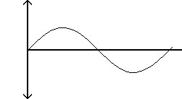
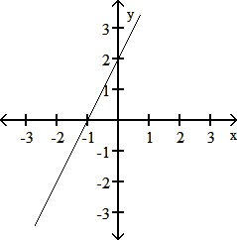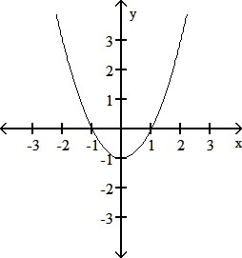
$$(2π,0)$$

______________________ ___________________________ _________________________________

Transformations of Function (rigid and non-rigid)

A transformation is the process of taking one equation or graph and performing some operation on it. The effect this has is called a transformation. Some of the possible effects can be classified as Rigid and Non-rigid.

Rigid Transformations are transformations where the graph shape remains untouched, only its position is changed. Pin the tail on the donkey is an example of a rigid transformation of the donkeys tail.

Non-rigid transformations are transformations where the actual shape of the graph is warped, stretched, or simply changed (through composition or some algebraic operation).

Shift, Scaling, and Reflecting Formulas

Rigid transformations are the following:
$y=f\left(x\right)+k$ Shifts the graph of $f$ ________ $k$ units if $k>0$
Shifts the graph of $f$ ________ $\left|k\right|$ units if $k<0$

$y=f(x+h)$ Shifts the graph of $f$ _________ $h$ units if $h>0$
Shifts the graph of $f$ _________ $\left|h\right|$ units if $h<0$
$y=-f(x)$ Reflects the graph of $f$ across the ___-axis
$y=f(-x)$ Reflects the graph of $f$ across the ___-axis

Non-rigid transformations are the following:
For $c>1$,

$y=cf(x)$ ____________ the graph of $f$ _____________ by a factor of $c$
$y=\frac{1}{c}f(x)$ ____________ the graph of $f$ _____________ by a factor of $c$
$y=f(cx)$ ____________ the graph of $f$ _____________ by a factor $c$
$y=f\left(\frac{x}{c}\right)$ ____________ the graph of $f$ _____________ by a factor of $c$
For $c=-1,$ this becomes the last two rigid transformations listed above

Note: If $c<1, c≠-1$, factor -1 out and “For $c>1$” above applies.

Transformation of Trig Graphs
$$y=af\left(b\left(x+c\right)\right)+d$$
$a$ – Amplitude: vertical stretch or compression; reflection about $x$-axis if negative
$b$ – horizontal stretch or compression; reflection about $y$-axis if negative
$c$ – horizontal shift
$d$ – vertical shift

Ex 5 The accompanying figure shows the graph of $y=\left|x\right|$ shifted to four new positions. Write equations for the new graphs.

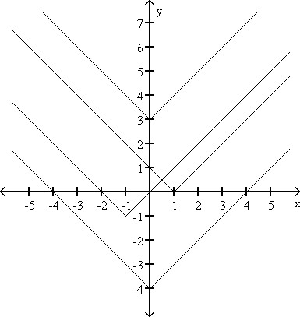
From top most vertex (a) down to lowest vertex (d)

a)______________________ c)_________________________

b)______________________ d)_________________________

Standard Equation of Circle with center $\left(h,k\right)$ Standard Equation of Ellipse with center $\left(h,k\right)$

Ex 6 Give an equation for the shifted graph. Then sketch the original and shifted graphs together.

- $x^{2}+\frac{y^{2}}{9}=1$ Down 3, right 2 Eqn: ______________________________

- $y=x^{3}$ Up 3, left 4 Eqn: ______________________________

- $y=x^{2/3}$ Down 1, left 1 Eqn: ______________________________

- $y=\frac{1}{x^{2}}$ Up 3, right 1 Eqn: ______________________________

Classifications and Combinations of Functions
(Graph them)
linear functions $f\left(x\right)=mx+b$
power functions $f\left(x\right)=x^{a}$ , where $a$ is a constant
nth root functions $f\left(x\right)=\sqrt[n]{x}$
- square root functions $f\left(x\right)=\sqrt{x}{=x}^{1/2}$
- cube functions $f\left(x\right)=\sqrt[3]{x}=x^{1/3}$
polynomial functions $p\left(x\right)=a_{n}x^{n}+a_{n-1}x^{n-1}+a_{n-2}x^{n-2}+…+a_{1}x+a_{0}$
- linear functions
- quadratic functions $f\left(x\right)=ax^{2}+bx+c, a≠0$
- cubic functions $f\left(x\right)=ax^{3}+bx^{2}+cx+d, a≠0$
rational functions $f\left(x\right)=\frac{p\left(x\right)}{q\left(x\right)} ,$ where $p\left(x\right)$ and $q(x)$ are polynomial functions and $q(x)≠0$
algebraic functions – any function constructed from polynomials using algebraic operations (such as addition, subtraction, multiplication, division, and taking roots) Note: could be multivariate (and thus polynomial, power, nth root, and rational functions are each a strict subset of algebraic functions)
trigonometric functions – sine, cosine, tangent, and their reciprocals: cosecant, secant, cotangent (see Appendix B for review)
exponential functions $f\left(x\right)=a^{x}, a>0, a≠1$
logarithmic functions $f\left(x\right)=\log_{b}{x}, b>0, b≠1$
transcendental functions – nonalgebraic function such as the trig, inverse trig, exponential, logarithmic, and hyperbolic functions.

Defn A function $y=f(x)$ is called an
even function if $f\left(-x\right)=f(x)$ (graph of $f$ is symmetric about the $y$-axis)
odd function if $f\left(-x\right)=-f(x)$ (graph of $f$ is symmetric about the origin)
for every $x$ in the function’s domain

Note: $f\left(x\right)=x^{n}$ is an even function if $n$ is even and an odd function if $n$ is odd

Ex 2 Decide whether the function is even, odd, or neither.
- $f\left(x\right)=13$

- $f\left(x\right)=x^{4}+x$

- $f\left(x\right)=-2x^{4}-x^{2}+7$

- $f\left(x\right)=\frac{x}{x^{2}-1}$

Note: Even and odd functions follow the same multiplication and division rules for +/- signs.

Algebra of Functions (Notation)
$$\left(f+g\right)\left(x\right)=f\left(x\right)+g(x)$$
$$\left(f-g\right)\left(x\right)=f\left(x\right)-g(x)$$
$$\left(fg\right)\left(x\right)=f\left(x\right)g(x)$$
$\left(\frac{f}{g}\right)\left(x\right)=\frac{f\left(x\right)}{g(x)}$, where $g(x)≠0$
$$\left(cf\right)\left(x\right)=cf(x)$$

Defn If $f$ and $g$ are functions, the composite function $f∘g$ (“$f$ composed with $g$”) is defined by
$\left(f∘g\right)\left(x\right)=f(g\left(x\right))$.
The domain of $f∘g$ consists of all the numbers $x$ in the domain of $g$ for which $g\left(x\right)$ is in the domain of $f$. In terms of sets, this is the intersection of Dom f & Dom g;
I.E. Dom $f\left(g\left(x\right)\right)=($Dom $f(x)∩$ Dom $g(x))$.

Ex 1 (# 6) If $f\left(x\right)=x-1$ and $g\left(x\right)=\frac{1}{x+1}$, find the following:
- $f\left(g\left(\frac{1}{2} \right)\right)$
- $g\left(f\left(\frac{1}{2}\right)\right)$
- $f\left(g\left(x\right)\right)$
- $g\left(f\left(x\right)\right)$
- $f\left(f\left(2\right)\right)$
- $g\left(g\left(2\right)\right)$
- $f\left(f\left(x\right)\right)$
- $g\left(g\left(x\right)\right)$

Ex 2 (#10) Let $f\left(x\right)=x-3, g\left(x\right)=\sqrt{x}, h\left(x\right)=x^{3},$ and $j\left(x\right)=2x$. Express each of the functions as a composite involving one or more of $f, g, h,$ and $j$.
- $y=2x-3$
- $y=x^{3/2}$
- $y=x^{9}$
- $y=x-6$
- $y=2\sqrt{x-3}$
- $y=\sqrt{x^{3}-3}$

