Inverse Functions
Given a function $f$, and some point on it $\left(x,y\right)$, the inverse function, written $f^{-1}$, is what you get when you switch the x and y values, so $\left(y,x\right)$ is a point on $f^{-1}.$

$f$ tells you how to get from x to y. $f^{-1}$ tells you how to get back, so it tells you how to get from y to x.

If you think of a function as a unique set of driving directions, then if $f$ tells you how to get from my house to yours, then $f^{-1}$ will be the directions that tell you how to get back. It tells you how to get from your house to mine via, the exact route taken from my house to yours only going the other direction.

Def Suppose that $f$ is a 1-1 function on a domain $D$ with range $R$.
Let $d∈D \& r∈R$.
The inverse function $f^{-1}$ is defined by $f^{-1}\left(r\right)=d$ if $r=f(d)$. The domain of $f^{-1}$ is $R$ and the range is $D$.

Def A function $f$ is ______________ on a domain $D$ if $f(x_{1})≠f(x_{2})$ whenever $x_{1}≠x_{2}$ in $D$. In other words, if we think of functions as sets of ordered pairs, each $y$-coordinate corresponds to exactly one $x$-coordinate.

Ex 1 Explain why the following functions are not 1-1.
- $f\left(x\right)=x^{2}$
- $f\left(x\right)=\cos{x}$
- $f\left(x\right)=-\left|x\right|$

Horizontal Line Test for One-to-One Functions
A function $y=f(x)$ is one-to-one if and only if its graph intersects each horizontal line at most once.

Ex 2 Prove that each function is 1-1.
- $f\left(x\right)=\sqrt{x}$
- $f\left(x\right)=2x^{3}$
Why doesn’t the same technique work for $f\left(x\right)=x^{2}$?

Note: A function need not be 1-1 in order to have an inverse. If $f$ is not 1-1, its inverse is a relation but not a function. A function from its domain onto its range needs to be 1-1 in order for its inverse relation to be a function. For our purposes, we will only speak of inverses if the original function is 1-1.

The Existence of an Inverse Function:
A function from its domain onto its range has an inverse function if and only if it is 1-1.

Warning: $f^{-1}(x)$ does NOT equal $\frac{1}{f\left(x\right)}$; that is, the -1 is NOT an exponent.

$f$ and $f^{-1}$ “undo” each other. Simple example: If we start with a number, say 13, and we add 2 then subtract 2, we arrive at where we started, namely 13. So a function that adds 2 and a function that subtracts 2 are inverses; that is $f\left(x\right)=x+2$ and $g\left(x\right)=x-2$ are inverses.

One way to tell if two functions are inverses is if they do in fact undo each other. The way to test this is to compose them to see if you do one then do the other, you get back to where you started.
i.e. put x into $f,$then put this result $f(x)$ into $f^{-1}$ to see if it will undo it.

Ex: $Let f\left(x\right)=x+2$ and $g\left(x\right)=x-2$ be inverses. Prove that they are inverses by composing them.
Alternate Definition for inverse functions:
A function $f(x)$ is the inverse function of the function $f^{-1}$ if

- $\left(f^{-1}∘f\right)\left(x\right)=x$ for all $x$ in the domain of $f$
And
- $\left(f∘f^{-1}\right)\left(x\right)=x$ for all $y$ in the domain of $f^{-1}$

Since $f^{-1}$ switches the x and y variables, the graph of $f^{-1}$ will look like that of $f$, but with all the values of x & y in the solution points being switched. What this will end up looking like is a reflection across the line $y=x$.

Therefore, the graphs of $f$ and $f^{-1}$ are mirror reflections of each other across the line $y=x$. Thus, we can create the graph of $f^{-1}$ from the graph of $f$.

T/F If $(x,y)$ lies on the graph of $f$ then $(y,x)$ lies on the graph of $f^{-1}$.

Ex 3 Use symmetry with respect to the line $y=x$ to add the graph of $f^{-1}$ to the sketch. (It is not necessary to find the formula for $f^{-1}$.) Identify the domain and range of $f^{-1}$.
$$y=f\left(x\right)=\tan{x, -\frac{π}{2}<x<\frac{π}{2}}$$
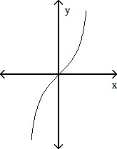

Ex 4 Find the formula for $f^{-1}$ if $f\left(x\right)=x^{2}, x≤0$.

Inverse Trigonometric Functions
If you consider trig functions to be the transcendental functions that map angles of a right triangle to the ratio of particular legs of that triangle, then
Inverse Trig functions are the transcendental functions that map the ratios of legs of a right triangle to their angles.

List the 6 trig functions and their inverses. Discuss their lack of being 1-1 and how we can restrict the domain of these functions to the inverses will be functions. List the Dom & Range of each inverse function. Pg 41.
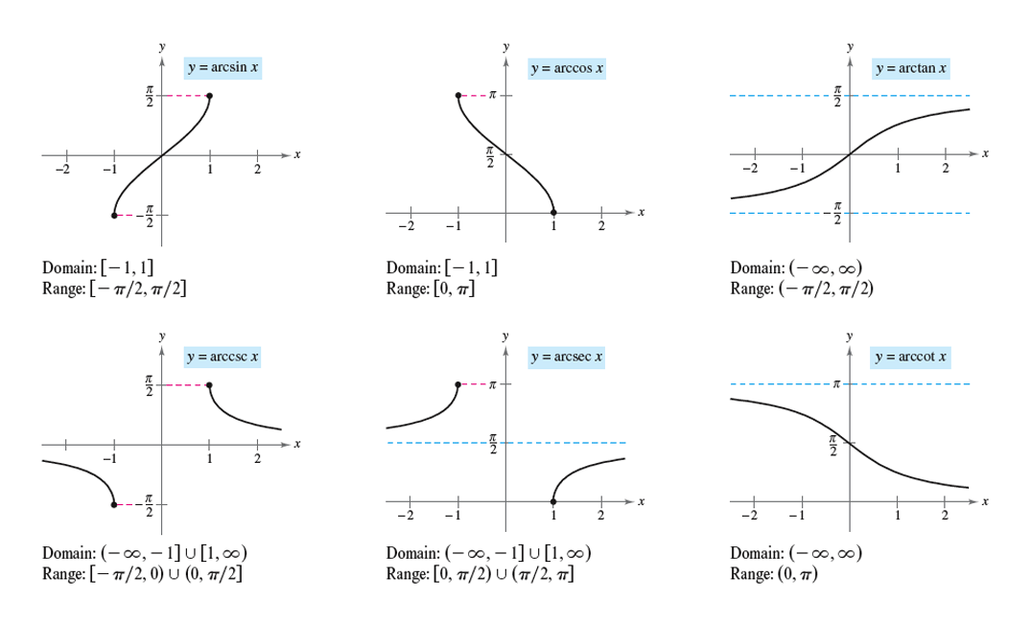
Trig functions have angle inputs and ratios of legs for out puts. The inverse trig functions have ratio of legs for inputs and angle for out puts.
Ex: Evaluate:
a)$arc Sin\left(-\frac{1}{2}\right)=$ b)$Cos^{-1}\left(0\right)=$ c)$Tan^{-1}\left(1\right)=$ d) $arcSin\left(\frac{2\sqrt{3}}{3}\right)=$ e)$Cos^{-1}\left(30°\right)=$

Ex: ($≈$1.5.118) Solve the equation for x:
$$Tan^{-1}\left(2x-5\right)=-\frac{π}{4}$$

Ex: Given $y=\arccos{x}$ $0<y<90°$ find $Sin y$

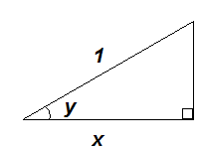

Defn The logarithm function with base a, $y=\log_{a}{x}$, is the inverse of the base $a$ exponential function $y=a^{x} (a>0, a≠1)$.

Recall What are the bases of the common and natural log functions?
Natural log $\log_{e}{x}=\ln{x}$
Common log $\log_{10}{x}=\log{x}$

This implies $\ln{(e^{u})}=u ∀uϵR$ and $e^{\ln{u}}=u ∀u>0$. Also, $\ln{x}=y⇔e^{y}=x$ and in particular, $\ln{e}=1$. See “Inverse Properties for $a^{x}$ and $\log_{a}{x}$ on page 52.)

Properties of Logarithms
For any numbers $b>0$ and $x>0$, the natural logarithm satisfies the following rules:
- Product Rule $\ln{bx}=\ln{b}+\ln{x}$
- Quotient Rule $\ln{\frac{b}{x}}=\ln{b}-\ln{x}$
- Reciprocal Rule (special case, when b=1) $\ln{\frac{1}{x}}=-\ln{x}$
- Power Rule $\ln{x^{r}}=r\ln{x}$

Change of Base Formula
$\log_{a}{x}=\frac{\ln{x}}{\ln{a}}$ $(a>0, a≠1)$

Ex 5 (# 32) Find simpler expressions for the quantities.
- $\ln\left(e^{secθ}\right)$
- $\ln\left(e^{(e^{x})}\right)$
- $\ln{(e^{2lnx}{)} }$

E x 6 Solve for $y$ in terms of $t$.
$$\ln{y}=-t+5$$

Review pages 55-58. (trig stuff)

