What is Calculus?
In Larson’s words, calculus is the mathematics of change – velocities, accelerations. It is also referred to as analytic geometry, because it incorporates geometric views and interpretations into its scope. Change alone is just subtraction and not in itself that interesting, but change relative to something else that is changing, now that takes some getting use to. With velocity, distance is changing relative to time, and this can be geometrically interpreted as the slope of a distance vs. time graph.

Precalculus also deals with velocity, but only under tight conditions, namely velocity or acceleration must be held constant. So in some ways Precalculus is only prepared to deal with static situations. Volumes of water in a odd shaped pool. But Calculus is the mathematics of change. With calculus you can find the volume of the pool as you fill it at any moment, you can predict how long it will take to fill, even if the flow of water is changing and the sides of the pool are not uniform.
Calculus
Limit Process
Precalculus
+ =

The first three chapters in this book will follow this exact formula.

Chapter 1 was a review of Precalculus
Chapter 2 will teach and review the concept of Limits
Chapter 3 will apply the first two chapters to develop and practice the foundations of Calculus

The Tangent Line Problem

The concept of a limit is an idea that distinguishes calculus from algebra and trig. It’s fundamental to finding the “tangent to a curve” or the velocity of an object. It will be central to our look at Calculus.

One such look is when you consider approximations of rates of change or averages of rates of change.

The average speed of an object $=\frac{distance covered}{time elapsed}$

In symbols, we have…
Defn Average Rate of Change over an Interval
The average rate of change of $y=f(x)$ with respect to $x$ over the interval $[x_{1},x_{2}]$ is

$\frac{Δy}{Δx}=\frac{f\left(x_{2}\right)-f\left(x_{1}\right)}{x_{2}-x_{1}}$

$\frac{Δy}{Δx}=\frac{f\left(x_{1}+h\right)-f\left(x_{1}\right)}{h},$ $h≠0$

- Replace $x_{2}-x_{1}$with $h$. We get
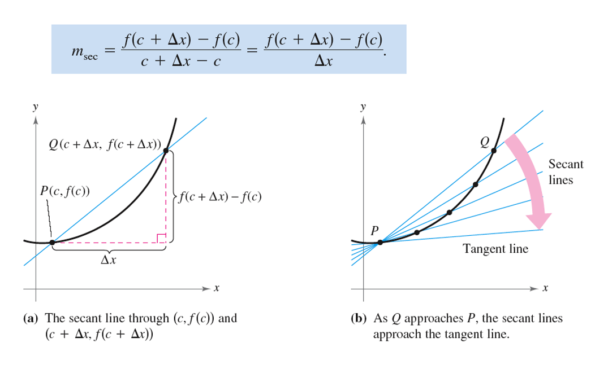

The Area Problem
