Ex 1 Find the limit of each. (Graph the functions.)
- $\lim_{x→3^{+}}{\frac{1}{x-3}}$
- $\lim_{x→3^{-}}{\frac{1}{x-3}}$
- $\lim_{x→3^{}}{\frac{1}{x-3}}$
- $\lim_{x→0}\frac{1}{x^{2 }}$

Consider example a). Although the limit as $x→3^{+}$ doesn’t exist, we can at least describe the behavior of $\frac{1}{x-3}$ near $3^{+}$ by indicating the limit is $∞$. We are not saying limit exists nor are we saying $∞$ is a real number, but merely that as we approach 3 from the right along the $x-$ axis, the graph of $\frac{1}{x-3}$ grows without bound. Examples a) & b) both have infinite limits, but in example c) we can not say it has a limit of $∞ or-∞$ since the limits from the right and left do not agree.
In example d) however, although the limit at 0 doesn’t exist, we can at least describe the behavior of $\frac{1}{x^{2}}$ on the right and left of 0 by indicating the limit is $∞$. We are not saying limit exists nor are we saying $∞$ is a real number, but merely that as we approach 0 from both sides along the $x-$ axis, the graph of $\frac{1}{x^{2}}$ grows without bound towards $+∞$.

Informal Defn
$\lim_{x→c}f\left(x\right)=∞$ means $f(x)$ approaches $∞$ as $x$ approaches $c$ if $f(x)$ grows arbitrarily large for all $x$ near $c$.
$\lim_{x→c}f\left(x\right)=-∞$ means $f(x)$ approaches $-∞$ as $x$ approaches $c$ if $f(x)$ grows arbitrarily small for all $x$ near $c$.
Note: When we say the limit=infinity, we are not saying the limit exist, but merely that the function is arbitrarily large as $x$ approaches c.

Ex 2 $\lim_{θ→0}(2-\cot{θ})$
Thomas 2.5.16

Ex 3 (# 20) Find limit of $\frac{x^{2}-1{ }}{2x+4}$ as
- $x→-2^{+}$
- $x→-2^{-}$
- $x→1^{+}$
- $x→0^{-}$

Ex 4 Let $f\left(x\right)=\frac{x-1}{x^{2}\left(x+2\right)}$. Find: Note: Do not need graph, look at signs and sizes of numbers.
- $\lim_{x→0^{+}}f\left(x\right)=$
- $\lim_{x→0^{-}}f\left(x\right)=$
- $\lim_{x→{-2}^{+}}f\left(x\right)=$
- $\lim_{x→{-2}^{-}}f\left(x\right)=$
- What, if anything, can be said about $\lim_{x→0}f\left(x\right)=$ _______? And $\lim_{x→-2}f\left(x\right)=$ _______?$\lim_{x→2}f\left(x\right)=$______?
Defn A line $x=a$ is a _____________________________ of the graph of $f$ of a function $y=f(x)$ if either $\lim_{x→a^{+}}{f(x)}=±∞$ or $\lim_{x→a^{-}}{f(x)}=±∞$.

Ex 5 (# 36) Sketch the graph of $y=\frac{x^{2}-1}{2x+4}$ by looking for asymptotes and intercepts. (Refer to ex 3)

Just so we can see the formal def.
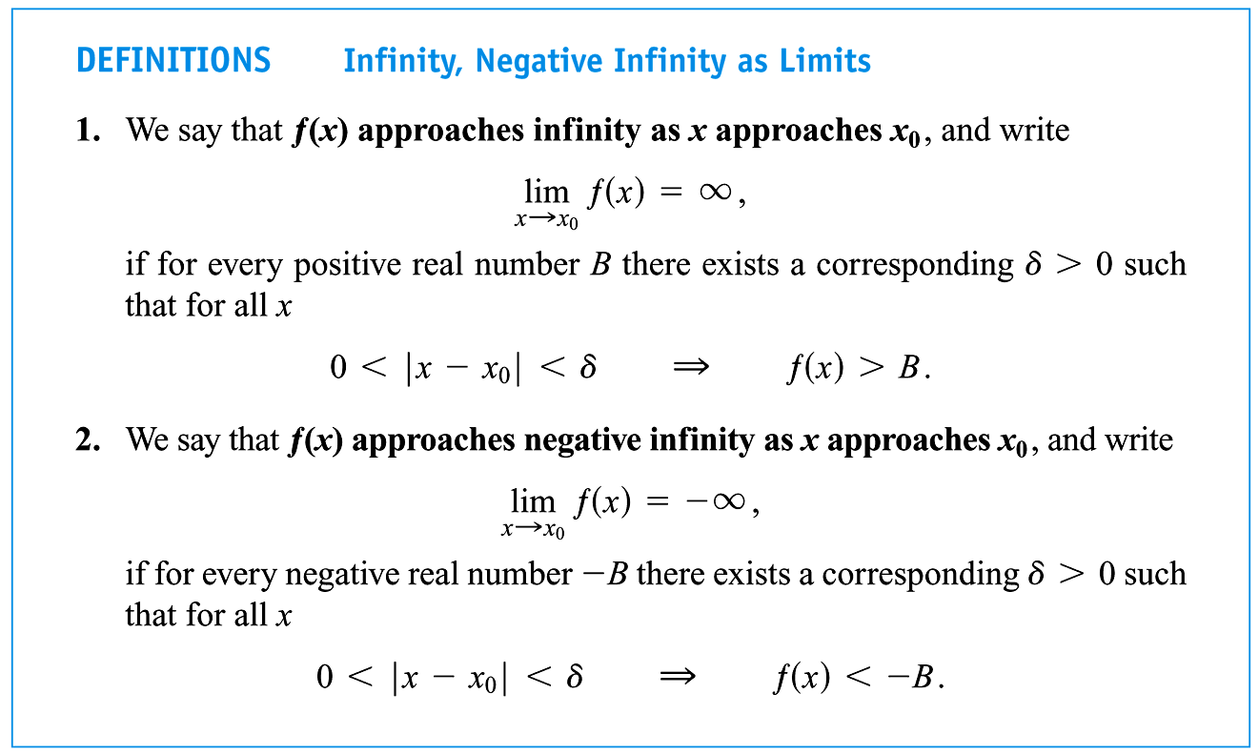

Limits at $∞$ (this section is discussed until section 4.5)

Find $\lim_{x→∞}\frac{1}{x^{2}}$

This limit is asking for the behavior of $f(x)$ as $x$ grows infinitely large ( $x→∞$). This is asking for the tendency of the function. If this limit exists, it will approach what we call a horizontal asymptote. If it is infinite, we will know it will grow without bound. In this case the right and left hand side of the function as x grows without bound, the function will approach the same horizontal asymptote, $y=0$. Can you think of a function where the function will approach a different horizontal asymptote on the left hand side than it will on the right hand side?

(Informal) Defn of Limits at $∞$
We say that $f\left(x\right)$ has the limit L as x approaches ___________ and write $\lim_{x→∞}f\left(x\right)=L$ if, $f(x)$ gets arbitrarily close to $L$ (as close as we want) as for all sufficiently large $x$.

We say that $f\left(x\right)$ has the limit L as x approaches ___________ and write $\lim_{x→-∞}f\left(x\right)=L$ if, $f(x)$ gets arbitrarily close to $L$ (as close as we want) as for all sufficiently small $x$.

Ex 3 Find the $\lim_{h→∞} h\sin{\frac{1}{h}}$. (Substitute $θ=1/h$)

From page 102:
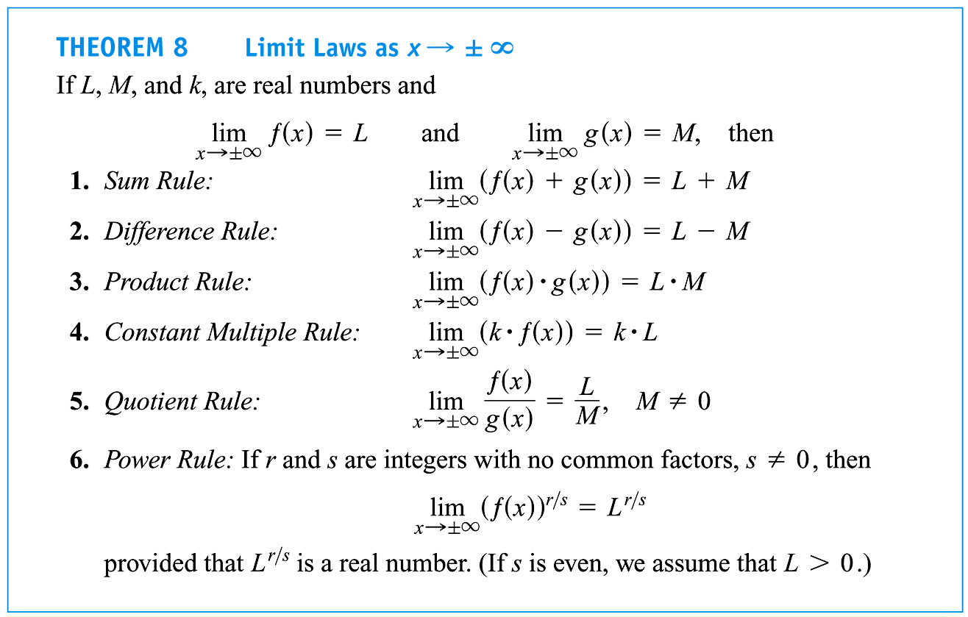
Ex 4 Find the right- and left-hand limits of each.

- $f\left(x\right)=\frac{1}{{\left(x+2\right)}^{2}}$ (at $x=-2$)

- $g\left(x\right)=\left\{\begin{aligned}-\frac{1}{x}, x<0 \\ \cos{x}, x≥0 \end{aligned}\right.$ (at $x=0$)

Ex 5 Find the limit and graph of each. [Show them virtual TI-83 if time permits.]

- $\sin{\frac{1}{x}}$ as $x→∞$

- $xsin\frac{1}{x}$ as $x→∞$

Defn A line $y=b$ is a _____________________________ of the graph of a function $y=f(x)$ if either

$\lim_{x→∞}f\left(x\right)=b$ or $\lim_{x→-∞}f\left(x\right)=b$.

- What is the horizontal asymptote of (the first example of) example 6?

- Can a graph ever cross it’s vertical asymptote?
- Horizontal?

Ex 6 Find
- $\lim_{x→∞}\frac{13x^{5}+12x^{4}-11x^{3}+2}{2x^{5}-3}$ What can we say about this limit?

What can we say about these limits?
- $\lim_{x→∞}3x^{3}+7x+8$

- $\lim_{x→-∞}3x^{3}+7x+8$

Limits of Rational Functions at $±∞$
Let $f\left(x\right)=\frac{p\left(x\right)}{q\left(x\right)}$ be a rational function.
- If the $\deg{p(x)}=\deg{q(x)}$, then $\lim_{x→±∞}f\left(x\right)= \frac{leading coeff of p(x)}{leading coeff of q(x)}$ and $y=\frac{leading coeff of p(x)}{leading coeff of q(x)}$ is a horizontal asymptote.
Ex:

- If $\deg{p(x)}<\deg{q(x)}$, then $\lim_{x→±∞}f\left(x\right)=0$ and $y=0$ is a horizontal asymptote.
Ex:

- If $\deg{p(x)}=\deg{q(x)}+1$, then $\lim_{x→±∞}f\left(x\right)=mx+b$ and $y=mx+b$ is an oblique/slanted asymptote.
Ex: $f\left(x\right)=\frac{2x^{2}+x+1}{x}=\underbrace{2x+1}+\frac{1}{x}$
Eqn of slant asymptote.

Defn In a rational function, if the degree of the numerator is one more than the degree of the denominator, the graph has an _________________________ asymptote. (The oblique asymptote is found by performing long division.)

At Home Example:
Find the slant asymptote of the function $f\left(x\right)=\frac{x^{2}+x-1}{x-1}$
$$\frac{x^{2}+x-1}{x-1}=\underbrace{x+2}+\frac{1}{x-1}$$

Slant Asymptote
General function behavior

Ex: Find $\lim_{x→∞}{e^{-x}Cos x}$ (Sandwich Theorem)

${{-e}^{-x}≤e}^{-x}\cos{x}≤e^{-x}$ and $\lim_{x→∞}{{-e}^{-x}=0}\&\lim_{x→∞}{e^{-x}=0 ∴\lim_{x→∞}{e^{-x}\cos{x}=0}}$ by Sandwich theorem

