Tangent to a Circle: A line $L$ is tangent to a circle if at a point $P$ if $L$ passes through $P$ and is perpendicular to the radius at $P$.
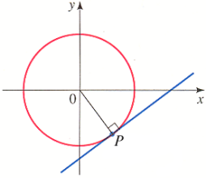

What does it mean to be tangent to a curve?

We can generalize that it means one of the following:
- The tangent line, L, touches the curve, C, at only one place P, for all points on the curve “near P”.
Below are pictures of two lines that are tangent to the curve and one line that is not tangent.
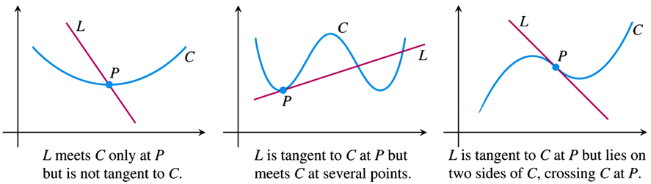

Give an example of a physical interpretation of the tangent line to a curve: (car driving along curve, rock thrown from a sling)

Discussion: Suppose we have a curve and we want to find the tangent to the curve at the point $P$. We can construct secant lines joined by $P$ and points $Q$ near $P$. We choose points $Q$ that approach $P$. If the resulting slopes of the secant lines have a limit, say $m$, we take it to be the slope of the curve at that point. The tangent line is the line that goes through $P$ and has slope $m$.
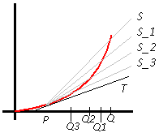
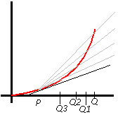

Defn The slope of a curve $y=f(x)$ at the point $P=\left(x_{0},f\left(x_{0}\right)\right)$ is the number
$$m=\lim_{h→0}{\frac{f\left(x_{0}+h\right)-f\left(x_{0}\right)}{h}}=Lim{}_{∆x→0}\frac{∆y}{∆x}=Lim{}_{∆x→0}\frac{f\left(x_{0}+∆x\right)-f(x_{0})}{∆x}$$
(provided the limit exists)

The tangent line to the curve at $P$ is the line through $P$ with this slope.

The expression $\frac{f\left(x_{0}+h\right)-f\left(x_{0}\right)}{h}$ is called the difference quotient of f at $x_{0}$ with increment h.

If $\lim_{h→0}{\frac{f\left(x_{0}+h\right)-f\left(x_{0}\right)}{h}}$ exists, the limit is called the derivative of f at $x_{0}$.

Defn The slope of a curve $y=f(x)$ at the point $P\left(x_{0},f\left(x_{0}\right)\right)$ is the number $m=\lim_{h→0}{\frac{f\left(x_{0}+h\right)-f\left(x_{0}\right)}{h}}$
(provided the limit exists)
The tangent line to the curve at $P$ is the line through $P$ with this slope.

The expression $\frac{f\left(x_{0}+h\right)-f\left(x_{0}\right)}{h}$ is called the difference quotient of f at $x_{0}$ with increment h. If $\lim_{h→0}{\frac{f\left(x_{0}+h\right)-f\left(x_{0}\right)}{h}}$ exists, the limit is called the derivative of f at $x_{0}$.

Defn The slope of a curve $y=f(x)$ at the point $P\left(x_{0},f\left(x_{0}\right)\right)$ is the number $m=\lim_{h→0}{\frac{f\left(x_{0}+h\right)-f\left(x_{0}\right)}{h}}$
(provided the limit exists)
The tangent line to the curve at $P$ is the line through $P$ with this slope.

The expression $\frac{f\left(x_{0}+h\right)-f\left(x_{0}\right)}{h}$ is called the difference quotient of f at $x_{0}$ with increment h. If $\lim_{h→0}{\frac{f\left(x_{0}+h\right)-f\left(x_{0}\right)}{h}}$ exists, the limit is called the derivative of f at $x_{0}$.

Defn The slope of a curve $y=f(x)$ at the point $P\left(x_{0},f\left(x_{0}\right)\right)$ is the number $m=\lim_{h→0}{\frac{f\left(x_{0}+h\right)-f\left(x_{0}\right)}{h}}$
(provided the limit exists)
The tangent line to the curve at $P$ is the line through $P$ with this slope.

The expression $\frac{f\left(x_{0}+h\right)-f\left(x_{0}\right)}{h}$ is called the difference quotient of f at $x_{0}$ with increment h. If $\lim_{h→0}{\frac{f\left(x_{0}+h\right)-f\left(x_{0}\right)}{h}}$ exists, the limit is called the derivative of f at $x_{0}$.

Ex 1 Find the derivative of $f\left(x\right)=mx+b$ at $x=x_{0}$. What can we conclude? (Easiest derivatives to find.)

Ex 2 Let $f\left(x\right)=x^{2}$. Find the slope of the parabola at $(3,9)$. Write an equation of the tangent to the parabola at this point.

Ex 3 (T18) Let $g\left(x\right)=\frac{1}{x^{2}}$. Find the slope of the function’s graph at $(2,\frac{1}{4})$. Find an equation for the line tangent to the graph there. (Outline steps)

EX 4 (T 14) Find the slope of the function $f\left(x\right)=\frac{8}{x^{2}}$ at the point $\left(2,2\right)$ and find the equation of the tangent line to the curve at that point.

Defn The slope of a curve $y=f(x)$ at the point $P\left(x_{0},f\left(x_{0}\right)\right)$ is the number $m=\lim_{h→0}{\frac{f\left(x_{0}+h\right)-f\left(x_{0}\right)}{h}}$
(provided the limit exists)
The tangent line to the curve at $P$ is the line through $P$ with this slope.

The expression $\frac{f\left(x_{0}+h\right)-f\left(x_{0}\right)}{h}$ is called the difference quotient of f at $x_{0}$ with increment h. If $\lim_{h→0}{\frac{f\left(x_{0}+h\right)-f\left(x_{0}\right)}{h}}$ exists, the limit is called the derivative of f at $x_{0}$.

Notation
Some common alternative notations for the derivative of $y=f(x)$:
$$f^{'}\left(x\right)=y^{'}=\frac{dy}{dx}=\frac{df}{dx}=\frac{d}{dx}f\left(܄\right)=D\left(f\right)\left(x\right)=D_{x}f(x)$$
The symbols $\frac{d}{dx}$ and $D$ are called differentiation operators and indicate the operation of differentiation the same way $+$ indicates the operation of addition.
$\frac{dy}{dx}$: “the derivative of $y$ wrt $x$”
$\frac{d}{dx}f(x)$ or $\frac{df}{dx}:$ “the derivative of $f$ wrt $x$”
$f'$, $y'$: “f prime”, “y prime” (respectively)

Ex 5 (T 18) Differentiate the function $y=f\left(x\right)=1+\sqrt{4-x}$. Then find an equation of the tangent line at the point $(3,2)$.

Defn $y=f(x)$ has a vertical tangent at $x_{0}$ if $\lim_{h→0}{\frac{f\left(x_{0}+h\right)-f\left(x_{0}\right)}{h}}=∞$ or $-∞$. $←$need for hw

Ex 6
Does $y=x^{\frac{1}{3}}$ have a vertical tangent at $x=0$?

Is $y=x^{\frac{1}{3}}$ differentiable on its domain (see pg 122 of Larson 4th ed)?

Does$y=x^{\frac{2}{3}}$ have a vertical tangent at $x=0$?

One-Sided Derivatives
$y=f(x)$ is differentiable on $[a,b]$ if it is differentiable at every point in $(a,b)$ and if the limits below exist:
Right-hand derivative at a: $\lim_{h→0^{+}}\frac{f\left(a+h\right)-f\left(a\right)}{h}$

Left-hand derivative at b: $\lim_{h→0^{-}}\frac{f\left(b+h\right)-f\left(b\right)}{h}$

Ex 4 (T 38) Does the function $f\left(x\right)=\left|x\right|=\left\{\begin{aligned}x, x≥0 \\ -x, x<0\end{aligned}\right.$ have a derivative at $x=0$? Is it continuous at $x=0$?

If this curve were to be a road, what would it be like to drive on at x=0? Why?

What does this imply about the relationship between continuity and differentiability?

Theorem
If $f$ has a derivative at $x=c$, then $f$ is continuous at $x=c$.
Note: The converse is not true as we saw in example 4.

Proof (If time permits)
WTS: Given that $f^{'}(x)$ exists at $x=c$ that $f$ is continuous at $x=c$ (i.e. that $\lim_{x→c}{f\left(x\right)=f(c)}$)

When Does A Function Not Have a Derivative?

BUT
Continuity $⇏$ Differentiability
Differentiability $⇒$ Continuity

Differentiable implies smooth $f\left(x\right)=\left|x\right|$

Ex 5 (T 31)
The graph below is that of $f$. At which points of the interval $[-3,5]$ is $f'$ not defined?
Graph the derivative of $f$.
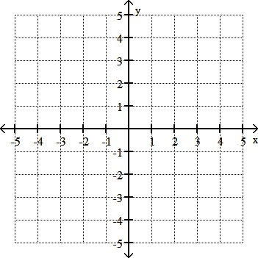
$f^{'}(x)$

$f(x)$

Ex: (L #55): On your own or if time.
Identify a function that has the following characteristics: $f\left(0\right)=0;f^{'}\left(0\right)=0;f^{'}\left(x\right)>0 for x≠0$

