Motivation: Often you will have equations which are not functions, or are not able to be solved explicitly (y=f(x)). This does not mean that we are any less interested in finding derivatives of these curves at given points. So we have Implicit differentiation to help with this.

Ex 1 Consider the curve $x=y^{2}$ below. ($y$ is implicitly defined) Find $\frac{dy}{dx}$ by solving for $y$ then next finding $\frac{dy}{dx}$ using “implicit differentiation”. Let $y=f(x)$. Then $y^{2}={\left[f\left(x\right)\right]}^{2}$.
(Note that for $x>0$, $\frac{dy}{dx}$ exists.)
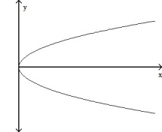
$x=y^{2}→y=±\sqrt{x }$ so $\frac{dy}{dx}=±\frac{1}{2\sqrt{x}}$

Note: In some equations that define an implicit relation between $x$ and $y$, we cannot solve for $y$ explicitly as we did above. And even if we could, it might look ugly. See below.

Ex 2 If $x^{3}+y^{3}=9xy$, then solving for $y$ gives $y=f(x)=\sqrt[3]{-\frac{x^{3}}{2}+\sqrt{\frac{x^{6}}{4}-27x^{3}}}+\sqrt[3]{-\frac{x^{3}}{2}-\sqrt{\frac{x^{6}}{4}-27x^{3}}}$ and $y=\frac{1}{2}\left[-f(x)±\sqrt{-3}\left(\sqrt[3]{-\frac{x^{3}}{2}+\sqrt{\frac{x^{6}}{4}-27x^{3}}}-\sqrt[3]{-\frac{x^{3}}{2}-\sqrt{\frac{x^{6}}{4}-27x^{3}}}\right)\right]$
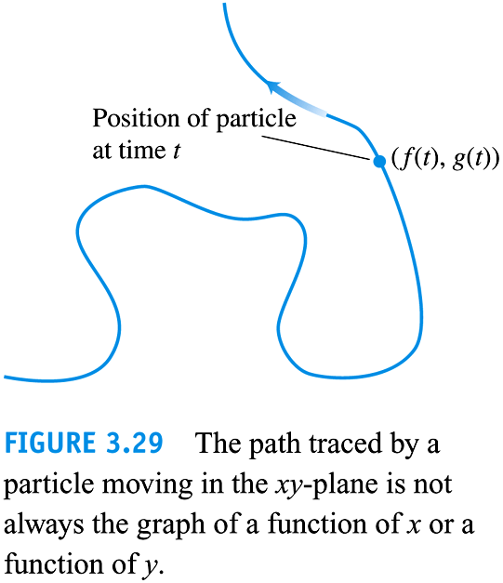
Find $\frac{dy}{dx}$. (Just kidding.)

Another great motivation is if we have a curve which is not a function. For some values of x, we may have two values of y, and at each of these y values we could have a tangent line. These curves will not all have the benefit of being able to be solved explicitly for y.

However, some functions y are written IMPLICITLY as functions of x . A familiar example of this is the equation
x² + y² = 25 ,
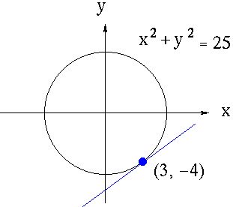
which represents a circle of radius five centered at the origin. Suppose that we wish to find the slope of the line tangent to the graph of this equation at the point (3, -4) .

How could we find the derivative of y in this instance ? One way is to first write y explicitly as a function of x . Thus,
x² + y² = 25 ,

and
where the positive square root represents the top semi-circle and the negative square root represents the bottom semi-circle. Since the point (3, -4) lies on the bottom semi-circle given by

the derivative of y is

i.e.,
(this is for $y'$ when you are looking at points in Quad. III or IV)
Thus, the slope of the line tangent to the graph at the point (3, -4) is

But this could be done easier by using implicit differentiation.

Implicit differentiation is a method where we find $\frac{dy}{dx}$ without actually solving for $y$. It is just an application of the chain rule.

Implicit Differentiation
1) Differentiate both sides of the equation wrt $x$, treating $y$ as a differentiable function of $x$.
2) Collect the terms with $\frac{dy}{dx}$ on one side of the equation.
3) Solve for $\frac{dy}{dx}$.

Let’s try the previous problem using implicit differentiation.
D ( x² + y² ) = D ( 25 ) $→$
So $y^{'}=$ (which works for points in any quadrant).
Now let’s find the slope of the curve at $(3,-4)$:
$y^{'}=$ as we anticipated.

Ex: Use implicit differentiation to complete example 2.

Ex 4 (# 26) Use implicit differentiation to find $\frac{dy}{dx}$ if $x^{2}=\frac{x-y}{x+y}$. (Avoid quotient rule here.)

Ex 6 Find $\frac{dy}{dx}$ and then $\frac{d^{2}y}{dx^{2}}$ if $xy+y^{2}=1$.

Ex 7 Verify that the given point is on the curve and find the lines that are a) tangent and b) normal to the curve at the given point. (The normal line is perpendicular to the tangent line at the given point.)
$2xy+π\sin{y}=2π, \left(1,\frac{π}{2}\right)$

Logarithmic Differentiation
Some Derivatives are easier to take the derivative of if you use properties of logs:
Ex: 3.5.70 Find $\frac{dy}{dx}$ if $y=\frac{\left(x+1\right)\left(x+2\right)}{\left(x-1\right)\left(x-2\right)}$ Note this would take a quotient rule and perhaps two product rules.
But we can consider this equivalent equation to make it easier to take our derivative:

Now we use implicit differentiation to take this derivative more easily!

EX: $f\left(x\right)=\ln\left(\frac{Sin\left(x\right)Cos\left(x\right)Tan\left(x\right)}{Cot\left(x\right)}\right)$

For more good examples see the link below
http://www.math.ucdavis.edu/~kouba/CalcOneDIRECTORY/implicitdiffdirectory/ImplicitDiff.html#PROBLEM%2014
I am including the problems from this link below. I recommend you look at the problems and to find the solutions, you should visit the link above.
The following problems range in difficulty from average to challenging.

PROBLEM 1 : Assume that y is a function of x . Find y' = dy/dx for x³ + y³ = 4 .

PROBLEM 2 : Assume that y is a function of x . Find y' = dy/dx for (x-y)² = x + y - 1 .

PROBLEM 3 : Assume that y is a function of x . Find y' = dy/dx for$y=\sin\left(3x+4y\right)$ .

PROBLEM 4 : Assume that y is a function of x . Find y' = dy/dx for y = x² y³ + x³ y² .

PROBLEM 5 : Assume that y is a function of x . Find y' = dy/dx for e^{xy} = e^{4x} - e^{5y} .

PROBLEM 6 : Assume that y is a function of x . Find y' = dy/dx for$Cos^{2}x+Cos^{2}y=Cos(2x+2y)$.

PROBLEM 7 : Assume that y is a function of x . Find y' = dy/dx for $x=\sqrt{x^{2}+y^{2}}$.

PROBLEM 8 : Assume that y is a function of x . Find y' = dy/dx for $\frac{x-y^{3}}{y+x^{2}}-x+2$

PROBLEM 9 : Assume that y is a function of x . Find y' = dy/dx for $\frac{y}{x^{3}}+\frac{x}{y^{3}}=x^{2}y^{4}$.

PROBLEM 10 : Find an equation of the line tangent to the graph of (x²+y²)³ = 8x²y² at the point (-1, 1) .

PROBLEM 11 : Find an equation of the line tangent to the graph of x² + (y-x)³ = 9 at x=1 .

PROBLEM 12 : Find the slope of the graph of x²y + y⁴ = 4 + 2x at the point (-1, 1) .
PROBLEM 13 : Consider the equation x² + xy + y² = 1 . Find equations for y' and y'' in terms of x and y only.

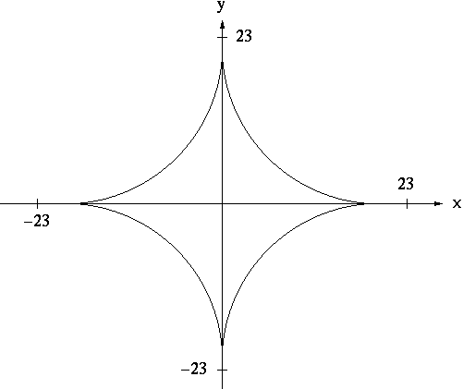
PROBLEM 14: (similar to problem 3.5.44) Find all points (x, y) on the graph of x^{2/3} + y^{2/3} = 8 (See diagram.) where lines tangent to the graph at (x, y) have slope -1 .

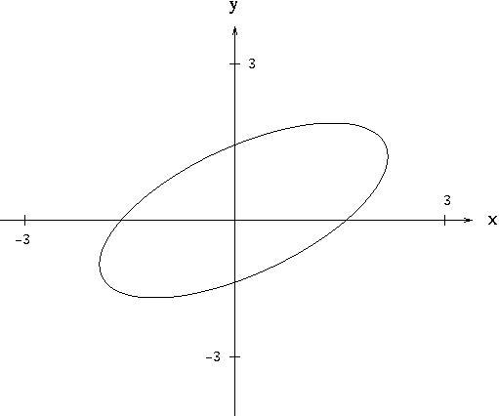
PROBLEM 15 : The graph of x² - xy + y² = 3 is a "tilted" ellipse (See diagram.). Among all points (x, y) on this graph, find the largest and smallest values of y . Among all points (x, y) on this graph, find the largest and smallest values of x .

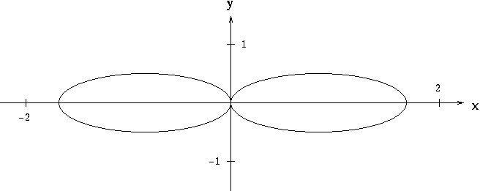
PROBLEM 16 : Find all points (x, y) on the graph of (x²+y²)² = 2x²-2y² (See diagram.) where y' = 0.

