Recall: If $f$ and $f^{-1}$ are inverse functions, then
- $(x,y)ϵf$ iff $\left(y,x\right)ϵf^{-1}$ (usually the definition)
- $\left(f∘f^{-1}\right)\left(x\right)=\left(f^{-1}∘f\right)\left(x\right)=x$ for all $xϵdomf∩domf^{-1}$, so $f$ and $f^{-1}$ undo each other (usually a theorem)
- The graphs of $f$ and $f^{-1}$ are reflections of each other across the line $y=x$. (graphical interpretation)
- The dom $f$ = range $f^{-1}$ and vice-versa
- If $a>0$ and $a≠1$, the inverse of $f\left(x\right)=a^{x}$ is $f^{-1}\left(x\right)=\log_{a}{x}$. In particular, $e^{x}$ and $\ln{x}$ are inverse functions.

Theorem: Continuity and Differentiability of Inverse Functions
Let $f$ be a function whose domain is an interval I. If $f$ has an inverse functions, then the following statements are true:
- If $f$ is continuous on its domain, then $f^{-1}$ is continuous on its domain.
- If $f$ is differentiable at $c$ and $f^{'}\left(c\right)≠0,$ then$f^{-1}$ is differentiable at $f(c)$.

- Given $f$, if $f^{-1}$ exists, instead of finding it then differentiating, we can find ${\left(f^{-1}\right)}^{'}$ using the following Theorem:
Recall that if the point $(a,b)$ lies on $f$, then as a consequence $(b,a)$ will lie on $f^{-1}$.

Theorem The Derivative for Inverses
Let $f$ be a function that is differentiable on an interval $I$. If $f$ has an inverse function $g\left(x\right)=f^{-1}(x)$, then $g$ is differentiable at any $x$ for which $f^{'}(g\left(x\right))≠0$. Furthermore,

$${(f}^{-1}(x))'=g^{'}(x)=\frac{1}{f^{'}\left(f^{-1}\left(x\right)\right)}=\frac{1}{f^{'}\left(g\left(x\right)\right)}:f^{'}(g\left(x\right))≠0$$

So the derivative of a function, $f^{'}s$ inverse, is the reciprocal of $f^{'}s$ derivative evaluated at $f^{-1}$.
If $f$ is defined at $(a,b)$ and $f^{'}(x)$ exists and is not zero there, then $f^{-1}$ is differentiable at $(b,a)$. Furthermore, ${\left(f^{-1}\right)}^{'}\left(b\right)=\frac{1}{f^{'}(a)}$
Proof:

Derivatives of Inverse Trig Functions
1) $\frac{d}{dx}\sin^{-1}{u}=\frac{1}{\sqrt{1-u^{2}}} \frac{du}{dx}$ 2) $\frac{d}{dx}\cos^{-1}{u}=\frac{-1}{\sqrt{1-u^{2}}} \frac{du}{dx}$

3) $\frac{d}{dx}\tan^{-1}{u}=\frac{1}{1+u^{2}} \frac{du}{dx}$ 4) $\frac{d}{dx}\cot^{-1}{u}=\frac{-1}{1+u^{2}} \frac{du}{dx}$

5) $\frac{d}{dx}\sec^{-1}{u}=\frac{1}{\left|u\right|\sqrt{u^{2}-1}} \frac{du}{dx}$ 6) $\frac{d}{dx}\csc^{-1}{u}=\frac{-1}{\left|u\right|\sqrt{u^{2}-1}} \frac{du}{dx}$

Ex 4 Find $Cos(Arc Sin x)$, then find the derivative of $y=ArcSin x$:

Ex 3 Find the derivative of the inverse Tangent function:

Ex 3 Find the derivative of the inverse Secant function:

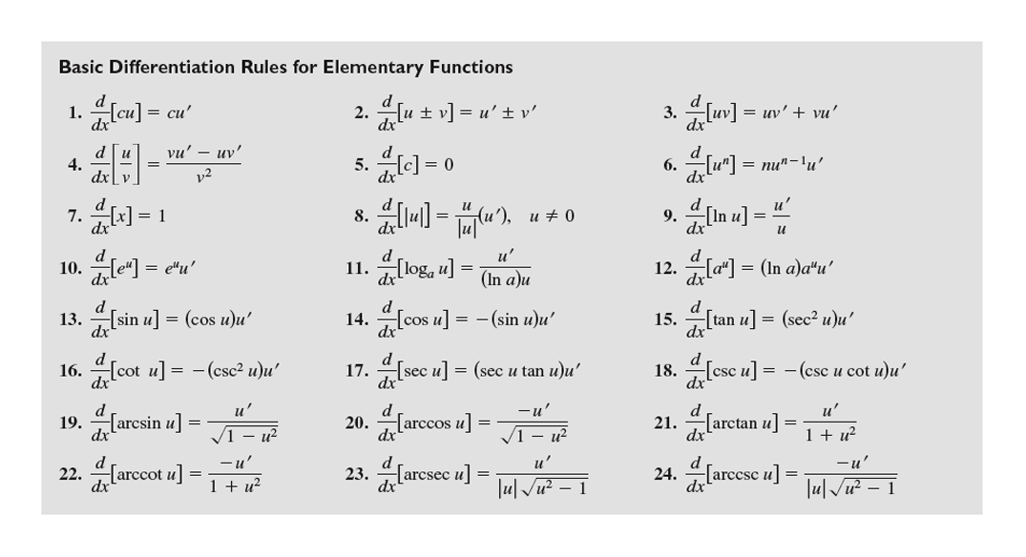
Ex 5 Find the following derivatives:

- (3.6.20) $f\left(t\right)=arc Sin \left(t^{2}\right)$

- (3.6.24) $f\left(x\right)=arc Tan\left(\sqrt{x}\right)$

- (3.6.27) $g\left(x\right)=\frac{arc Cos (x)}{x-1}$

- (3.6.31) $h\left(t\right)=Sin(arc Cos t)$

- (3.6.34) $y=2\ln\left(t^{2}+4\right)-arc Tan\frac{t}{2}$

- (3.6.58) Find $\frac{dy}{dx}$: $arc Tan\left(xy\right)=arc Sin (x+y)$

