In this section, we learn how to locate and identify Maximum and Minimum values (extreme values)of continuous functions from its derivative to aid in things like function graphing and optimization problems.

Let $f$ be defined on an interval $I$ containing $c$

1. $f(c)$ is the **minimum of $f$ on $I$** if $f\left(c\right)≤f\left(x\right)$ for all $x$ in $I$.
2. $f(c)$ is the **maximum of $f$ on $I$** if $f\left(c\right)≥f\left(x\right)$ for all $x$ in $I$.

The minimum and maximum of a function on an interval are the extreme values, or extrema (the singular form of extrema is extremum), of the function on the interval. The minimum and maximum of a function on an interval are also called the **absolute minimum** and **absolute maximum** on the interval.

If the interval $I$ is the entire domain of the function then the minimum value becomes the **absolute minimum.** If the interval is simply an open neighborhood around $c$ then minimum value is called a **relative minimum**. The same holds true for maximum values.

*Formal Defn* Let $f$ be a function with domain $D$. Then $f$ has an ***absolute maximum*** value on $D$ at a point $c$ if $f(x)≤f(c)$ for all $x$ in $D$. Similarly, $f$ has an ***absolute minimum*** on $D$ at a point $c$ if $f(x)≥f(c)$ for all $x$ in $D$.

* Absolute maximum and minimum values = ***absolute extrema*** = ***global extrema***
* Not all graphs have absolute extema.

For any continuous function consider the following questions.

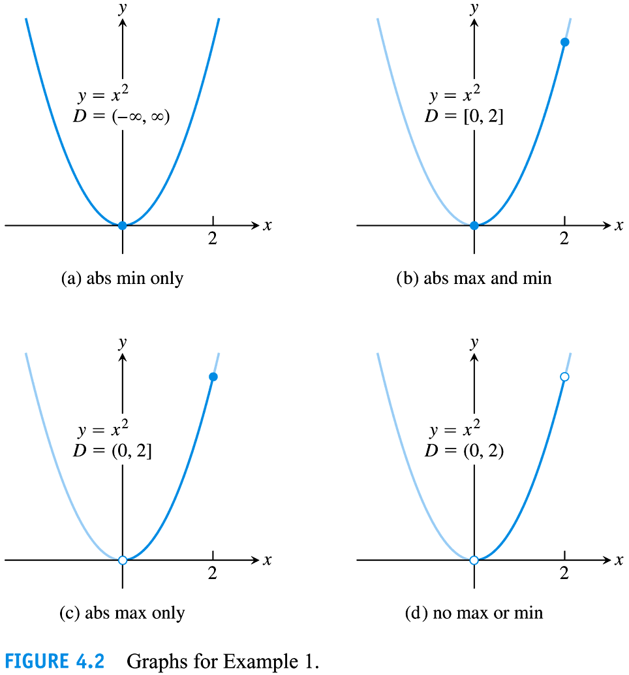Q: Is it possible to have no absolute Max/Min on

1. I = closed set? b) I = open set? c) I = Not open and not closed set?

Q: Is it possible to have only a absolute Max or Min on

1. I = closed set? b) I = open set? c) I = Not open and not closed set?

Ex: Circle and label appropriately the location and type of all the (relative) maximum and minimum values for each graph.

Label Where does the absolute max/min occur?

*Theorem Extreme Value Theorem (EVT)*

If $f$ is continuous on a closed interval $[a,b]$, then $f$ attains both an absolute maximum value $M$ and an absolute minimum value $m$ in $[a,b]$. That is, there exists $x_{1}, x_{2} ϵ[a,b]$ with $f\left(x_{1}\right)=m$ and $f\left(x_{2}\right)=M$ such that $m$ $≤f\left(x\right)≤$ $M$ $∀xϵ[a,b]$.

Note:­­­­­­­­_________________________________________________________________________________________

Note: Heine-Borel Theorem: A subset of $R^{k}$ is compact iff it is closed and bounded

*Idea for Proof* – $f$ is continuous so it has the

$⇒$ $f\left(\left[a,b\right]\right)=I$____________________________

, $I$ an interval. $f$ is continuous on a ____________________ set so it’s image is compact; that is, $I$ is

$⇒$ $I=[c,d]$____________________

so $c=$______________________and $d=$ $∎$

___________________________

Ex 1 We need both conditions of the EVT (continuity and a closed interval) to guarantee absolute extrema. Give an example of $f$ that fails to have both absolute extrema when **a)** continuity is removed and **b)** interval is not a compact interval (either not closed or not bounded (could be infinite)).

*Other types of extreme values: Local minima/maxima*

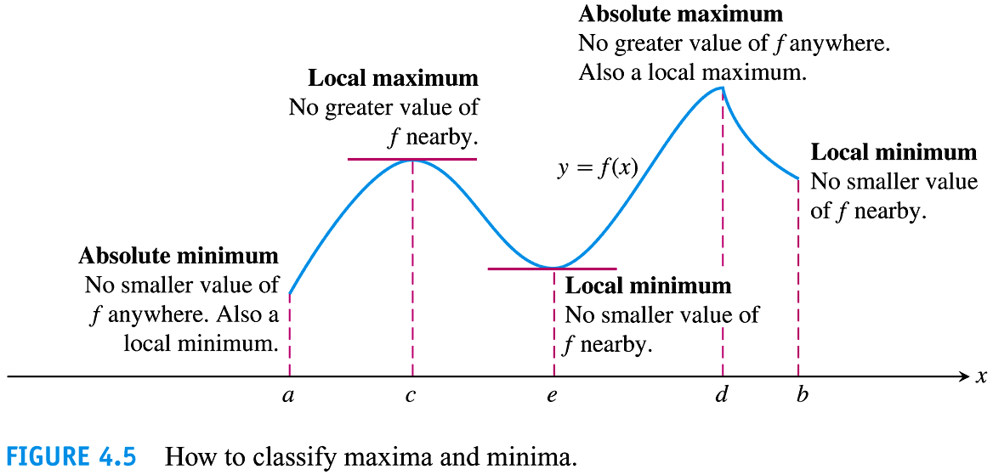

*Defn*   
A function $f$ has a ***local maximum or relative maximum*** value at an interior point $c$ of its domain if

$f(x)≤f(c)$ for all $x$ in some neighborhood of $c$. (“neighborhood” means open interval)

A function $f$ has a ***local minimum or relative minimum*** value at an interior point $c$ of its domain if

$f(x)≥f(c)$ for all $x$ in some neighborhood of $c$.

Note:

The definition above can be extended to local extrema at ___________________. It would look like this: A function $f$ has domain $[a,b]$, then $f$ has a local max at, say $a$, if $f(x)≤f(a)$ for all $x$ in $[a,a+δ]$ for some $δ>0$.

*Theorem* *The First Derivative Theorem*

If $f$ has a local maximum or minimum value at an interior point $c$ of its domain, and $f'$ is defined at $c$, then $f^{'}\left(c\right)=0$.

*Defn* If $c$ is an interior point of $f$ and if either $f^{'}(c)=0$ or $f^{'}(c)$ is undefined, then $c$ is called a ***critical number*** of $f$.

Ex: Find one example (graph or equation)of each way to obtain a critical number.

Note: ­­­­­­­­­­­­­­­­­­­­­­­­­________________________________________________________________________________________

**T / F** The converse of the First Derivative Theorem is also true.

*How To Find Absolute Extrema of a Continous Function $f$ on a Closed Interval*

1. Find all critical numbers by setting $f^{'}=0$ and finding where $f'$ DNE (but $f$ does).
2. Evaluate $f$ at all critical numbers and endpoints.
3. Take the largest of these values will be the absolute max and smallest of these values will be the absolute min.

\

Ex 2 Find the absolute max and min values of each function on the given interval. Then graph the function. (Note the difference between “find the absolute max/min” vs “what is the absolute max/min?”)

$f\left(x\right)=4-x^{2}; -3≤x≤1$

$g\left(x\right)=-\sqrt{5-x^{2}}; -\sqrt{5}≤x≤0$

Ex 3 Find the extreme values of the function and where they occur.

$y=-3x^{2}-12x-1$

$y=\frac{1}{\sqrt{1-x^{2}}}$

$y=x^{2}\ln{x}$

$y=\sin^{-1}{(e^{x})}$

Note: When we are asked to find all extrema and the domain is not a closed interval, we sometimes need to look at the graph to determine if the extremum is local or absolute. In section 4.3, the 1st Derivative Test will help us do this.

Also, use graphing utility for #34 (but not for problems like #15 and #17)

**Conceptual Questions:** Consider these problems on your own or with friends, we will not discuss them in class.

(#77) If an odd function g(x) has a local minimum value at $x=c$, can anything be said about the value of g at $x=-c$? Give reasons for your answer.

(#78) Give an example of a continuous function with no critical points or endpoints. Will the function have any Extreme values on its domain? Why/ why not?

EX (Thomas #68) Length of a guy wire: One tower is 50 ft high and another tower is 30 ft high. The towers are 150 ft apart. A guy wire is to anchor the tops of both poles to one point on the ground between the towers.

1. Locate the point of the anchor so that the total length of guy wire used is a minimum.
2. Show in general that regardless of the height of the towers, the length of the guy wire is minimized if the angles at the anchor point are equal.

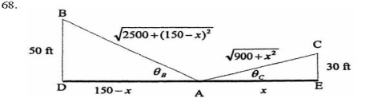 L(x): 



