We’ll learn 2 theorems that relates a function and its derivative (so that we can make deductions about $f'$ if we know information about $f$ and vice-versa).

* Consider: $f$ is a continuous function on $[a,b]$ and $f\left(a\right)=f(b)$. What do you notice?

*Theorem Rolle’s Theorem*

Suppose that

1. $f$ is continuous on $[a,b]$
2. $f$ is differentiable on $(a,b)$

$f\left(a\right)=f(b)$

Then there exists a number $c$ in $(a,b)$ such that $f^{'}\left(c\right)=0$.

Geometrically, it makes sense:

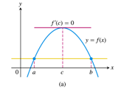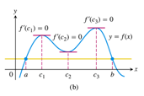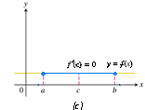

Proof:

a) $f\left(x\right)=\left(x-3\right)\left(x-1\right)=x^{2}-4x+3 on [1,3]$

b) $f\left(x\right)=x^{\frac{2}{3}} on [-1,1]$

c) $f=x-2\ln{x}$ on $[1,3]$. Will $f$ have any horizontal tangents, if so where?

On your own:

Ex ($\sim$ 4.2.21) Repeat the above directions for $f\left(x\right)=Sin x$ on $\left[\frac{π}{4},\frac{3π}{4}\right]$.

Consider the interval $\left[\frac{π}{4},\frac{3π}{4}\right]$. $f\left(x\right)=\sin{x}$ is cont. on this interval and diff. on the open interval $\left(\frac{π}{4},\frac{3π}{4}\right)$.

$f\left(\frac{π}{4}\right)=\frac{\sqrt{2}}{2}=f\left(\frac{3π}{4}\right)=\frac{\sqrt{2}}{2}$ By Rolle’s Theorem there exist a number $c∈\left[\frac{π}{4},\frac{3π}{4}\right]$ namely $c=\frac{π}{2}$ such that $f^{'}\left(c\right)=Cos\left(c\right)=Cos\left(\frac{π}{2}\right)=0$.

Next, give 3 examples (graphs ok) where $f'$ is never 0 because one of the conditions in Rolle’s Theorem is not met.

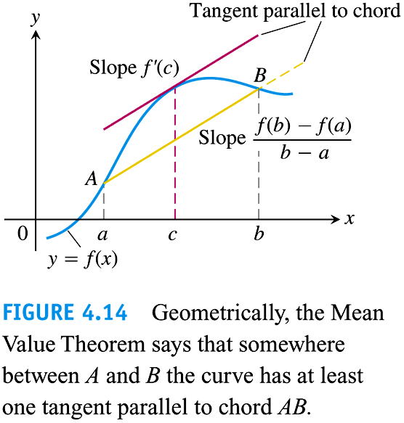

*Theorem Mean Value Theorem (MVT)*

Suppose that

1. $f$ is continuous on $[a,b]$
2. $f$ is differentiable on $(a,b)$

Then there exists a $c$ in $(a,b)$ such that $\frac{f\left(b\right)-f\left(a\right)}{b-a}=f^{'}(c)$.

The MVT says that if conditions 1 and 2 are met, then the slope of the secant line and the slope of the tangent line at some point in the interval are the same.

* Driving example. If $f$ represents a position, then MVT says at some point in that time interval, the (instantaneous) rate of change is the same as the average rate of change.

Ex: If you drive between 2 checkpoints on the freeway with an average speed of 80mph, then you can get a ticket for driving this speed because at some point you must have been driving 80 mph.

Ex A trucker handed a ticket at a toll booth showing that in 2 hours she had covered 160 miles on a toll road with speed limit 65 mph. The trucker was cited for speeding. Why?

Ex 2 Determine whether the Mean Value Theorem (MVT) can be applied to $f\left(x\right)$ on $\left[a,b\right]$. If so, Find all values of $c$ in $(a,b)$ that satisfy the conclusion of the MVT.

1. (4.2.50) $f\left(x\right)=2Sin x+Sin 2x$ on $[0,π]$
2. (4.2.51) $f\left(x\right)=xlog_{2}x on \left[1,2\right]$

On your own: $f\left(x\right)=x^{2}+3x-4; [0,1]$

Ans: YES, Students must show why. $\frac{f\left(b\right)-f\left(a\right)}{b-a}={\frac{f\left(1\right)-f\left(0\right)}{1-0}=\frac{0-(-4)}{1}=4=f}^{'}(c)$ when $2c+3=4→c=\frac{1}{2}$

Ex 3 Which of the functions satisfy the hypotheses of the MVT on the given interval and which do not? Give reasons for your answer. (Graphing can help here.)

1. $f\left(x\right)=x^{2/7}$ on $[-1,8]$

1. $f\left(x\right)=x^{2/7}$ on $[0,1]$

1. $f\left(x\right)=\frac{x^{2}+5x+6}{x+3}$ on $[-4,4]$
2. $f\left(x\right)=\left\{\begin{aligned}x^{2}\sin{\frac{1}{x}}, x≠0 \\ 0, x=0\end{aligned}\right.$ on $[-1,1]$

Ex 4 ($\sim 4.2.$ 5-8) Show that the function $g\left(x\right)=\frac{1}{1-x}+\sqrt{1+x}-3.1$ has exactly one zero in the interval $(-1,1)$. HINT:(Use IVP to show it has at least one 0. Next, show the derivative is always + to verify that it cannot have any more than 1 real root.)

*Corollary 1*

If $f^{'}\left(x\right)=0$ at every point $x$ in an open interval $(a,b)$, then $f\left(x\right)=C$ for all $xϵ(a,b)$, where $C$ is a constant.

$⟶$ This helps us identify where a function is constant (if at all).

*Corollary 2*

If $f^{'}\left(x\right)=g^{'}(x)$ at every point $x$ in an open interval $(a,b)$, then there exists a constant $C$ such that $f\left(x\right)=g\left(x\right)+C$ for all $xϵ(a,b)$. That is, $f-g$ is a constant on $(a,b)$.

$⟶$ This tells us that two functions whose derivatives are the same differ only by a constant.

Ex 5 Suppose that $f\left(0\right)=5$ and that $f^{'}\left(x\right)=2$ for all $x$. Must $f\left(x\right)=2x+5$ for all $x$? Give reasons for your answer.

Ex 6 Find all possible functions with the given derivative. (This is a process we will later call Integration)

$y^{'}=2x$

$y^{'}=x$

$y^{'}=6x^{2}$

$y^{'}=5x^{3}$

Ex 7 Find a function $f$ that has the derivative $f^{'}\left(x\right)=2x+3$ and whose graph passes through the point (0,1)

If time in class go over the next two examples, if not students should do on their own.

Ex: 4.3.64 & 66 The graph of $f$ is given. Sketch the graph of $f'$ over the top of the graph of $f$.



Ex: 4.3.70 Use the graph of $f'$ (shown) to sketch the graph of $f$.

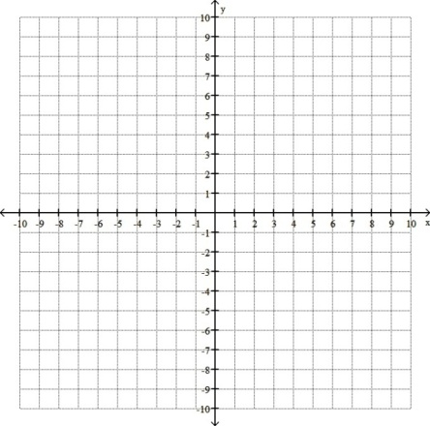

Ex: ($≈$ 4.2.73) Determine the values of $a,b,c$ such that the function satisfies the hypotheses of the MVT on the interval [0,3]

$$f\left(x\right)=\left\{\begin{aligned}2, &x=0 \\ ax+b, &0<x≤1 \\ x^{2}+6x+c, &1<x≤3\end{aligned}\right.$$

Diff on (0,3):

\*\*\*WRONG\*\*\*

@ x=0:

$0=a$

Correct:

@x=1:

$$a=2\left(1\right)+6=8$$

$$SO, a=8,b=2,$$

Solving for c from

$$c=a-5$$



$$⇒c=8-5=3$$



$$c=3$$

 \*\*

Cont. on [0,3]:

@x=0:

$$2=a\left(0\right)+b→b=2$$

&

@x=1:

$a\left(1\right)+b={\left(1\right)}^{2}+6\left(1\right)+c→a+2=7+c$ So $c=a-5$

$$∴a=8,b=2,c=3$$

\*\*

On you own: Do problem 4.2.74

Determine the values of $a,b,c,\& d$ such that the function $f$ satisfies the hypotheses of the MVT on the interval $[-1,2]$. Where

$$f\left(x\right)=\left\{\begin{aligned}a, &x=-1 \\ 2, 1<&x≤0 \\ bx^{2}+c, 0<&x≤1 \\ dx+4, 1<&x≤2\end{aligned}\right.$$