* We have discussed how to find relative extrema with derivatives, but have yet to use derivatives to determine if these points are local max or local min. In this section we introduce the 1st Derivative Test which will help us do that and learn more about the behavior of a (differentiable) function.

Consider the function below.

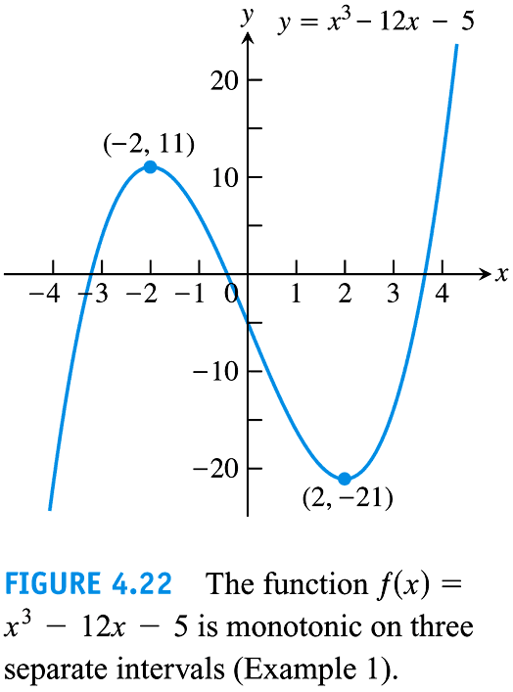What can we say about the derivative of the function where the function is increasing?

Decreasing?

Try to sketch the derivative over the top of this graph.

*Defn* Let $f$ be a function defined on an interval $I$ and let $x_{1}$ and $x_{2}$ be **ANY** two points in $I$ with $x_{1}<x_{2}$.

1. If $f\left(x_{1}\right)<f(x_{2})$ then $f$ is said to be ***strictly increasing*** or just **increasing** on $I$.
2. If $f\left(x_{1}\right)>f(x_{2})$ then $f$ is said to be ***strictly decreasing*** just **decreasing** on $I$.

A function that is only increasing or decreasing (but not both) on $I$ is said to be ***monotonic*** on $I$.

Def: A function is said to be **monotonic** if it is strictly increasing or strictly decreasing on an interval I.

*(1st Derivative Test for Monotonic Functions)*

Suppose that $f$ is continuous on $[a,b]$ and differentiable on $(a,b)$.

1. If $f^{'}\left(x\right)>0$ at every point $xϵ(a,b)$, then $f$ is **strictly increasing** or **increasing** on $[a,b]$.
2. If $f^{'}\left(x\right)<0$ at every point $xϵ(a,b)$, then $f$ is **strictly decreasing** or **decreasing** on $[a,b]$.

Is the converse of this statement true, that if $f$ is **increasing** on $[a,b]$, then If $f^{'}\left(x\right)>0$ at every point $xϵ(a,b)$?

Note: To say a function is increasing on $[a,b]$ and decreasing on $\left[b,c\right]$ leaves $x=b$ to be a place of some ambiguity. To say a function is increasing on $[a,b]$ implies that it is increasing at the place where $=$ $b$, and it is decreasing where $x=$ $b$ in the interval $[b,c]$ making the function both increasing and decreasing there. This will contradict our definition of increasing or decreasing which is defined only on **open** intervals because It is impossible for a function to increase at a single place, $x=$ b. it is important to note that we will only be asking for and looking for OPEN intervals of increasing and decreasing.

Ex: 4.3.22 Find the critical numbers of the function $f\left(x\right)=x^{3}-6x^{2}+15$ (if any) and find the open intervals on which the function is increasing or decreasing.

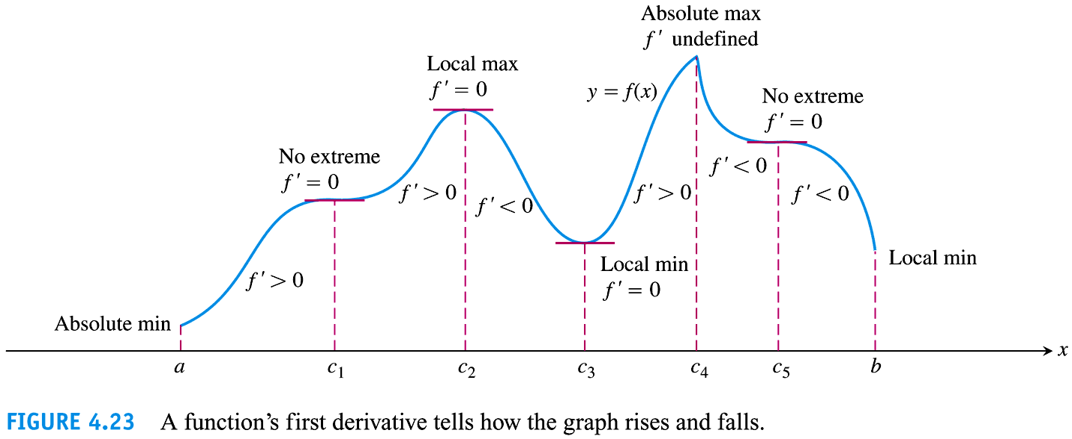

*First Derivative Test for Local Extrema*

Suppose that $c$ is a critical point of a continuous function $f$ and that $f$ is differentiable at every point in some interval containing $c$ except possibly at $c$ itself. Moving across $c$ from left to right,

1. if $f'$ changes from (-) to (+) at $c$, then $f$ has a local/relative min at $c$
2. if $f'$ changes from (+) to (-) at $c$, then $f$ has a local/relative max at $c$
3. if $f'$ does not change sign at $c$, then $f$ has no local/relative extremum at $c$

* Remind Students they can use graphing calculator to verify answers in hw. Remind of Virtual TI-83 on webpage.

Ex 1 Answer the questions about each function whose derivative is given

1. What are the critical points of $f$?
2. On what open intervals is $f$ increasing or decreasing?
3. At what points, if any, does $f$ assume a local max and min values?
$f^{'}\left(x\right)=\left(x-1\right)(x+2)$

4. 4.3.40 $f\left(x\right)=e^{x}(x-1)$

Ex 2 For each function, find:

1. the open intervals on which the function is increasing or decreasing
2. any local extrema, saying where they occur
3. which, if any, of the extreme values absolute
4. 4.3.24 $g\left(x\right)={\left(x+2\right)}^{2}(x-1)$
5. 4.3.36 $f\left(x\right)=\frac{x+3}{x^{2}}$

Ex 3 4.3.54 Consider the function $f\left(x\right)=\frac{Sin x}{1+Cos^{2} x}$ on $\left(0,2π\right)$ Find:

a) the open intervals on which the function is Inc. or Dec.

b) all relative extrema

c) (optional) Use graphing utility to confirm your results

Ex: 4.3.64 & 66 The graph of $f$ is given. Sketch the graph of $f'$ over the top of each graph.



Ex: 4.3.70 Use the graph of $f'$ (shown) to sketch the graph of $f$.

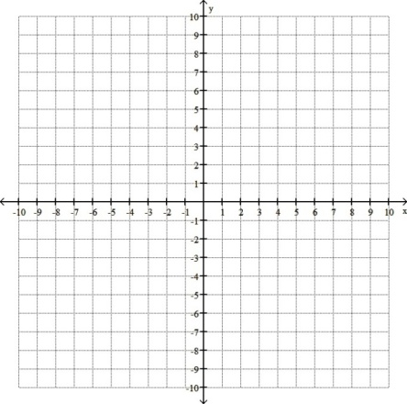

*How to Find Local and Absolute Extrema When an Interval is not Given*

1. Find all critical points of $f$. Note the domain of $f$ (whether or not it’s all reals) and any vertical asymptotes. (If the domain is not all reals, then we want to evaluate the endpoints where the function is defined to check for absolute extrema.)
2. Find where $f$ is increasing or decreasing.
3. Find where $f$ has a local min/max by looking at changes in sign of $f'$.
4. Use the above to get a general idea of the graph to determine if any of the local extrema are absolute extrema.

**Summary:**

We can tell a lot about a function based upon what its derivative tells us.

* In 4.1 we learned it identifies CN’s (potential local extrema) and local extrema only occur at CN’s
* In 4.2 we learned Rolles and MVT, which can help us identify intervals containing local extrema
* In 4.3 we learned that it can identify intervals of “increasingness/decreasingness” as well as identify if a particular CN is a relative max, min, or neither.

**Fun Conceptual Questions:** Consider these problems on your own or with friends, we will not discuss them in class.

* Given the following information about a function $=f(x)$, sketch a graph of the function. Label the $x-$ coordinates for all key points that have been indicated.

1. $y=f(x)$ is defined for all real numbers
2. $f^{'}\left(x\right)=0$ for $x=-2, 1, 3$
3. $f^{'}(x)$ is undefined at $x=5$
4. $f^{''}\left(x\right)=0$ for $x=0,2, 3$
5. $f^{''}(x)$ is undefined at $x=5$
6. $f'$ is $(+)$ on $\left(-∞,-2\right), \left(1,3\right), (5,∞)$ and $(-)$ on $\left(-2,1\right), (3,5)$
7. $f''$ is $(+)$ on $\left(0,2\right)$ and $(-)$ on $\left(-∞,0\right), (2,5), (5,∞)$

* For what values of $a, m,$ and $b$ does the function $f\left(x\right)=\left\{\begin{aligned}3, x=0 \\ -x^{2}+3x+a, 0<x<1 \\ mx+b, 1≤x≤2 \end{aligned}\right.$ satisfy the hypotheses of the Mean Value Theorem on the interval $[0,2]$?

Def: A function is said to be One-to-one if for any $a,b∈Dom(f)$ where $f\left(a\right)=f(b)$ then $a=b$. This means that every $y$ value a function has corresponds to (came from) one and only one $x$ value.

One to one functions are part of the requirements to ensure that a functions inverse will itself be a function.

* Show that strictly increasing functions and strictly decreasing functions are one-to-one. To Show this, show that for any $x_{1} and x_{2}$ in $Dom\left(f\right)where x_{1}≠x_{2}$ then this implies that $f(x_{1})≠f(x_{2})$.
* (Thomas # 58) Prove that $e^{x}≥1+x$ if $x≥0$ Hint: let $f\left(x\right)=e^{x}-x-1$ if you can show that this is an increasing function on $(0,∞)$, a decreasing function on $(-∞,0)$, that $f\left(0\right)=0$, and that there is a local min at x=0 then you would know that $f\left(x\right)≥0$ on $(0,∞)$.