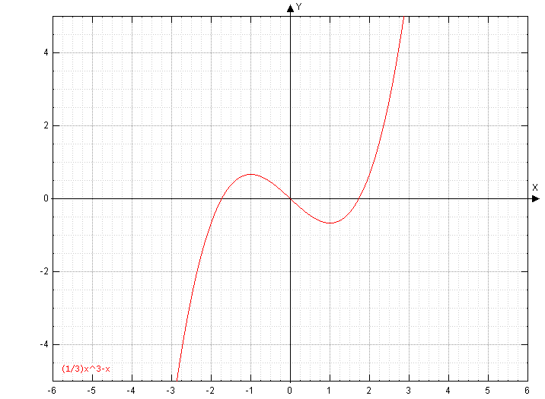
We have already seen how the derivative, $f^{'}(x)$, can help us to find local extrema and even determine if that point will lead to a local max or min. With this information we can help determine the basic shape of a graph. What we can not tell however is the curvature, or what we will call the concavity, of the graph. Take for example the graph of $f\left(x\right)=x^{\frac{2}{3}}$. From the first derivative test we know that there is a critical point at $x=0$. By examining the slopes to the left and right of $x=0$ we can determine that this point is a local min. What we are not sure of is if the graph looks more like a parabola with concave up sides or concave down sides or even straight sides.

Ex: Find the open intervals on which $f\left(x\right)$ is
Concave up and concave down:

The idea of this section is to examine how the slope changes. Since the rate of change of $f^{'}=$ $\frac{d\left(f^{'}\right)}{dx}=f"$ we are going to be looking to $f"$ to guide us.
By knowing if the slope is increasing or decreasing as we move from left to right we can learn a lot about the concavity of the original function. We can also use this information to determine if a critical point is a local max or min.
Consider graph below. Observe the slopes of tangent lines at points to the left of, to the right of, and at 0. Are they increasing or decreasing?

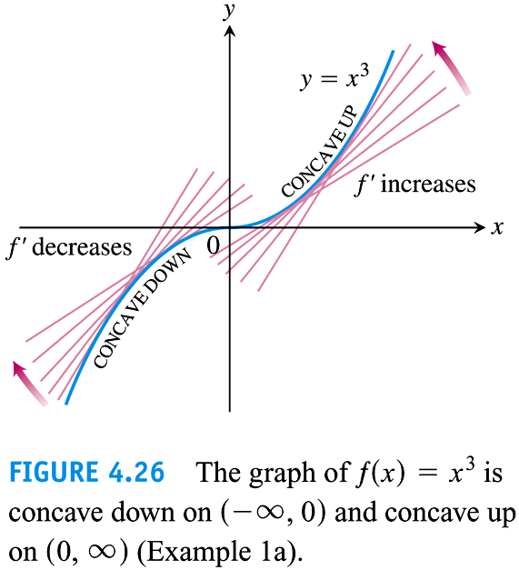

Defn: For the graph of a differentiable function $y=f(x)$,
- If $f'$ is increasing on an open interval$I$, then $f$ is concave up on $I$.
- If $f'$ is decreasing on an open interval $I$, then $f$ is concave down on $I$.

Lets tie this idea down to $f"$

The Second Derivative Test For Concavity
Let $y=f(x)$ be twice-differentiable on an interval $I$.
- If $f^{''}>0$ on $I$, the graph is concave up.
- If$f^{''}<0$ on $I$, the graph is concave down.

NOTE: Since we are looking for places where $f"$ is + and – we will want to look to the right and left of where $f"$ is 0 or undef.

Ex 1 4.4.7 Determine the open intervals on which the graph of $f\left(x\right)=3x^{2}-x^{3}$is concave upward or concave downward.
NOTE: Hardest part of this section is computationally finding the second derivative and displaying it as a factored rational expression.

Ex: (4.4.5) Find the open intervals where $f\left(x\right)=\frac{x^{2}+1}{x^{2}-1}$ is concave up and concave down.

IF time: Try these examples:
Ex: Find the open intervals on which $f\left(x\right)=\frac{1}{x}$ is Concave Up and Down.

Ex: (Students do) (4.4.3) Find the open intervals on which $f\left(x\right)=\frac{24}{x^{2}+12}$ is Concave Up and Down.

Consider the graph of $y=x^{3}$. It has no local min/max but it changes concavity at $(0,0)$ -- this point is called a point of inflection.

DefT Let $f$ be a function that is continuous on an open interval and let $a$ be a point in the interval. The point $\left(a,f\left(a\right)\right)$ is a point of inflection of $f$ if
- The tangent line exists at this point (it could be infinite/a vertical tangent)
AND
- The graph changes concavity at $\left(a,f\left(a\right)\right)$

To check for a point of inflection, be sure the tangent line exists, then check the concavity to the left of $x=a$ then to the right of $x=a$. If the graph moves from CC-up to CC-down or vice versa, then it is a point of inflection.

SKIP THIS NOTE, JUST LEAVE IT IN THE STUDENT NOTES AS IT IS REPITIVE
Note: For the concavity to change the second derivative must change sign. In order to change sign of the second derivative, it must either pass through a point where the value of $f''$ is 0 or undefined. This point will be the point of inflection.
Ex: Find all points of inflection of $f\left(x\right)=\frac{1}{3}x^{3}-x$

Ex: Find any inflection points of $y=x^{6}$, $y=x^{1/3},y=x^{2/3}$.

Ex 3 4.4.20 Find any point of inflection and the open intervals where the function is concave up/down.
$$f\left(x\right)=\frac{x+1}{\sqrt{x}}$$

Or Ex: (4.4.19) 20 Find any point of inflection and the open intervals where the function is concave up/down.
$$f\left(x\right)=\frac{x}{x^{2}+1}$$

Note: In the previous section, if the function had only one local extremum, we used 2 nearby points to determine if the extremum was a local max or local min. However, if we knew the concavity of the graph at the local extrema, then we could tell instantly if it is a local max or a local min.

The 2nd Derivative Test can sometimes do that. It may tell us if the point is a local max or min by evaluating at just 1 point (the local extrema or CN).
Theorem The Second Derivative Test for Local Extrema
Suppose $f''$ is continuous on an open interval that contains $x=c$.
- If $f^{'}\left(c\right)=0$ and $f^{''}\left(c\right)<0$, then $f$ has a local max at $x=c$.
- If $f^{'}\left(c\right)=0$ and $f^{''}\left(c\right)>0$, then $f$ has a local min at $x=c$.
- If $f^{'}\left(c\right)=0$ and $f^{''}\left(c\right)=0$, then the test fails. The function may have a local max, a local min, or neither. (If this happens, use the 1st Derivative Test.)

Ex Find the local max/min values using the 2nd Derivative Test.
- (4.4.33) $f\left(x\right)=x^{3}-3x^{2}+3$

- 4.4.39 $f\left(x\right)=x+\frac{4}{x}$

- $f\left(x\right)=x^{2/3}$

- (Students Easy) 4.4.31 $f\left(x\right)={\left(x-5\right)}^{2}$

- (Students Easy) 4.4.47 $f\left(x\right)=\frac{e^{x}+e^{-x}}{2}$

Extra problems:
- 4.4.42 $f\left(x\right)=2Sin x+Cos 2x on \left[0,2π\right]$

- 4.4.34 $f\left(x\right)=x^{3}-9x^{2}+27x$

- 4.2.52 $f\left(x\right)=x^{2}\log_{3}{x}$ For this problem, also discuss intervals of concavity and points of inflection.

Summary:

Just like the cases where $f(x)$ is a position function, we used the first derivative to tell us about the speed of the object, and we used the second derivative to tell us about the acceleration of the object, so too can we use the first derivative to tell us where on a graph$f(x)$ has local extrema (first derivative) and whether what the curvature of the graph looks like (Second derivative) and where it changes curvature (inflection points). Watch out for silly algebra mistakes!!

