Limits at $∞$ (We discussed this section back in 2.5)

Find $\lim_{x→∞}\frac{1}{x^{4}}$

This limit is asking for the behavior of $f(x)$ as $x$ grows infinitely large ( $x→∞$). This is asking for the tendency of the function. If this limit exists, it will approach what we call a horizontal asymptote. If it is infinite, we will know it will grow without bound. In this case the right and left hand side of the function as x grows without bound, the function will approach the same horizontal asymptote, $y=0$. Can you think of a function where the function will approach a different horizontal asymptote on the left hand side than it will on the right hand side?

(Informal) Defn of Limits at $∞$
We say that $f\left(x\right)$ has the limit L as x approaches infinity and write $\lim_{x→∞}f\left(x\right)=L$ if, $f(x)$ gets arbitrarily close to $L$ (as close as we want) as for all sufficiently large $x$.

We say that $f\left(x\right)$ has the limit L as x approaches minus infinity and write $\lim_{x→-∞}f\left(x\right)=L$ if, $f(x)$ gets arbitrarily close to $L$ (as close as we want) as for all sufficiently small $x$.

(Formal) Defn of Limits at $∞$
Let L be a real number.
- The statement $\lim_{x→∞}f\left(x\right)=L$ means that for each $ε>0$ there exists an $M>0$ such that
If for all $x>M$ then $\left|f\left(x\right)-L\right|<ε$
- The statement $\lim_{x→-∞}f\left(x\right)=L$ means that for each $ε>0$ there exists an $n<0$ such that
If for all $x<N$ then $\left|f\left(x\right)-L\right|<ε$

Defn A line $y=b$ is a horizontal asymptote of the graph of a function $y=f(x)$

if either $\lim_{x→∞}f\left(x\right)=b$ or $\lim_{x→-∞}f\left(x\right)=b$.

Limits at $∞$
- If $r$ is a positive rational number and $c$ is any real number, then
$$\lim_{x→∞}\frac{c}{x^{r}} =0 \& \lim_{x→-∞}\frac{c}{x^{r}} =0$$

The second limit is valid only if $x^{r}$ is defined when $x<0$.

- $\lim_{x→∞}e^{-x} =0 \& \lim_{x→-∞}e^{x} =0$

We say that $f\left(x\right)$ has the limit L as x approaches minus infinity and write $\lim_{x→-∞}f\left(x\right)=L$ if, $f(x)$ gets arbitrarily close to $L$ (as close as we want) as for all sufficiently small $x$.

Ex: Find:
- $\lim_{x→∞}\frac{1999}{x^{r}}$
- $\lim_{x→∞}\frac{x}{x^{r}}$
- $\lim_{x→-∞}e^{3x}$
- $\lim_{x→∞}e^{-x^{2}}$
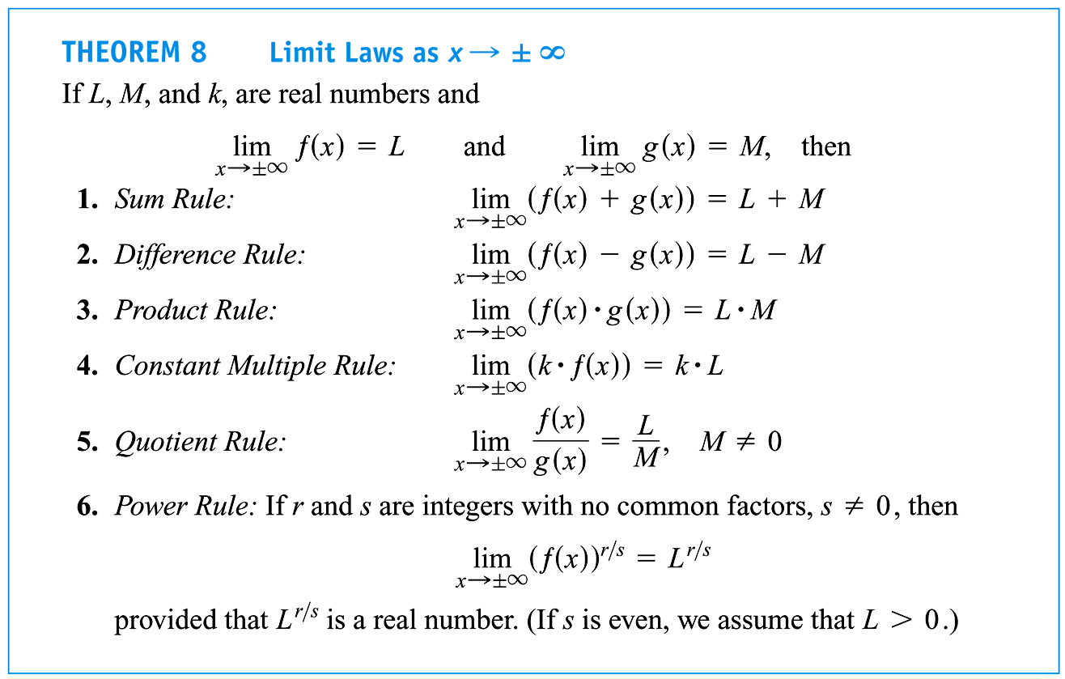
Limits of Rational Functions at $±∞$
Let $f\left(x\right)=\frac{p\left(x\right)}{q\left(x\right)}$ be a rational function.
- If the $\deg{p(x)}=\deg{q(x)}$, then $\lim_{x→±∞}f\left(x\right)= \frac{leading coef of p(x)}{leading coef of q(x)}$ and $y=\frac{leading coef of p(x)}{leading coef of q(x)}$ is a horizontal asymptote.

- If $\deg{p(x)}<\deg{q(x)}$, then $\lim_{x→±∞}f\left(x\right)=0$ and $y=0$ is a horizontal asymptote.

- If $\deg{p(x)}=\deg{q(x)}+1$, then $\lim_{x→±∞}f\left(x\right)=mx+b$ and $y=mx+b$ is an oblique/slanted asymptote.
Ex: $f\left(x\right)=\frac{2x^{2}+x+1}{x}=\underbrace{2x+1}+\frac{1}{x}$
Eqn of slant asymptote.

Ex: Find
- $\lim_{x→∞}\frac{13x^{5}+12x^{4}-11x^{3}+2}{2x^{5}-3}$
- $\lim_{x→∞}\frac{12x^{4}-11x^{3}+2}{2x^{5}-3}$
- $\lim_{x→∞}\frac{13x^{5}+12x^{4}-11x^{3}+2x^{6}}{2x^{5}-3}$

- What is the horizontal asymptote of the previous example a)?

- Can a graph ever cross it’s vertical asymptote?
- Horizontal?

Defn In a rational function, if the degree of the numerator is one more than the degree of the denominator, the graph has an oblique (slanted) asymptote. (The oblique asymptote is found by performing long division.)

Find the slant asymptote of the function $f\left(x\right)=\frac{13x^{5}+12x^{4}-11x^{3}+2x^{6}}{2x^{5}-3}$
$$\frac{13x^{5}+12x^{4}-11x^{3}+2x^{6}}{2x^{5}-3}=\underbrace{x+\frac{13}{2}}+\frac{12x^{4}-11x^{3}+3x+\frac{39}{2}}{{2x}^{5}-3}$$

Slant Asymptote
General function behavior (near $x=-1$)

Try At Home Example:
Find the slant asymptote of the function $f\left(x\right)=\frac{x^{2}+3x+1}{x+1}$
$$\frac{x^{2}+3x+1}{x+1}=\underbrace{x+2}-\frac{1}{x+1}$$

Slant Asymptote
General function behavior
(near $x=-1$)

Ex Find the limit and graph of each. [Show on virtual TI-83 if time permits.]
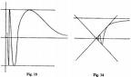
- $\sin{\frac{1}{x}}$ as $x→∞$

- $xsin\frac{1}{x}$ as $x→∞$

Ex: 4.5.32 Find $\lim_{x→∞}{\frac{3(x-Cos x)}{x}}$ (need to employ Sandwich Theorem for part of this)

Ex: Find the limit:
- 4.5.28 $\lim_{x→-∞}\frac{x}{\sqrt{x^{2}+1}}$

- 4.5.34 $\lim_{x→∞}Cos\frac{1}{x}$

- 4.5.40 $\lim_{x→∞}\left(\frac{5}{2}+\ln{\frac{x^{2}+1}{x^{2}}}\right)$

- 4.5.41 $\lim_{t→∞}\left(\frac{5}{t}-arcTan t\right)$

Ex: $4.5.74$Sketch the graph of the equation. Look for any extrema, intercepts, symmetry, asymptotes, and curvature. $f\left(x\right)=\frac{2x}{1-x^{2}}$
Assume: $f^{'}\left(x\right)=\frac{2+2x^{2}}{1-x^{2}}>0 \& f^{''}\left(x\right)=\frac{4x{\left(1-x^{2}\right)}^{2}-\left(2+2x^{2}\right)\left(-4x+4x^{3}\right)}{{\left(1-x^{2}\right)}^{4}}=\frac{-4x\left(x^{2}-1\right)\left(x^{2}+3\right)}{{\left(1-x^{2}\right)}^{4}}=0$
$$@x=0,-1,1$$

