What is linearization? It is the process of approximating functions as lines (at points in a neighborhood of a point where the function is differentiable) using tangent lines. In truth it is little more then using the slope of the tangent line at that point to be the slope of our linear approximation.

Ex Consider the Graph $y=x^{2}$ below and it’s tangent at $(1,1)$. Observe what happens as we magnify the graph at $(1,1)$.
- Conclusion: ___________________________________________________________________________

The tangent line at $x=1$ is called the linearization of $f$ at 1 and is a good approximation of $f$ for values near 1.
- Why would we want to find the linearization of a function? _____________________________________________________________________________________

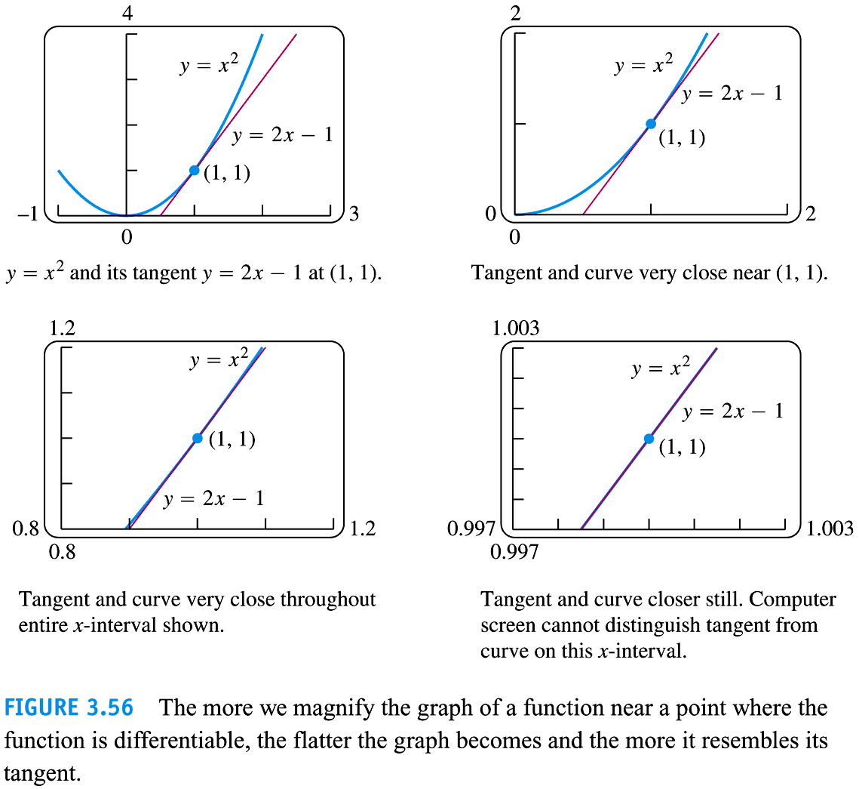
Note: We can also approximate functions using polynomials. There are a special type of functions called Bernstein Polynomials which are a continuous approximation of any continuous function.

Cool Fact: Some functions, in fact, MANY functions except the few types we look at in this book, are nowhere differentiable but continuous. That means that for these functions, this linearization process doesn’t work to approximate function values. Also, if we were to zoom in on any point of their graph, it would be “infinitely spiky”.

What would we want from a good approximation, $L(x)$, of a function?

To be a good liner approximation of a function it should:
a) have the same value at the point $x=a$, hence_______________,and
b) it should have the same slope at the point $x=a$ , hence_________________.
Now to make it so that at the point $x=a$ $L\left(a\right)=f(a)$ we need $f^{'}(a)$ to go away.
To do this we multiply $f^{'}(a)$ by $(x-a)$.

Then we get $L\left(x\right)=$_________________________________

Defn
If $f$ is differentiable at $x=a$, then the approximating function $L\left(x\right)=$___________________________ is the linearization of $f$ at a. The approximation $f(x)≈L(x)$ of $f$ by $L$ is the standard linear approximation of $f$ at a. The point $x=a$ is the center of the approximation.

Notice: This is the same line we used in Newton’s Method. It is called the first degree Taylor Polynomial and you will work with them more in section 9.7.

As the saying goes, if it looks like a duck and walks like a duck, then its probably a duck, or at least it would make a good replacement for a duck.

Ex 1 Find the linearization $L(x)$ of $f\left(x\right)=\sqrt{x^{2}+9}$ at the point $(-4,5)$ so $a=-4$.

Discussion: We sometimes use Leibniz’s notation $\frac{dy}{dx}$ to denote the derivative of $y$ wrt $x$. Although $\frac{dy}{dx}$ looks like a ratio/fraction, it’s not. It’s a function of $x$. So at this point, $dy$ alone does not make sense. However, we will now define $dy$ and $dx$ as variables with the property that it their ratio exist, it will equal the derivative.
Before section 3.10, couldn’t do this (because if $du=0$ the expression would be undefined):

So in order to make this notation meaningful we define the following:
Defn Let $y=f(x)$ be a differentiable function on an open interval containing $x$.
The differential of x, $dx$, is a non-zero number. The differential $dy$ is defined to be $dy=f^{'}\left(x\right)dx$.

Notice, this is just saying that the actual change in a function $∆y$ can be approximated by the differential $dy$. Also notice that $dy$ is the change in our linearization function, and that for really small neighborhoods around $x=a$, $∆y≈dy$

Consider the pix below for Geometric Interpretation of $dy$:
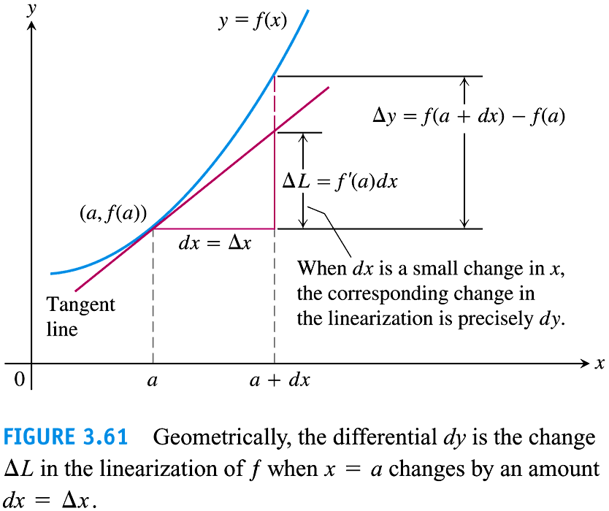

Note that:
- $dx=Δx$
- $Δy=f\left(a+dx\right)-f(a)$
- $ΔL=L\left(a+dx\right)-L\left(a\right)$

$=$____________________________________

$=$_____________________________

$:=$_______

So, the differential $dy$ is the change in the linearization of $f$, $ΔL$, when $a$ changes by an amount $dx$. (If $Δx$ is small, the vertical change in the tangent line from $a$ to $a+dx$ is precisely $dy=f^{'}\left(a\right)dx$.)

Notation: We can write $df=f^{'}\left(x\right)dx$ in place of $dy=f^{'}\left(x\right)dx$. $df$ is called the differential of $f$.

So differential formulas like $\frac{d\left(u-v\right)}{dx}=\frac{du}{dx}-\frac{du}{dx}$ can be written as $d\left(u-v\right)=du-dv$.
Ex: Comparing $Δy \& dy$: 4.8.8 Use the information to evaluate and compare $Δy \& dy$ if
$y=1-2x^{2}$, $x=0$, $Δx=dx=-0.1$

For your own reading pleasure!!
How would you find the error between these two values?

Error in Differential Approximation
Let $f$ be a differentiable at $x=a$ and let $dx=Δx$. Consider the change in $f$ as $x$ changes from $a$ to $a+Δx$.
True Change: $Δy=∆f=f\left(a+Δx\right)-f(a)$
The Differential Estimate: $dy=df=f^{'}(a)Δx$

To find the error, we simply look at the difference between the true change and the differential estimate:

$Δy-dy=\left[f\left(a+Δx\right)-f\left(a\right)\right]-f^{'}\left(a\right)dx=\left(\frac{f\left(a+Δx\right)-f\left(a\right)}{Δx}-f^{'}\left(a\right)\right)∙Δx$ .

Now by choosing to Let $ε=\frac{f\left(a+Δx\right)-f\left(a\right)}{Δx}-f^{'}\left(a\right)$ (the difference quotient minus $f^{'}(a)$), we have the error is $ε∙ Δx$.

Note that as $Δx→0$, $ε→0$ since $f$ is differentiable at $a$.
Change in $y=f(x)$ near $x=a$
If $y=f(x)$ changes from $a$ to $a+Δx$, the change in $Δy$ in $f$ is given by an equation of the form
$y=f^{'}\left(a\right)Δx+εΔx$ in which $ε→0$ as $Δx→0$.

Ex 2 Find the differential of each function, $dy,$ for the following functions.

Ex 3 4.8.34 Write a differential formula that estimates the change in volume $V=x^{3}$ of a cube when the edge lengths change from $x_{0}$ to $x_{0}+dx$.
Note from $x_{0}$ to $x_{0}+dx$ this is a $∆x$ distance of $dx$

how will a $possible error of 0.03 cm$ in side length affect its volume if $x_{0}=12 cm$?

Ex: 4.8.48 Use a linearization approximation to approximate the value of the expression $\sqrt[3]{26}$

Summary: Linearization is a good way to approximate differentiable functions.

Differentials allow us to consider the term $\frac{dy}{dx}$ as the quotient of two amounts $dy \& dx$.
This also allows us to estimate the error propagated in a function (Volume, areas, etc.) if the input value is not exact ($x±∆x)$.
This is a highly important idea for engineers and physicists as they are constantly approximating the actual world with equations that assume away many difficulties. When this is done, it is crucial to be able to calculate the propagated error created by these assumptions. This is one of the major applications of this section.

Also, this section ties in the ideas from Newton’s method and sets us up for the topic of Taylor polynomials in a later section.

