Hyperbolic functions arose from looking at the area under a hyperbolic curve. They are commonly used when dealing with curves that are catenary, curves created by hanging a rope/cable which is supported only at its two ends. Some examples of catenary curves are a jump rope, the support cables on the golden gate bridge, & the St. Louis Arch.
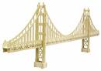

Ordinate \Or"di*nate\, n. (Geom.)
The distance of any point in a curve or a straight line,
measured on a line called the axis of ordinates or on a line
parallel to it, from another line called the axis of
abscissas, on which the corresponding abscissa of the point
is measured.

Note: The ordinate and abscissa, taken together, are called
co["o]rdinates, and define the position of the point
with reference to the two axes named, the intersection
of which is called the origin of co["o]rdinates. See
Coordinate.
We now define the Hyperbolic Functions below.
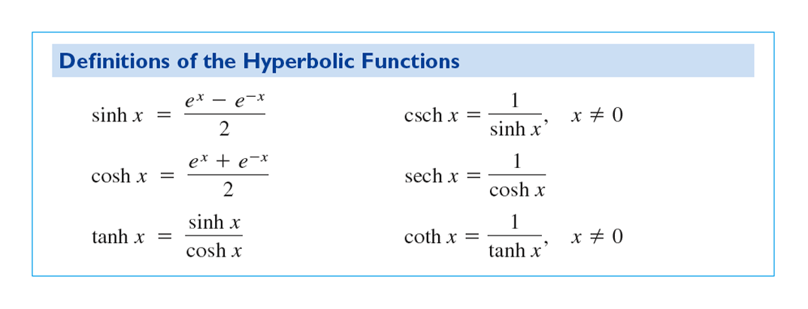
And their graphs are given below. Notice that the graph of Sinh(x) can be obtained by addition of ordinates using the exponential functions $f\left(x\right)=\frac{1}{2}e^{x}$ and $g\left(x\right)=-\frac{1}{2}e^{-x}$. Like wise for Cosh(x) for $f\left(x\right)=\frac{1}{2}e^{x}$ and $h\left(x\right)=\frac{1}{2}e^{-x}$.
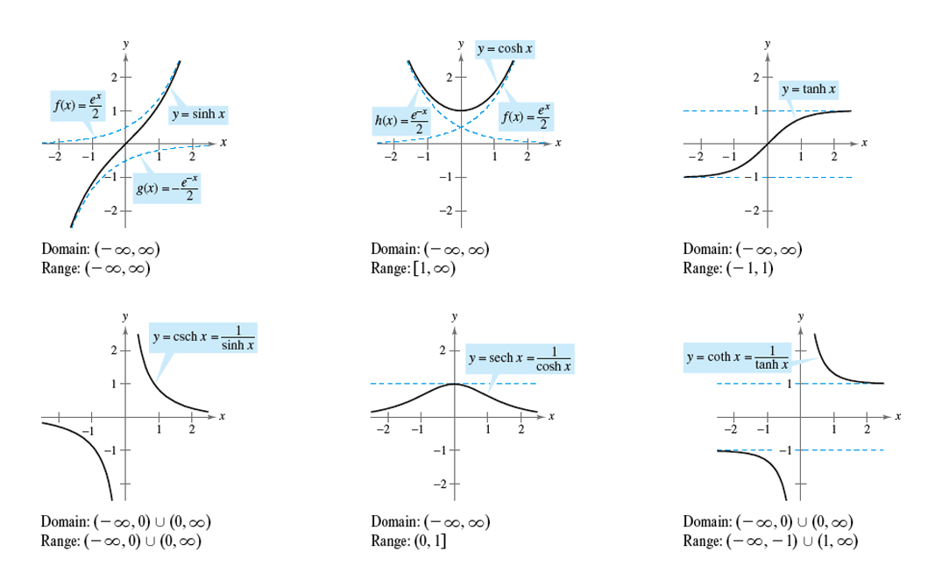

Many of the identities of the hyperbolic trig. Functions have a corresponding identity.
Ex: $Cosh\left(x+y\right)=Cosh x Cosh y+Sinh x Sinh y$

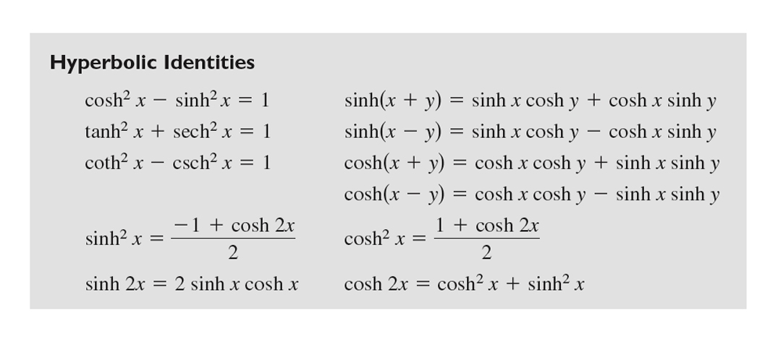

Ex: 5.9.13 Use the value of the given hyperbolic function to find the values of the other hyperbolic functions at x. If $Sinh x=\frac{3}{2}$.

Taking derivatives of the hyperbolic functions. This is as easy & difficult as taking the derivative of $e^{x}$.

Ex: Find $\frac{d(\cosh{x)}}{dx}$ Ex: Find $\frac{d(\operatorname{Sinh}{x)}}{dx}$

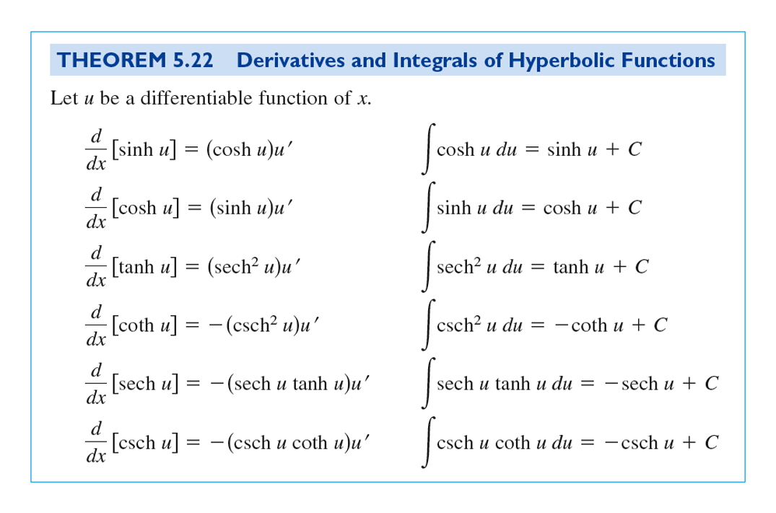
The basic derivatives of the hyperbolic functions are given below.

Ex: 5.9.18 Find the derivative of $f\left(x\right)=ln⁡(\cosh{x)}$

Ex: If $y=7x Cosh x-7 Sinh x$, find $y'$. (Simplify your answer)

Similar to 5.9.33 T / F The function $y=a Sinh x$ satisfies the differential equation $y^{'''}-y^{'}=0$

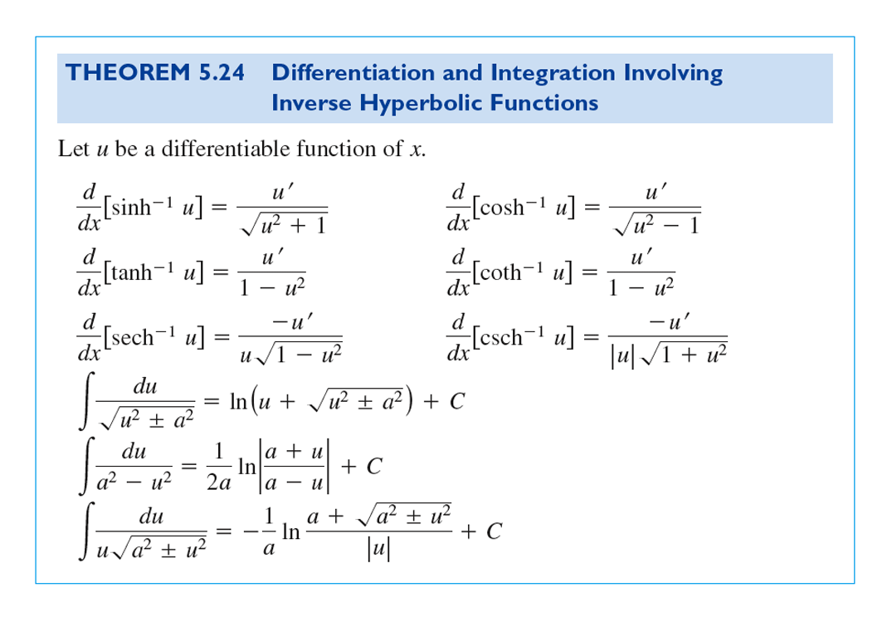
Some Inverse Hyperbolic Functions and their derivatives and integrals:

