# Areas of a Region Between Two Curves

The point of this section is to consider how to find areas of more complex shapes, namely how do we find the area beneath one curve but not above the x-axis but rather above another curve.

In the next section we will use this as the bases for finding areas and even volumes of even more complicated shapes.

## Example:

# Area of a Region Between Two Curves

If $f \& g$ are continuous on $[a,b]$ and $g\left(x\right)≤f(x)$ for all $x$ in $[a,b]$, then the area of the region bounded by the graphs of $f \& g$ and the vertical lines $x=a \& x=b$ is

$$A=\int_{a}^{b}{[f\left(x\right)-g\left(x\right)]}dx=\int_{a}^{b}{[top\left(x\right)-bottom\left(x\right)]}dx$$

Consider the orange shaded region between the graph of $f(x)=\cos{x}$& $g\left(x\right)=\sin{x}$ on $x=0 to x=\frac{π}{4}$.

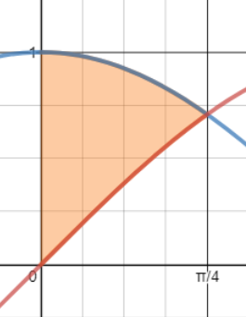

Note $f\left(x\right)=\cos{x}=\sin{x}=g\left(x\right)$

$$→1=\tan{x}$$

$$→x=\frac{π}{4}+πn, nϵZ$$

We know that areas below curves and above the x axis are given by the definite integral.

So, we know that each integral below corresponds to the shaded region beneath it.

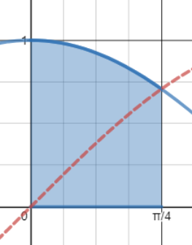 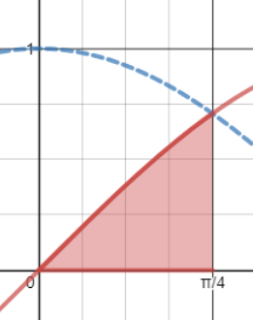 

And visually the area between the two curves $f\left(x\right) \& g(x)$ is simply the first area $f(x)$ with the second area $g(x)$ subtracted (removed) from it.

**How do we find the area of this shaded region?** Will this still be the case if one of the functions is above the x-axis and the other is below?

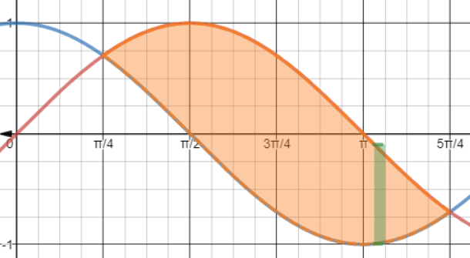

<https://www.desmos.com/calculator/dthhmojt2o>

Lets look at the region between $g\left(x\right) \& f\left(x\right),$ and then underneath the curve of $(g-f)(x)$ on

[What is this graph illustrating?](https://www.desmos.com/calculator/5axznldxwb) Of the many ideas that can be pulled from this, what do you notice?

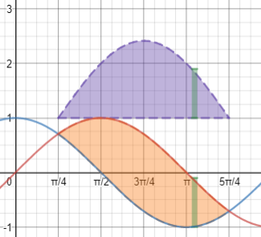

$$A=$$

How do we find the area of this shaded region? Will anything change if both the functions are below the x-axis, or is it top – bottom? Will we reverse the subtraction? What do we notice is the overall pattern?

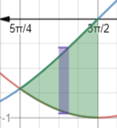<https://www.desmos.com/calculator/bdhzdpkvql>

If you want to see which areas consist of y-values that are bigger than $g(x)$ but less than $f(x)$

i.e. $f(x)$ is the top function and $g(x)$ is the bottom one or in math $g\left(x\right)<y<f\left(x\right)for\{0<x\}$

we can [let desmos show us](https://www.desmos.com/calculator/hcvbgyzbw5) what that looks like, and if that region is effected by being above or below the x-axis.

If you want to see which areas consist of y-values that are bigger than $f(x)$ but less than $g(x)$

i.e. $g(x)$ is the top function and $f(x)$ is the bottom one or in math $f\left(x\right)<y<g\left(x\right)for\{0<x\}$

we can [let desmos show us](https://www.desmos.com/calculator/qlordgdjed) what that looks like, and if that region is effected by being above or below the x-axis

Question: **T** or **F** If $f\left(x\right)\& g(x)$ are both continuous functions on $[a,b]$ where $g\left(x\right)≤f(x)$ on $[a,b]$ then no matter if $f\left(x\right)<0$ or $f\left(x\right)>0$ the area between the two curves is always given by the integral

$$A=\int_{a}^{b}{\left[f\left(x\right)-g\left(x\right)\right]}dx$$

Or equivalently in psudo math terms

$$A=\int_{a}^{b}{\left[top\left(x\right)-bottom\left(x\right)\right]}dx$$

Answer: **True False**

# ­Example: The integrand of the definite integral is a difference of two functions. Sketch the graph of each function and shade the region whose area is represented by the integral, $\int_{-1}^{1}{\left[\left(1-x^{2}\right)-\left(x^{2}-1\right)\right]dx}$

## Solution:

L4e: 7.1.8 Note:

 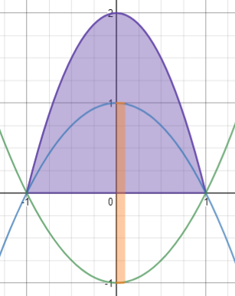

# ­Example: Sketch the region bounded by the graphs of

# $f\left(y\right)=y\left(2-y\right)\& g\left(y\right)=-y$, then set up and find the area of the region.

## Solution:

L4e: 7.1.28



# ­Example: Sketch the region bounded by the graphs of

# $f\left(x\right)=\sqrt[3]{x-1} \& g\left(x\right)=x-1$, then set up and find the area of the region.

## Solution:

L4e: 7.1.26



# ­Example (if time or student do at home): Sketch the region bounded by the graphs of

# $f\left(x\right)=\sin{x} \& g\left(x\right)=\cos{2x} for-\frac{π}{2}≤x≤\frac{π}{6}$,

# then set up and find the area of the region.

## Solution:

L4e: 7.1.44

Note: if $\cos\left(2x\right)=sinx→\cos^{2}{x}-\sin^{2}{x}=1-2\sin^{2}{x}=sinx→2\sin^{2}{x}+\sin{x}-1=0→\left(2sinx-1\right)\left(sinx+1\right)=0→x=-\frac{π}{2},\frac{π}{6}$

