# Volumes of Revolution

In the next two sections we will be inquiring into the process of finding the volumes of shapes that that are or can be thought of as a 2-D shape that has been revolved around an axis. Such shapes are called Solids of Revolution.

For Example a cone is a solid of revolution. If you take a triangle formed by the line segments bounded by the points $\left(0,0\right),\left(0,2\right),(1,0)$ and then rotate this triangle about the y-axis you will create a solid region which is a cone with a base radius of 1 unit and height of 2 units.

# Calculating the Volume of a Solid of revolution

In this example, we can use a known geometric formula to find the area of the cone (this was already known in the time of Greek geometers such as Democritus and Euclid of Alexandria), but we can now find this volume by means of calculus. As we have seen before, calculus often the mixture of the method of exhaustion combined with the concept of limits.

We will consider the cone as a finite number of slices of small volumes of either discs (cylinders) or shells (hollow cylinders) with some small, $dx$, thickness. We will then add up all these slices and take the limit of this ever increasing number of slices, the process we have come to recognize as integration.

# An Example using the Disk Method (cylinder or washer method) to find the Volume of Revolution of our Cone.

Consider the depiction of the cone from above. <https://www.geogebra.org/m/xG6svqyH>

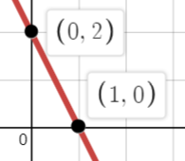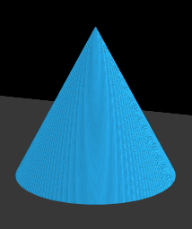 note: $r=1 and h=2$. What is

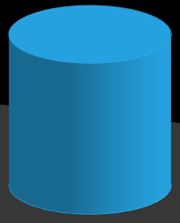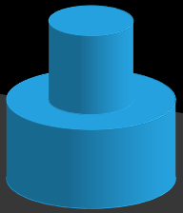 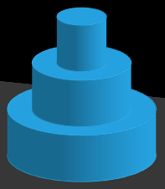 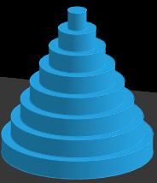 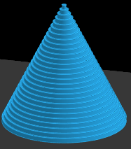 

Volume:

$V_{1}$ $V_{2}$ $V_{3}$ $V_{8}$ $V_{n}$ $V_{cone}$

$V_{1}=A∙h=πr^{2}∙h=π{\left(1\right)}^{2}∙2$

$$V_{2}=π{\left(1\right)}^{2}∙1+ π{\left(\frac{1}{2}\right)}^{2}∙1$$

$$V_{3}=π{\left(1\right)}^{2}∙\frac{2}{3}+ π{\left(\frac{2}{3}\right)}^{2}∙\frac{2}{3}+π{\left(\frac{1}{3}\right)}^{2}∙\frac{2}{3}$$

$$∶$$

$$V_{8}=\sum_{i=1}^{8}{π{\left(\frac{9-i}{8}\right)}^{2}∙\frac{2}{8}}$$

$$V_{n}=\sum_{i=1}^{n}{A_{i}∙dh_{i}}=\sum_{i=1}^{n}{π{\left(r_{i}\right)}^{2}∙dh_{i}}=\sum_{i=1}^{n}{π{\left(\frac{9-i}{n}\right)}^{2}∙\frac{2}{n}}$$

$$V_{cone}=\lim_{n→∞}{\sum_{i=1}^{n}{A_{i}∙dh_{i}}}=\int_{y=0}^{y=2}{π{\left(r\left(y\right)\right)}^{2}dy}=\int_{y=0}^{y=2}{π{\left(\frac{y-2}{-2}\right)}^{2}dy}=\frac{2π}{3} {units}^{3}$$

### Can you fill in the details for why this is true?

# The Disk Method (cylinder method)

The line passing through the points (0,2) & (1,0) is given by $y=-2x+2$ where y is a function of x

Or it can be rewritten as a function of y by simply solving the function for x in terms of y,

$x=\frac{y-2}{-2}=r(y)$

$$\int_{y=0}^{y=2}{π{\left(\frac{y-2}{-2}\right)}^{2}dy}=\frac{π}{4}\int_{y=0}^{y=2}{\left(y^{2}-4y+4\right)dy}=\frac{π}{4}[\frac{y^{3}}{3}-\frac{4y^{2}}{2}+4y|\begin{matrix}2 \\ 0\end{matrix}=\frac{π}{4}[\frac{8}{3}-8+8-\left(0\right)]=\frac{2π}{3}$$

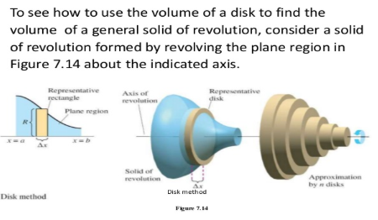

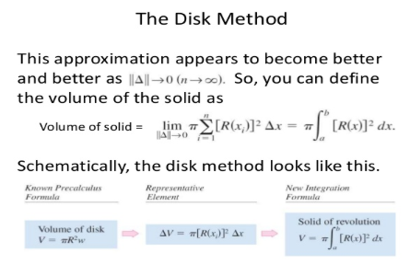

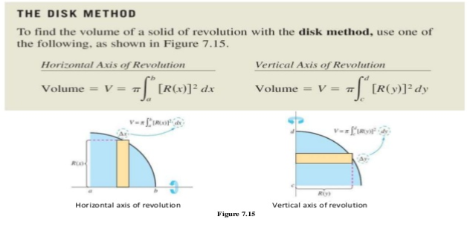

*from Larson Calculus with early transendentals 4th ed. Pg497

# Example: Find the volume of revolution generated revolving the region bounded by $y=2x^{2},y=0,\& x=2$ about the a) x-axis and b) y-axis

## Solution:

L4e: 7.2.12

a)  b) 

# Example: Find the volume of the solid generated by revolving the region bounded by $y=\frac{1}{2}x^{2}, y=4, x=0$ about the line $y=4$.

## Solution:

L4e: 7.2.1



# The Washer Method (the 3-D volume analogy to the area between two curves)

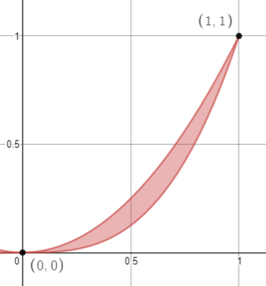Lets consider the instance that we want to find the area between two curves $y=x^{2} \& y=x^{3}$. Now lets consider revolving this region about the x-axis. What we would get is a sort of hollowed out Hershey’s Kiss. Physically, one way to create this Solid of Revolution would be to create the solid of revolution from rotating the top function of the region about the x-axis, and then remove the solid of revolution created by rotating the bottom function about the same x-axis.

The equations for this would look like:

$V_{region}=\int_{x=0}^{x=1}{π{\left[x^{2}\right]}^{2}dx}-\int_{x=0}^{x=1}{π{\left[x^{3}\right]}^{2}dx}$

We can clean this up a bit by using some properties of the integral to

$$V_{region}=\int_{x=0}^{x=1}{\left(π{\left[x^{2}\right]}^{2}-π{\left[x^{3}\right]}^{2}\right)dx}=π\int_{x=0}^{x=1}{\left({\left[x^{2}\right]}^{2}-{\left[x^{3}\right]}^{2}\right)dx}$$

In more generalized form the washer method would look like this

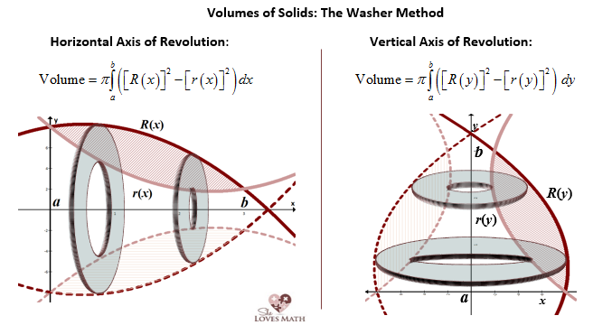

*from: <https://www.shelovesmath.com/wp-content/uploads/2017/01/Washer-Method-Drawing.png>

Where $R(x)$ is the topmost function (radius) and $r(x)$ is the bottom or innermost function (radius)

Caution:

It is important to note that this formula cannot be shortened to

Wrong: Correct:

$$π\int_{a}^{b}{{\left(R\left(x\right)-r\left(x\right)\right)}^{2}dx}≠π\int_{a}^{b}{(\left[{R\left(x\right)]}^{2}-{\left[r\left(x\right)\right]}^{2}\right)dx}$$

For the simple reason that ${\left(x-y\right)}^{2}≠(x^{2}-y^{2})$ as the squaring function is not distributive in this way.

So it is helpful to remember that we are just subtracting one volume from the other volume.

# Example: Set up the integral to find the volume of the solid generated by the region bounded by $x=0,y=2,y=4 \& y=\sqrt{x}$ about the a) x-axis & b) y-axis.

As a follow up, look at example 4 in 7.2 in the book.

## Solution:

L4e: $\sim$ 7.2.42

1. X-axis, using a dx element

Since the functions on top and bottom are not consistent throughout the region, we will have to break this up into two solids.

$$π\int_{x=0}^{x=4}{\left(4^{2}-2^{2}\right)}dx+ π\int_{x=4}^{x=16}{\left(4^{2}-{\left[\sqrt{x}\right]}^{2}\right)}dx$$

If we wanted to use a dy element, we would no longer have a disk or a washer, instead we would have a “shell” or “hollow pipe” and for this we will need a new approach which will be highlighted in section 7.3

1. Y-axis using a dy element

$$π\int_{y=2}^{y=4}{\left({[y^{2}]}^{2}\right)}dy$$

This time, to use a dx element would produce the “shell\hollow pipe”

# Generalization to volumes where the base area is not that of a circle but instead some other function of a variable.

Volumes of Solids with Known Cross Sections

If you have a cross sectional area that is a function of x, $A\left(x\right),$ which is perpendicular to the x-axis

$$Volume=\int_{x=a}^{x=b}{A(x)}dx$$

If you have a cross sectional area that is a function of y, $A\left(y\right),$ which is perpendicular to the y-axis

$$Volume=\int_{y=a}^{y=b}{A\left(y\right)}dy$$

# Find the volume of the solid formed by having a bounding base shaped of a circle with radius 2, centered at the origin, but has a perpendicular cross section of a square.

## Solution:

L4e: 7.2.62

 

# Exercises to consider:

7.2.48 Prove the volume formula for a sphere by finding the volume bounded by a circular base region with radius r, and centered at the origin, whose cross section is that of a circle.

7.2.49 Prove the volume formula for a cone by finding the volume of a triangular region bounded by the points $\left(0,0\right),\left(0,h\right),\& (r,0)$ and revolving it about the y-axis.(see example 7 in book if guidance is needed)