The focus of the section is to use integrals to find the length of a curve of finite length, then to revolve that length about an axis and attempt to use integrals to find the surface area of solids of revolution.

# Draw the curve and find the length of the curve/line that joins the points $\left(0,0\right),\left(1,1\right),\left(2,3\right),\left(6,6\right),(7,6)$

## Solution:

$$d_{1}=\sqrt{1^{2}+1^{2}}=\sqrt{2}$$

$$d_{2}=\sqrt{{(2-1)}^{2}+{(3-1)}^{2}}=\sqrt{5}$$

$$d_{3}\left(3,4,5\right)∆=\sqrt{{(3)}^{2}+{(4)}^{2}}=5$$

$$d_{4}=\sqrt{{(7-6)}^{2}+{(6-6)}^{2}}=1$$

Length = $\sqrt{2}+\sqrt{5}+6$

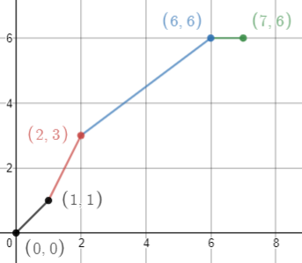

# Finding the Length of a Curve

The main idea behind the arc length formula is simply the distance formula. We will break up the curve using a partition of the x-axis. This will give us $∆x_{i}$ and $∆y_{i}$ for each increment, and the approximate length of the curve can be found using the distance formula, $d_{i}=\sqrt{∆x_{i}^{2}+∆y_{i}^{2}}$. Add up all these lengths and you have an approximate length, $S≈\sum_{i=1}^{n}{\sqrt{∆x_{i}^{2}+∆y_{i}^{2}}}$. Use limits as the norm of your partition goes to zero and you will arrive at the actual length of the curve, $=\lim_{\left\|∆\right\|→0}{\sum_{i=1}^{n}{\sqrt{∆x_{i}^{2}+∆y_{i}^{2}}}}$.

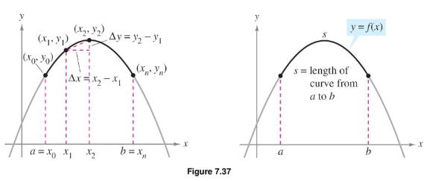

In order to whip this into the integral we need a fairly strong requirement,

$f'(x)$ must be continuous on $[a,b]$ (in order to utilize the result of the MVT).

If this case is met, then $f(x)$ is both continuous and smooth.

Do a little factoring and algebra, and apply the MVT and we arrive at the relatively simple result

for the details of this last part of the proof, see the text on pg 476 or come see me in office hours and we can discuss them together.

# The Definition of Arc Length

Let the function given by $y=f(x)$ represent a smooth curve on the interval $\left[a,b\right].$ The **arc length** of $f$ between $a \& b$ is

$$S=\int_{a}^{b}{\sqrt{1+f^{'}{\left(x\right)}^{2}}dx}$$

Or if $x=g(y)$ is a smooth curve on $[c,d]$ then the **arc length** of $g$ is given by

$$S=\int_{c}^{d}{\sqrt{1+g^{'}{\left(y\right)}^{2}}dy}$$

# Example: Find the arc length of the graph of the function $f\left(x\right)=\ln\left(cosx\right)$ over $\left[0,\frac{π}{3}\right]$

## Solution:

L4e 7.4.10

 

# Example: Prove that the arc length of a circle with radius r is $2π\left(r\right).$

## Solution:

Assuming the circle to be centered at the origin, $f\left(x\right)=\sqrt{r^{2}-x^{2}}$; $f^{'}\left(x\right)=\frac{-x}{\sqrt{r^{2}-x^{2}}}$ we will find the arc length of the quarter circle then 4 times that length.

$$\sqrt{1+{f'(x)}^{2}}=\sqrt{1+\frac{x^{2}}{r^{2}-x^{2}}}=\sqrt{\frac{r^{2}}{r^{2}-x^{2}}}$$

$$\int_{a}^{b}{\sqrt{1+{f^{'}\left(x\right)}^{2}}}dx=4\int_{x=0}^{x=r}{\sqrt{\frac{r^{2}}{r^{2}-x^{2}}}dx}=4\int_{x=0}^{x=r}{r\sqrt{\frac{1}{r^{2}-x^{2}}}dx}=4r\int_{x=0}^{x=r}{\frac{1}{\sqrt{r^{2}-x^{2}}}dx}$$

$$=4r[arcSin\left(\frac{x}{r}\right)|\begin{matrix}r \\ 0\end{matrix}=4r\left[arcSin\left(\frac{r}{r}\right)-arcSin\left(\frac{0}{r}\right)\right]=\frac{4rπ}{2}-0=2πr QED$$

Def: If the graph of a continuous function is revolved about a line, the resulting surface is a **surface of revolution**.

In order to find the surface area of a surface of revolution, we start with the simple idea of the surface area of a cylinder, $2πrh$, which has a constant radius along its surface. If we have a radius that is not constant, but rather a straight line, from geometry, we know that the surface area of a cone and the frustum of a cone are similar in their formulas to the cylinder; $2πrL$ where $L$ is the slant height or length of the line which was revolved.

So the idea is to think of our surface area as a bunch of little frustums whose surface area we will add up, $\sum{2πrL}$.

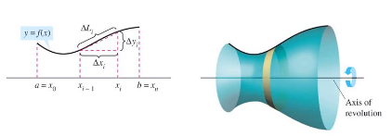

But how do we do it?

First, lets assume we have a smooth and continuous curve $f(x)$ on $[a,b]$ rotated about the x-axis. Once again we will partition the interval $[a,b]$, then we will treat each arclength as a small line segment with length $∆L_{i}$. If we consider the $i^{th}$ subinterval, to calculate the surface area of this small approximation of a frustum the surface area will approximately be $2πr_{i}L_{i}$

To find $r_{i},$ we notice that there will potentially be two different radii, but in our approximation we will let $r_{i}=r_{avg}$, the average radius. But since this is a continuous curve, by the intermediate value theorem, there will exist an x-value, $d_{i}∈(x_{i-1},x_{i})$ such that $\left(d_{i}\right)=r_{i}$, meaning that the average radius will be some y-value on our curve in the $i^{th}$ subinterval.

Now we have the surface area being $2πf\left(d_{i}\right)L_{i}$.

Borrowing our work to find the arc length, $L_{i}=\sqrt{1-f^{'}{\left(c_{i}\right)}^{2}} ∆x_{i}$

Add it all up from $k=1 to k=n$, and you get your approximating surface area.

$$SA≈\sum_{k=1}^{n}{2πf\left(d_{k}\right)\sqrt{1-f^{'}{\left(c_{i}\right)}^{2}} ∆x_{i}}$$

Taking the limit as the norm of the partition tends to zero, $\left\|∆\right\|→0$ and we have our resulting formula.

$$SA=\int_{a}^{b}{2πf(x)}\sqrt{1-f^{'}{\left(x\right)}^{2}}dx$$

# Example: Find the surface area of the surface of revolution generated by revolving the curve $y=9-x^{2}$ about the y-axis

# The Definition of the Area of a Surface of Revolution

Let the function given by $y=f(x)$ represent a smooth curve (its derivative is continuous) on the interval $\left[a,b\right].$ The area of the **Surface of Revolution** of $f$ between $a \& b$ is

$$SA=2π\int_{a}^{b}{r(x)\sqrt{1+f^{'}{\left(x\right)}^{2}}dx}$$

Where $r(x)$ is the distance between the graph and the axis of revolution. If the axis of revolution is the y-axis then $r\left(x\right)=x$, if the axis of revolution is the x-axis, then $r\left(x\right)=f(x)$.

If $x=g(y)$ on the interval $[c,d]$ then the surface area is given by

$$SA=2π\int_{a}^{b}{r(y)\sqrt{1+g^{'}{\left(y\right)}^{2}}dy}$$

Where $r(y)$ is the distance between the graph and the axis of revolution.

## Solution:

L4e 7.4.44



# Example: Find the surface area of the surface of revolution generated by revolving the curve $y=2\sqrt{x}$ about the x-axis

## Solution:

L4e 7.4.40



On your own, consider proving the surface area formulas for the cone and the sphere, see problems 7.4.51&52.