Patterns of the Unit Circle

The individual papers can be cut in more of a standard square shape if desired, but the step isn’t necessary. The finished unit circle will be stapled with page 6 as the front, and the remaining 5 pages stapled in descending order, so 6 – 1, starting with page 6.

Page 1

Patterns for the denominators of the angles in radians
- Fill in the denominators with the number 2.
- Now fill in the remaining denominators using only the numbers 3, 4, and 6. Once you add these you will see a pattern. Starting from the positive x-axis with 0 rad the denominators of the angles will descend as you move counterclockwise in the pattern 6,4,3,2. The 2 will be the denominator of the angle at the top of the y-axis or $\frac{π}{2}.$ From here and continuing counterclockwise the pattern of the denominators of the angles in radians will ascend in the pattern of 2,3,4,6 until you get to the negative x-axis. Then the pattern repeats.

Page 2

Patterns for the numerators of the angles in radians.
- Fill in the numerators.
- Notice the 4 quadrants. Quadrant I being the upper right area going counterclockwise to the upper left area is quadrant II, etc.
- Once you fill in all of the numerators, notice the patterns. In quadrant I there are no numbers other than π, so 1π over the denominators.
- In quadrant 2, the numerators are as fractionally close to making 1 (as in 1$π)$ as possible. 2/3rds is almost 3/3rds, 3/4ths is almost 4/4ths, and 5/6ths is almost 6/6ths.
- $π$is at the 180º line or negative x-axis.
- The numerators in the bottom left quadrant make a fractional part just past one. Notice 4/3rds is 1/3rd past 3/3rds, 5/4ths is 1/4th past 4/4ths, etc.
- The numerators in quadrant IV are fractionally close to making 2 (as in 2$π)$. 5/3rds is almost 6/3rds, 7/4ths is almost 8/4ths, and 11/6ths is almost 12/6ths.

Page 3

Patterns for the $(x,y)$ ordered pairs

Patterns within the angles $\frac{π}{6},\frac{5π}{6},\frac{7π}{6},\frac{11π}{6}$
- The $(x,y)$ coordinates. Imagine your past algebra classes where you had to graph points or ordered pairs on that pesky Cartesian Coordinate graphs. Label your unit circle so that the horizontal axis correctly reflect the positive and negative x-axis, then label the vertical lines on the unit circle the positive and negative y-axis.
That is what this Unit Circle is being placed so its center is at the origin of a Cartesian Coordinate grid!! So the $(x,y)$ coordinates can be easy when you think of them in this way. Aside from the standard 5 ordered pairs $\left(1,0\right),\left(0,1\right),\left(\frac{1}{2},\frac{\sqrt{3}}{2}\right),\left(\frac{\sqrt{2}}{2},\frac{\sqrt{2}}{2}\right) and\left(\frac{\sqrt{3}}{2},\frac{1}{2}\right)$, you only have four combinations of negative and positive fractions.
- Fill in the ordered pairs for each of the angles $\frac{π}{6},\frac{5π}{6},\frac{7π}{6},\frac{11π}{6}$.
- Notice that each of these ordered pairs are the same with the exception of negative signs. In quadrant I the angle $\frac{π}{6}$ forms a standard 30-60-90 triangle and the sides of this triangle that correspond to the x,y-axises are $\left(\frac{\sqrt{3}}{2},\frac{1}{2}\right)$. Color the two angle lines (same color) that have all these coordinates, even if they have negatives in the ordered pair.
- Notice that the two ordered pairs in quadrants I & II and in III & IV have the same y-values. Draw two dashed lines connecting the two different sets of ordered pairs that have the same y-values in a new color. These pairs of points share the same y-values because on the graph they are at the same y height!
- Now notice that the ordered pairs in quadrants I & IIV and in II & III have the same x-values. Draw two dashed lines connecting the two different sets of ordered pairs that have the same x-values in another new color. These pairs of points share the same x-values because on the graph they are at the same x location!

Page 4

Patterns for the $(x,y)$ ordered pairs

Patterns within the angles $\frac{π}{3},\frac{2π}{3},\frac{4π}{3},\frac{5π}{3}$
- Label your unit circle so that the horizontal axis correctly reflect the positive and negative x-axis, then label the vertical lines on the unit circle the positive and negative y-axis.
- Fill in the $(x,y)$ coordinates corresponding to the angles $\frac{π}{3},\frac{2π}{3},\frac{4π}{3},\frac{5π}{3}$. The same patterns exist here as in the previous section with the obvious note that all the x & y-values are switched disregarding the positive and negative signs. This is because the angles forming these ordered pairs are a 60-30-90 triangle, so the x & y values (or the opposite and adjacent sides) are switched.
- Find the same patterns by following the same coloring pattern and dashing lines the same way it was instructed on page 3.

Page 5

Patterns for the $(x,y)$ ordered pairs

Patterns within the angles $\frac{π}{4},\frac{3π}{4},\frac{5π}{4},\frac{7π}{4}$
- Label your unit circle so that the horizontal axis correctly reflect the positive and negative x-axis, then label the vertical lines on the unit circle the positive and negative y-axis.
- Fill in the $(x,y)$ coordinates corresponding to the angles $\frac{π}{4},\frac{3π}{4},\frac{5π}{4},\frac{7π}{4}$. The same patterns exist here as in the previous section with the obvious note that all the x & y-values are the same differing only by a positive or negative sign.
- Find the same patterns by following the same coloring pattern and dashing lines the same way it was instructed on page 3.

Page 6

Patterns for the negative signs for the $(x,y)$ ordered pairs
- Label your unit circle so that the horizontal axis correctly reflect the positive and negative x-axis, then label the vertical lines on the unit circle the positive and negative y-axis.
- Fill in all the ordered pairs for the entire unit circle.
- Notice that ALL the signs are positive for the x & y-values of the ordered pairs in quadrant I.
- Notice that in quadrant II, only the x-values are negative! This is because in this quadrant all the points are located in the positive y-direction and the negative x-direction.
- Notice that in quadrant III, since all the ordered pairs are located in the negative x and negative y directions, both values of the ordered pairs will be negative!
- Notice that in quadrant IV, only the y-values are negative because they are all points located in the positive x-direction and negative y-direction!

Page 7

Angles in degrees
- The degrees should come relatively easy, but for some, it might be easier to fill in all of the angles in increments of 30º starting from the positive x-axis or the right horizontal line, then go back and fill the remaining four. Notice to get these remaining 4, simply add in increments of 45$°$.

Page 8

Practice: Putting the entire unit circle together
- Use what you just learned to fill out the entire unit circle together without any help.

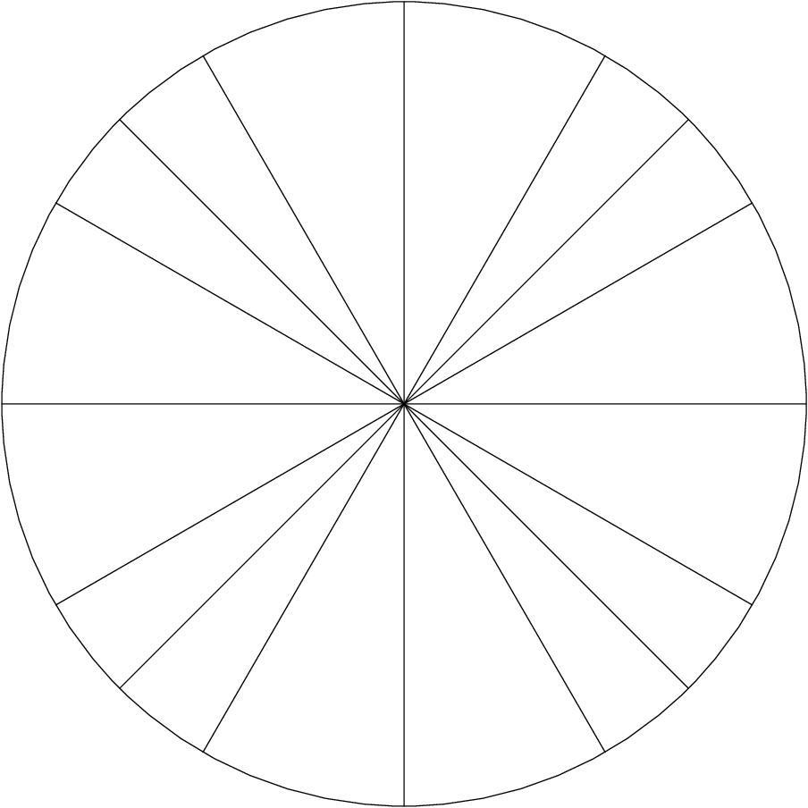

KEY:

